EPS 100 (Stapleton) Name: ___________________________
Notes: Pressure and Buoyancy, Part 1
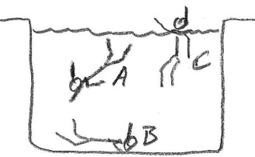
1. In the first picture on the right, which swimmer is experiencing the strongest water pressure?

2. In the second picture on the right, who is experiencing the greatest air pressure?
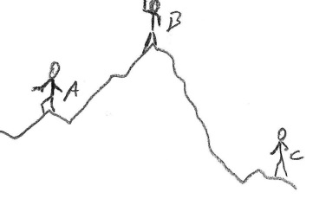

3. Whether you’re in air or water (or any other fluid), the origin of ambient pressure is the same. What creates the air pressure that we’re feeling right now?

4. Use the ears below to explain the source of pain with a change in altitude.

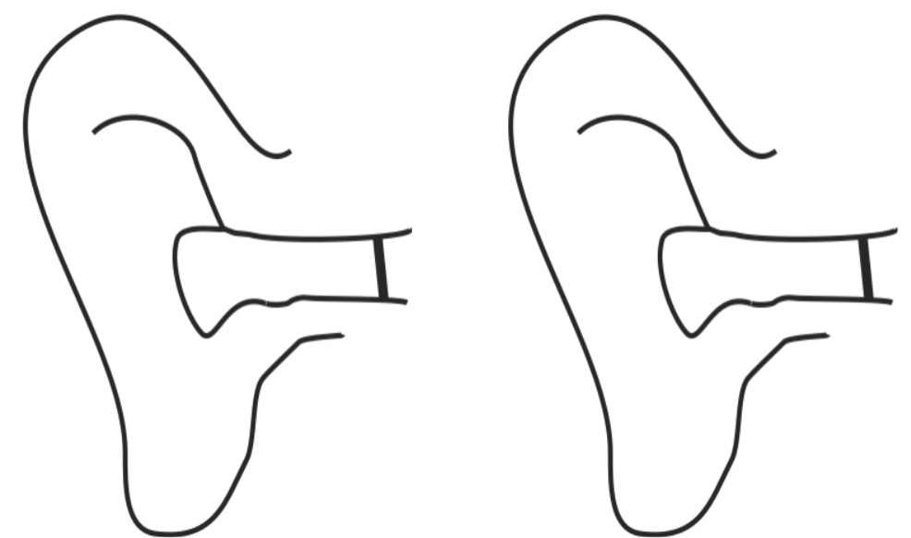

5. At sea level, one cubic meter of air weighs about _______ pounds and has a mass of about ______ kg.

6. Atmospheric Pressure (average air pressure at sea level) = ______ psi

7. “psi” stands for ____________________________________________________________________

8. $Force=pressure ×area$

a. Find the approximate force of air pressure that is pushing against each square inch of your skin.

Pressure = _________ Area = _____________ Force = ______________

b. Find the approximate force of air pressure that is pushing against a 2 square inch piece of paper.

Pressure = _________ Area = _____________ Force = ______________

c. Find the approximate force of air pressure that is pushing against a 10 square inch suction cup.

Pressure = _________ Area = _____________ Force = ______________

9. According to sources, an average human has about 1.8m² (≈2,800 in²) of skin. If you consider the force of air pressure pushing on that many square inches, what total force (in pounds) is pushing against an average human’s skin?

10. Why doesn’t this force crush us?

11. The two people on the right are inside trash bags. One has a vacuum hose inserted in the bag. The other does not. Use arrows to show how the sensation of vacuum packing is caused by air pressure pushing inward from the outside of the bag.
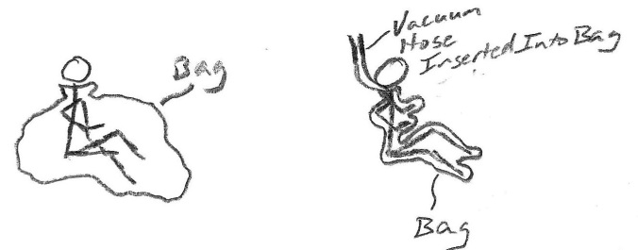

12. Suppose the bag can be sealed to form a pillow with surface dimensions 30 inches x 50 inches. What is the maximum weight that the bag can support if it is inflated with a shop vac providing 1psi of pressure?

13. Explain why a suction cup sticks to a glass surface and why a book does not.

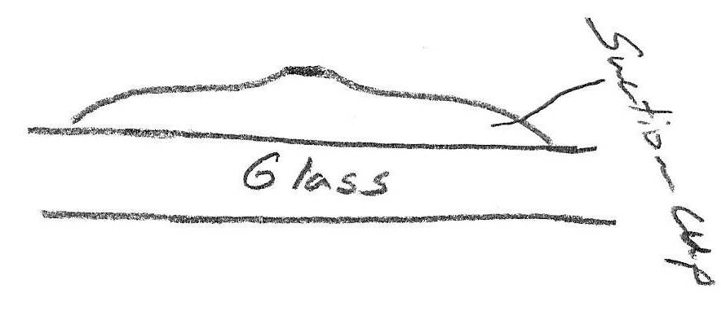

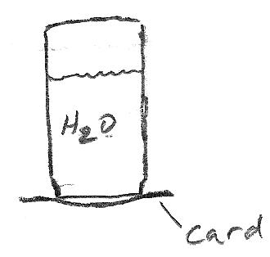

14. What happens if you fill a jar with water, cover it with a laminated card, and then turn the jar upside down? Explain why.

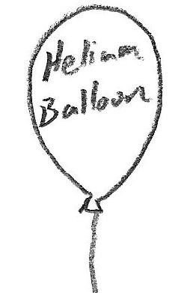
15. A helium balloon floats upward. Show and explain how it “knows” which way to go.

