EPS 200 (Stapleton) Name: ___________________________
Pressure, Buoyancy, and Archimedes’ Principle

Buoyancy is the net force of fluid pressure acting on an object.

Net force:

The diagram below shows a tank of water. The water is motionless. Consider a cube of water in the middle of the rest of the water. The water in the center is separated from the rest of the water by a permeable box of negligible thickness and mass. It’s so think you can pretend that it’s not there, except for the fact that it keeps the water separate…

1. Use arrows to show hypothetical forces exerted on the cube by the surrounding water pressure.

2. Show the net force of water pressure that is acting on the cube. Label it “buoyant force.”

3. Show the force of gravity (weight) acting on the cube of water.

4. Since the water is motionless the buoyant force acting on the water is _____________ the weight of the water.

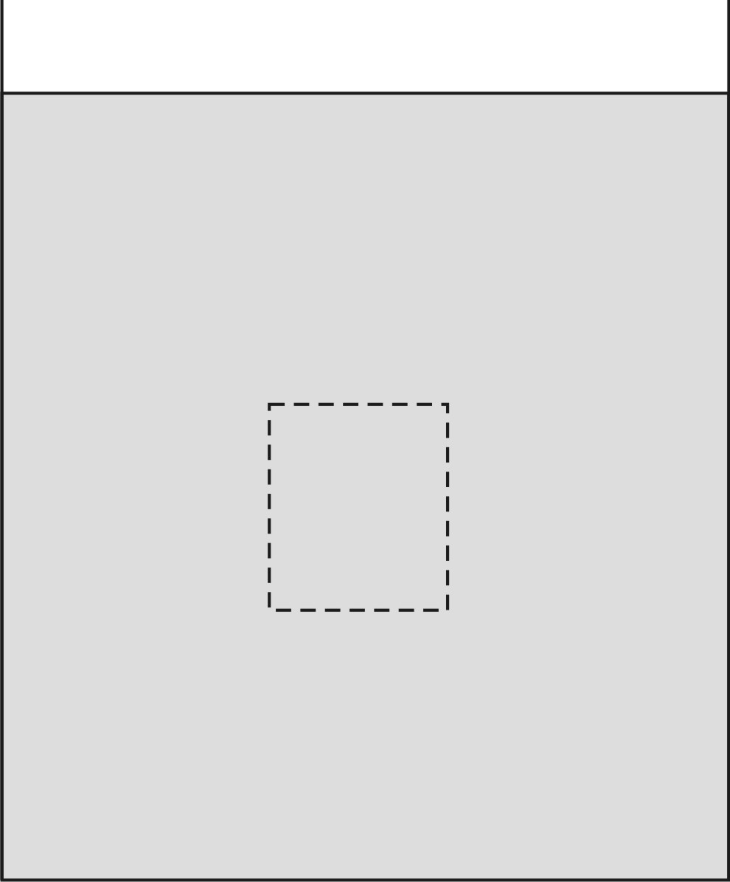

Archimedes’ Principle:
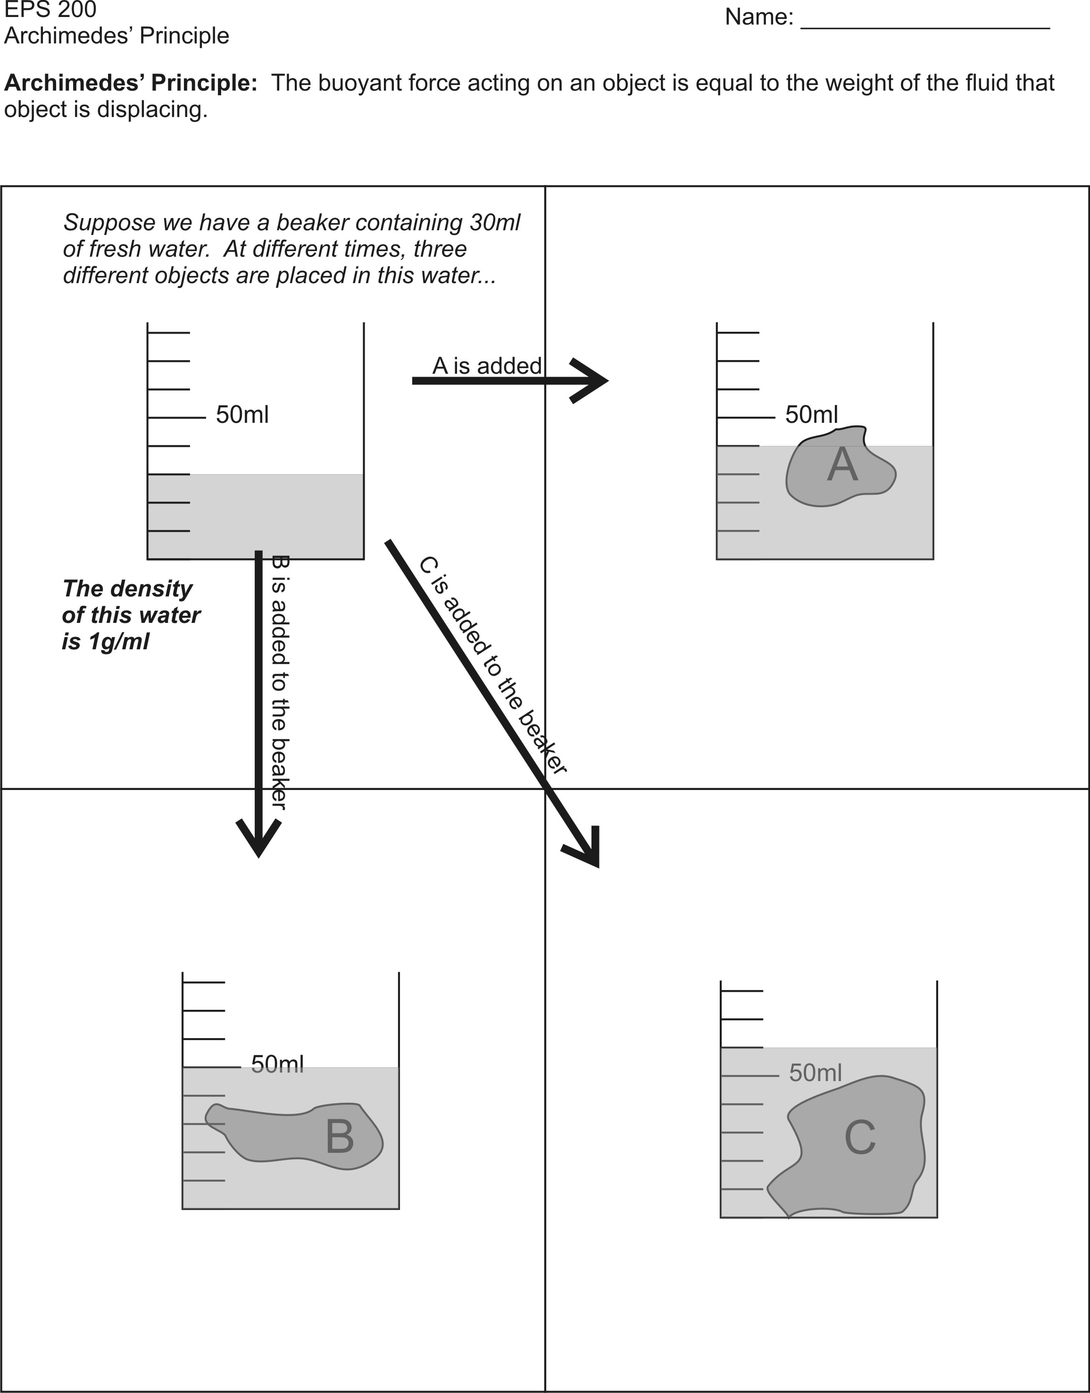

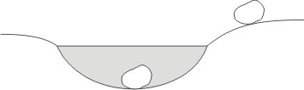
5. If you try to lift the same rock on land and under water, the rock will feel heavier on land. Is its weight different under water? Explain.

6. A giant boulder is sitting on the bottom of a lake. A fishing bobber is floating on the surface. Which of these two items is being acted upon by the strongest buoyant force? Explain.

7. If you were standing on a very, very, very precise scale, and someone suddenly removed the air from the room in which you were standing, what would happen to the reading of the scale? Why?

8.
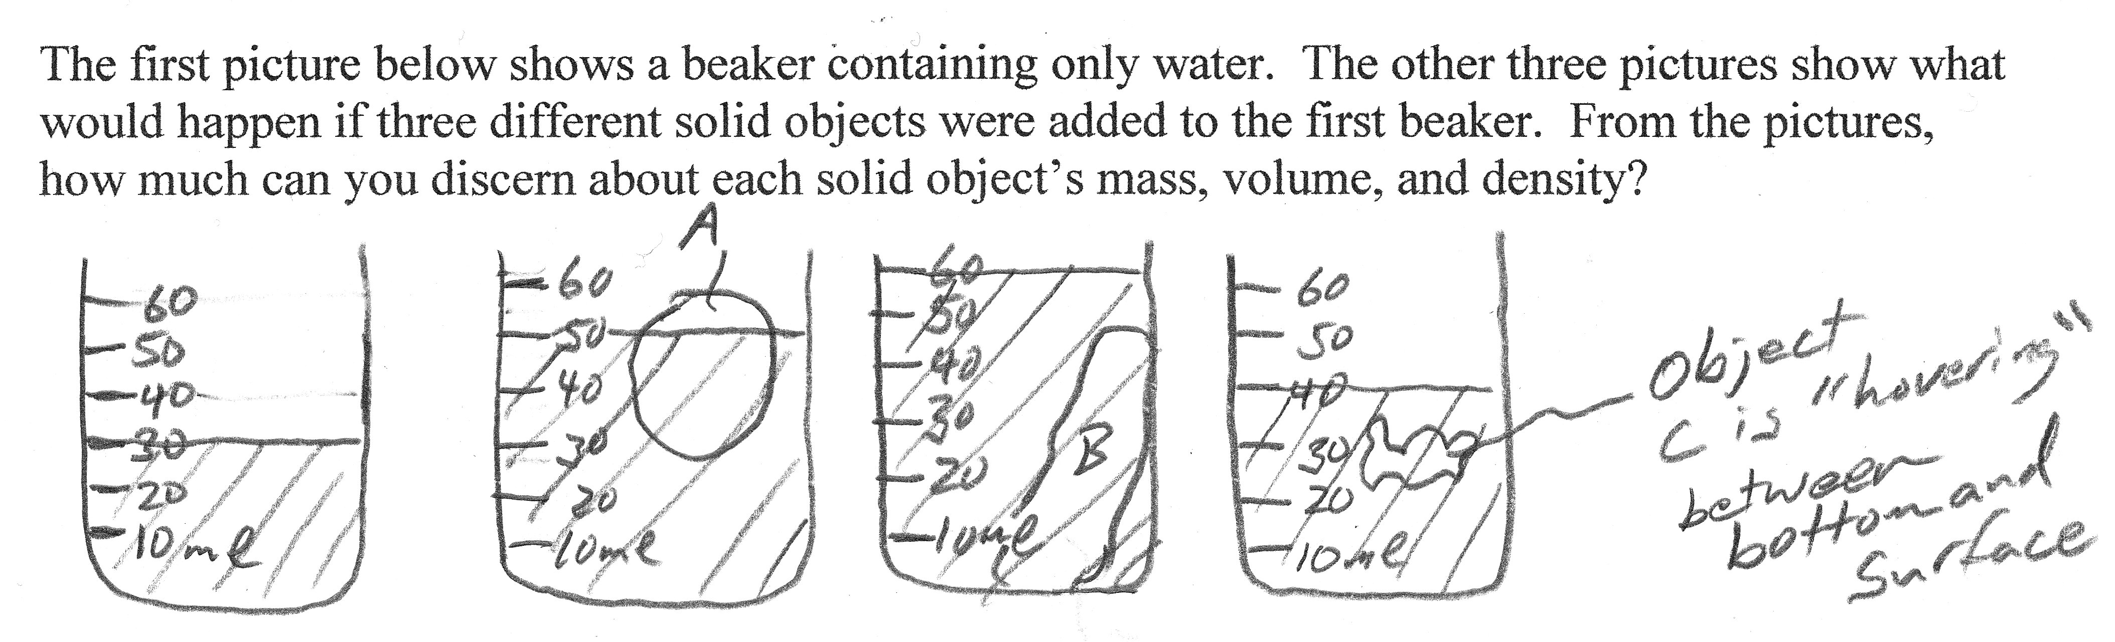

Density of water = ____ g/ml

Object | Mass | Volume | Density
A
B
C

9. Use Archimedes’ Principle to solve this problem.
