EPS 100 (Stapleton)
Rock Dating: Practice Quiz 2

Organize the lettered rock samples from oldest to youngest. Then make a mark where the earthquake occurred in the sequence.

Oldest Newest

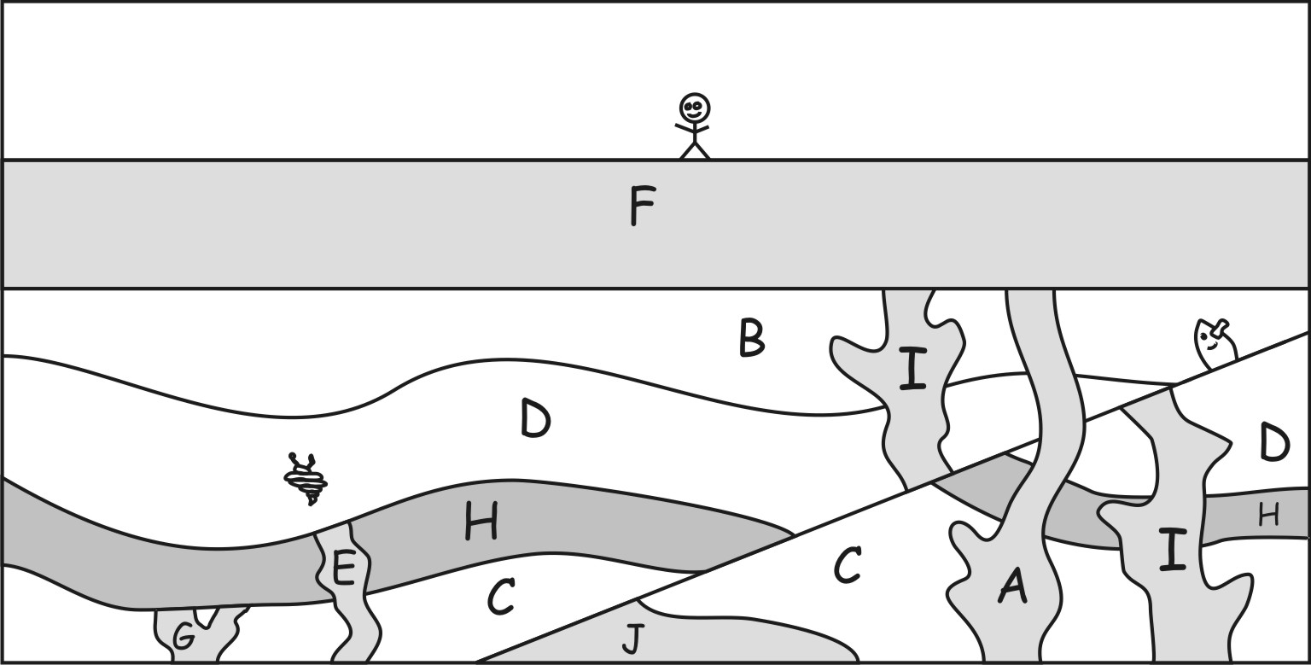
1. Sample G contains 90 U-238 parent atoms and 480 Pb-206 daughter atoms.
a. What percentage of those atoms are parent atoms?

b. Which of the following is closest to the age of Sample G?
0by 3by 6by 9by 12by 15by

2. Sample E contains 30 U-238 parent atoms and 90 Pb-206 daughter atoms.
a. What percentage of those atoms are parent atoms?

b. Which of the following is closest to the age of Sample E?
0by 3by 6by 9by 12by 15by

3. Sample A contains 90 U-238 parent atoms and 52 Pb-206 daughter atoms.

a. What percentage of those atoms are parent atoms?

b. Which of the following is closest to the age of Sample A?
0by 3by 6by 9by 12by

4. Sample I contains 50 U-238 parent atoms and 77 Pb-206 daughter atoms.
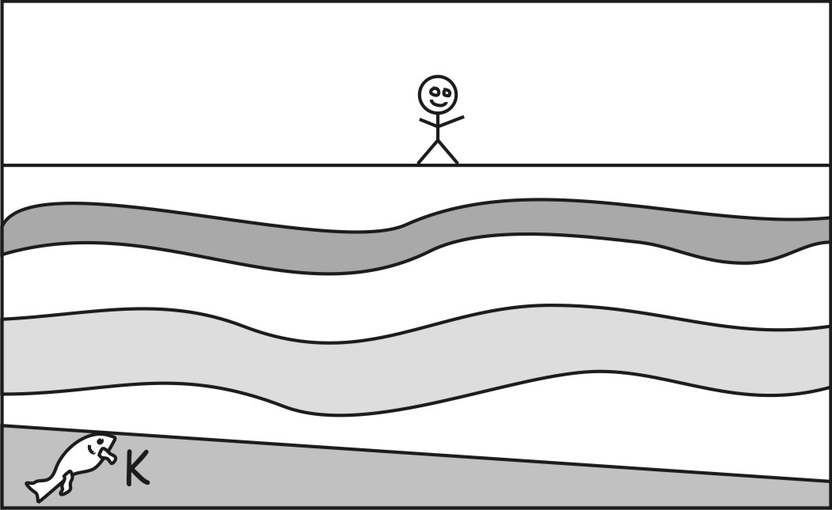
a. What percentage of those atoms are parent atoms?

b. Which of the following is closest to the age of Sample I?
0by 3by 6by 9by 12by 15by

3. Which of the following is closest to the age of the fault created by the earthquake?
3-6by 6-9by 9-12by 12-15by 15-18by

6. The diagram on the right shows rock samples from another location on Earth. Choose the most likely age range for layer K, in that diagram.
3-6by 6-9by 9-12by 12-15by 15-18by

