EPS 100 (Stapleton) Name: ___________________________
Test: Star Life Cycles and the Big Bang
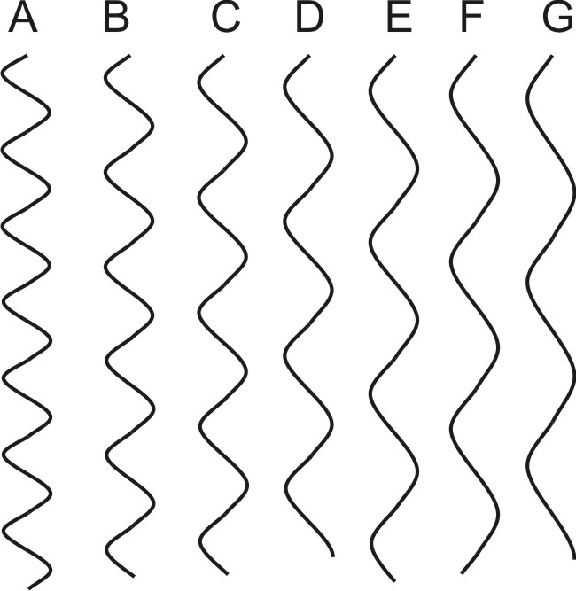
1. What color are the hottest stars?

2. What color are the coolest stars?

3. Which wave on the right has the shortest wavelength?

8. The people in the diagram below are looking at the same star. One person in the diagram below sees a blue-shift, and the other person sees a red-shift. Complete the drawing to show:
a. The direction of the star’s movement. Use an arrow.
b. The light waves leaving the star. Draw them with appropriate wavelengths.

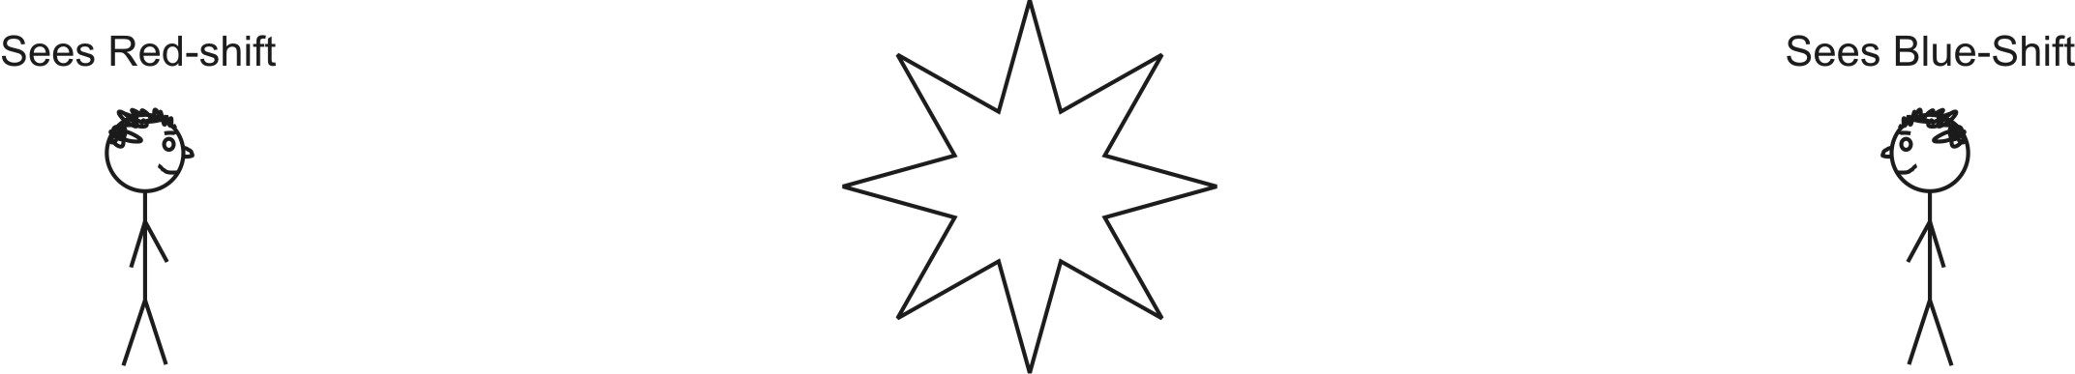

9. Circle the person who is observing the type of shift that we see when we look at distant galaxies.

22. Briefly describe two pieces of evidence that support the Big Bang theory.

High
A

B

Brightness
(brightness units)
C

D
E

Low

High Low
Temperature (º C)
The figure above is a Hertzprung-Russell diagram.

10. In the diagram, which of the stars above is most similar to our present day sun?

11. Which star in the diagram is coolest?

12. List all of the stars that are main sequence stars.

13. What do all main sequence stars have in common?

14. Which star is most likely a red giant?

15. Which star is most likely a white dwarf?

19. a. A very large star (many times bigger than our Sun) dies in an event called a _________________________.

a. What process created the lighter elements (up to the mass of iron)?

b. What process created the heaviest elements (heavier than iron)?

