ESS (Stapleton) Name: _______________________________________
Practice Quiz: Star Lifetimes

For multiple choice and matching questions, please darken the appropriate letter.
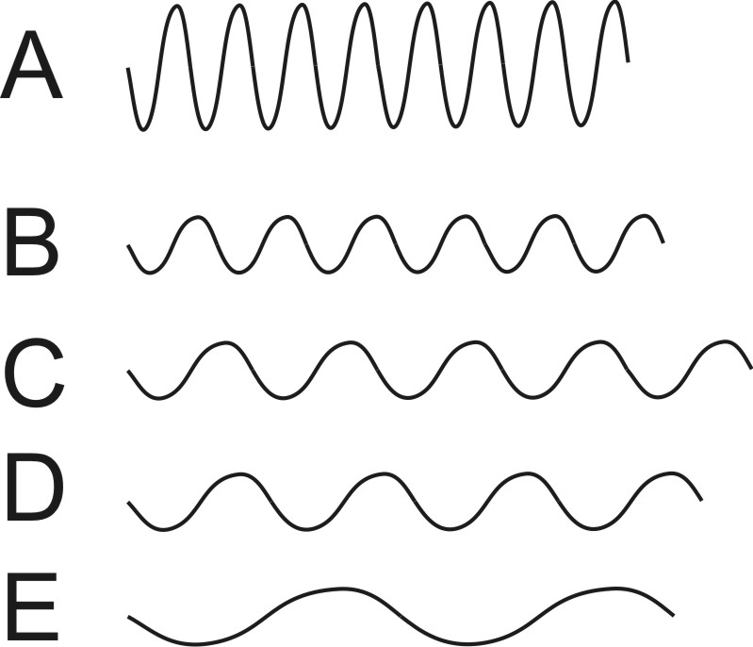
1. Which of the waves on the right has the longest wavelength?
A B C D E

2. Which of these colors has the shortest wavelength?
a. Red b. Yellow c. Green d. Blue

3. Which star colors are ordered from hottest to coolest?
a. Hottest -- Orange, Red, Yellow, Blue, White -- Coolest
b. Hottest -- Green, Red, Yellow, white, Orange – Coolest
c. Hottest -- Red, Orange, Yellow, white, blue – Coolest
d. Hottest -- Blue, White, Yellow, Orange, Red -- Coolest

4. What do all main sequence stars have in common?
a. They are red giants. b. They are white dwarfs.
c. They all die as supernovae. d. They are medium sized stars.
e. Their nuclear fuel is hydrogen.

5. What is the heaviest element that can be created by fusion in a very large star?
a. Hydrogen b. Helium c. Carbon d. Oxygen e. Iron

#6-9. Matching Choices:

a. Neutron Star b. Supernova c. White Dwarf
d. Black Hole e. Red Giant f. Main sequence Star

6. Right now, our sun is best described as a: a b c d e f

7. In its next stage of life, our sun will become a: a b c d e f

8. In its last stage of life, our sun will be a: a b c d e f

9. Very massive stars become supergiants. After the supergiant stage, what happens next in a massive star’s life?
a b c d e f

10. When a star is destroyed in a supernova, which of the following is not a possible fate of the leftover material?
a. It can form a neutron star.
b. It can turn into a main sequence star.
c. It can form a black hole.
d. It can be recycled into another nebula.

High
D
E

Brightness
A
(brightness units)

C
B
Low

High Low
Temperature (º C)

11. In the diagram above, which star is a red giant? A B C D E

12. In the diagram above, which star is a white dwarf? A B C D E

13. In the diagram above, which star is most similar to our sun? A B C D E

14. Which of the stars in the diagram are main sequence stars? (select all that apply) A B C D E

15. When we observe the light from a star that is moving away from us, the light waves are:
a. unchanged b. blue-shifted c. red-shifted

16. Briefly describe two pieces of evidence that support the Big Bang theory.

Evidence:

Evidence:

17. The early universe was mostly Hydrogen and Helium. Now there are at least 92 different elements on Earth. Where did all of the other elements (other than Hydrogen and helium) come from?

a. How were the lighter elements created? These “lighter” elements include carbon, oxygen, nitrogen, phosphorus, iron and all of the other elements that are lighter than iron.

b. How were the heaviest elements (heavier than iron) created?

