ESS 100 (Stapleton) Name: ________________________________
Geology Test Review

Part 1: Properties of Mafic and Felsic Materials:

1. | Mafic Material | Felsic Material
Provide an example of a rock of this type.
Describe its density (more or less)
Describe its viscosity (runniness or gooiness) when it is molten.
Where can this be found? List two different types of location for each.
Describe its appearance (shade/color)
Describe the effect of this type of lava/magma on the shape of a volcano.
Describe the effect of this type of lava/magma on the eruptions of a volcano.

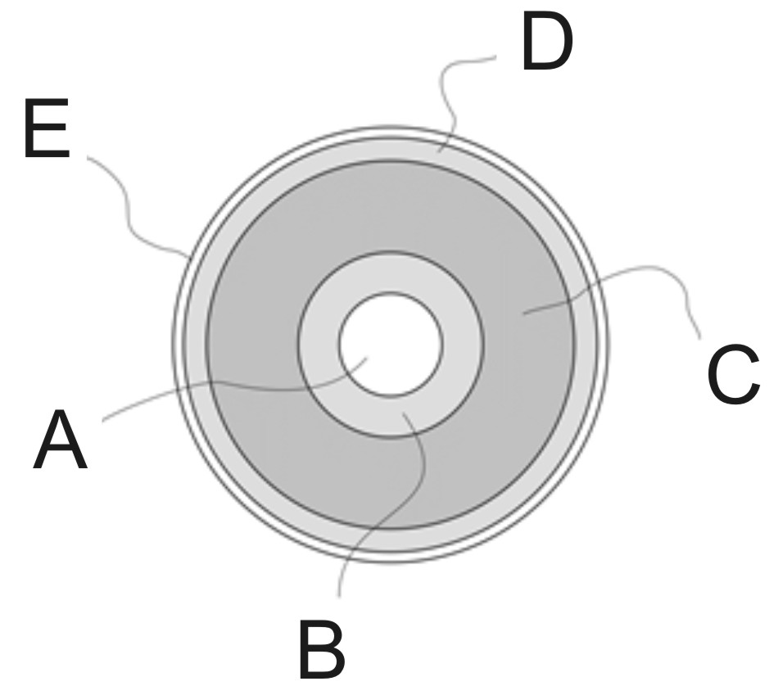
Part II: Earth Layers and Internal Heat

2. Letter | Name of Layer | Describe the material in this layer.
A
B
C
D
E

3. Why is the inside of the Earth hot? Provide two reasons.

Part III: Plate Tectonics

4. Add all of the following to each of the diagrams below.
- Arrows showing the direction of plate movement
- Arrows showing circulation of the mantle and any other mantle currents
- The name of the tectonic feature
- Labels showing especially hot or cool parts of the mantle
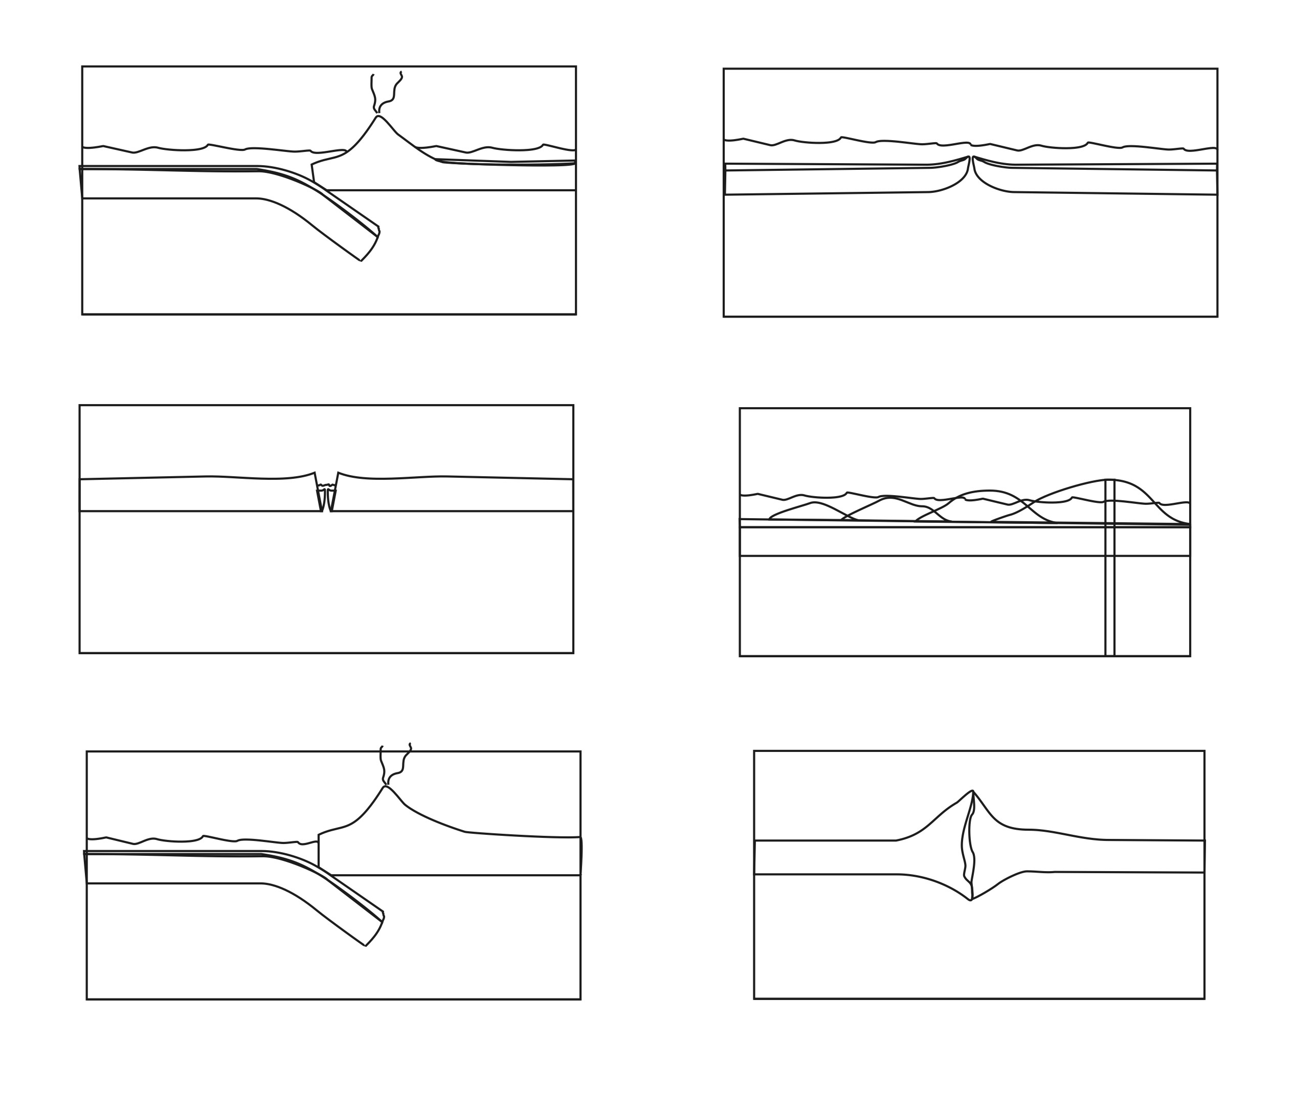
- Correct shading of the plates, mantle, and sediment

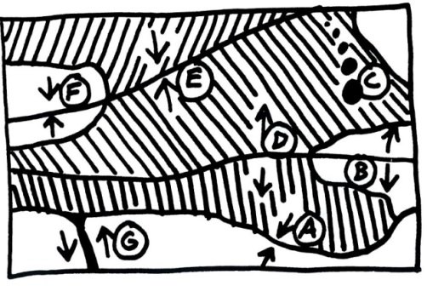
5. Use the map on the right to complete the table.

Letter | Name of Plate Feature | Where does this exist in the real world?
A
B
C
D
E
F
G

Read each of the descriptions below. Then choose all of the choices that apply.

Choices:
H. Ocean Hotspot I. Ocean-Ocean Convergent J. Ocean-Ocean Convergent
K. Ocean-Ocean Divergent L. Continent-Continent Divergent M. Continent-Continent Convergent
N. Transform

6. Where can shield cone volcanoes be found? H I J K L M N
7. Where can deep-focus earthquakes be found? H I J K L M N
8. Which location has nothing but shallow-focus earthquakes? H I J K L M N
9. Where are there very tall mountains, but no volcanoes? H I J K L M N
10. Where are steep, composite cone volcanoes found? H I J K L M N
11. Where is there a rift valley? H I J K L M N

Part IV: The Rock Cycle
12. Which rock type is created when rock is crushed to little bits and then those little bits are compressed together? A. Igneous B. Metamorphic C. Sedimentary

13. Which rock type is created when rock is melted and then allowed to cool again, returning to solid form?
A. Igneous B. Metamorphic C. Sedimentary

14. Which rock type is created when existing rock is smashed or heated or both, but not entirely melted?
A. Igneous B. Metamorphic C. Sedimentary

15. Which type of rock can be dated using radiometric methods?
A. Igneous B. Metamorphic C. Sedimentary

Part V: Rock Dating

16. Three rules for relative dating:
- When one layer reaches higher than another, the one that reaches the highest…

- When one rock formation cuts through another formation, the one that does the cutting…

- When two rock formations cross an earthquake fault, and one of the formations is broken by the fault but the other is not, the formation that is broken…

17. Write the formula for determining the percentage of parent atoms remaining in a rock sample, given the numbers of parent atoms and daughter atoms that are currently in the rock sample.

18. A rock sample has 38 parent atoms and 58 daughter atoms. What percentage of those atoms are parent atoms?

19. Complete the table below for a rock sample containing parent atoms with a half-life of 10,000 years.

Age of sample, in Half-Lives | Percentage of Parent Atoms Remaining in the rock | Age of rock Sample, in years
0 Half-lives
1 Half-Life
2 Half-lives
3 Half-lives
4 Half-lives

Organize the lettered rock samples from oldest to youngest. Then make a mark where the earthquake occurred in the sequence. Then use the graph on the back (or your own graph) to answer questions 20-26.

Oldest Newest
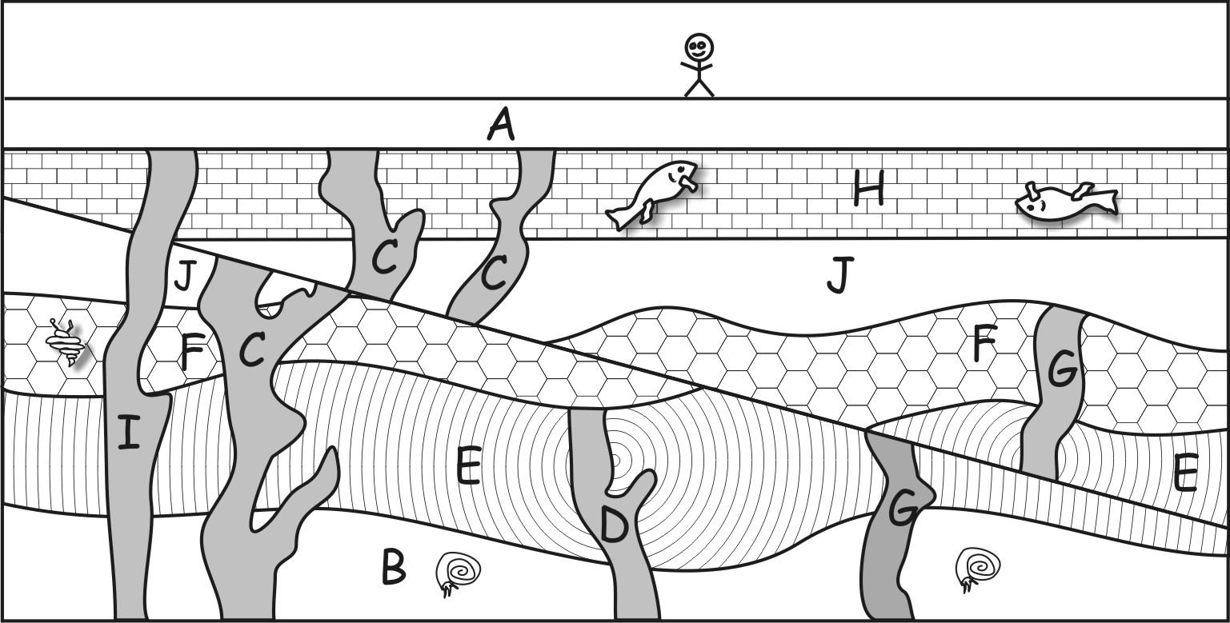
20. Of the following four layers, which is the youngest? J I C H

21. Of the following four layers, which is the oldest? G F E D

22. Sample I contains 20 U-238 parent atoms and 30 Pb-206 daughter atoms.
a. What percentage of those atoms are parent atoms?
20% 40% 60% 80%

b. Which of the following is closest to the age of Sample I?
0by 3 by 6by 9by 12by 15by

23. Sample C contains 60 U-238 parent atoms and 180 Pb-206 daughter atoms.
a. What percentage of those atoms are parent atoms?
25% 50% 75% 100%
b. Which of the following is closest to the age of Sample C?
0by 3 by 6by 9by 12by 15by 18by

24. Sample D contains 40 U-238 parent atoms and 600 Pb-206 daughter atoms.

a. Approximately what percentage of those atoms are parent atoms?
6% 22% 48% 88% 94%
b. Which of the following is closest to the age of SampleD?
0by 3 by 6by 9by 12by 15by 18by

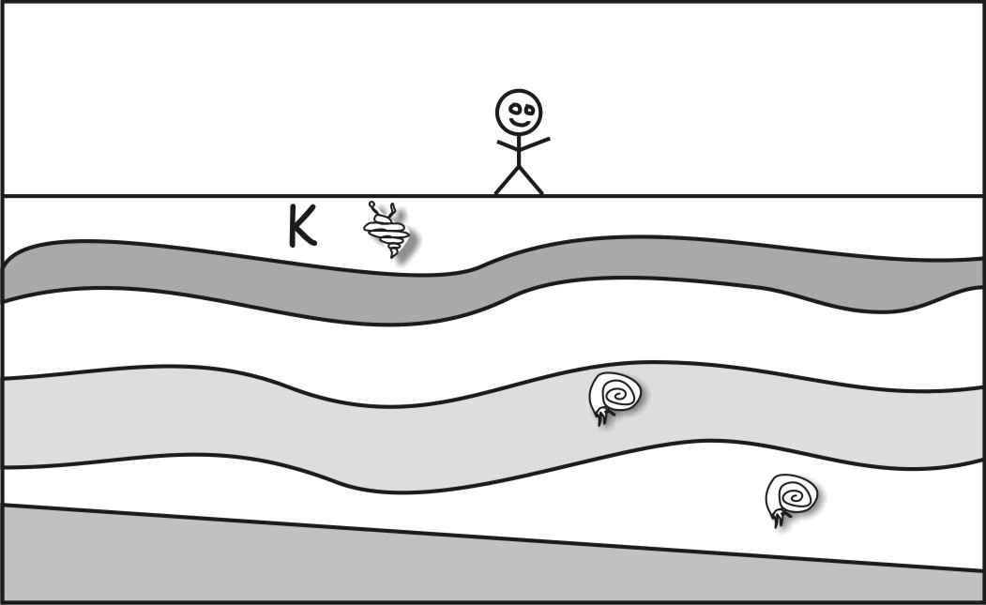
25. Sample G contains 30 U-238 parent atoms and272 Pb-206 daughter atoms.
a. Approximately what percentage of those atoms are parent atoms?
10% 20% 30% 40% 50% 60%
b. Which of the following is closest to the age of SampleG?
0by 3 by 6by 9by 12by 15by 18by

26. Which of the following is closest to the age of the fault created by the earthquake?
0-3by 3-6by 6-9by 9-12by
12-15by 15-18by

27. The diagram on the right shows rock samples from another location on Earth. Choose the most likely age range for layer K.
2-3by 3-4by 4-5by 5-6by

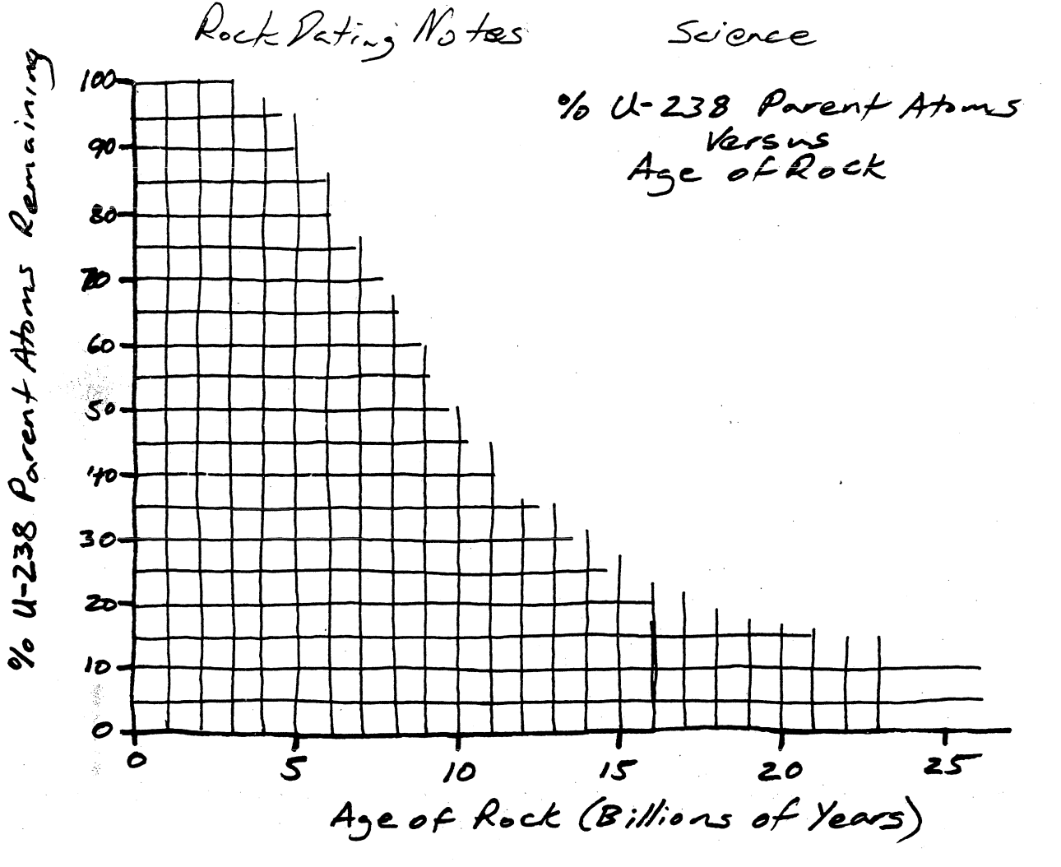

The half-life of U-238 is 4.5 Billion Years

