EPS 200 (Stapleton) Name: __________________________
More Geology Review Practice

Part 1: Rock Dating
1. Organize the lettered rock samples from oldest to youngest. Then make a mark where the earthquake occurred in the sequence.

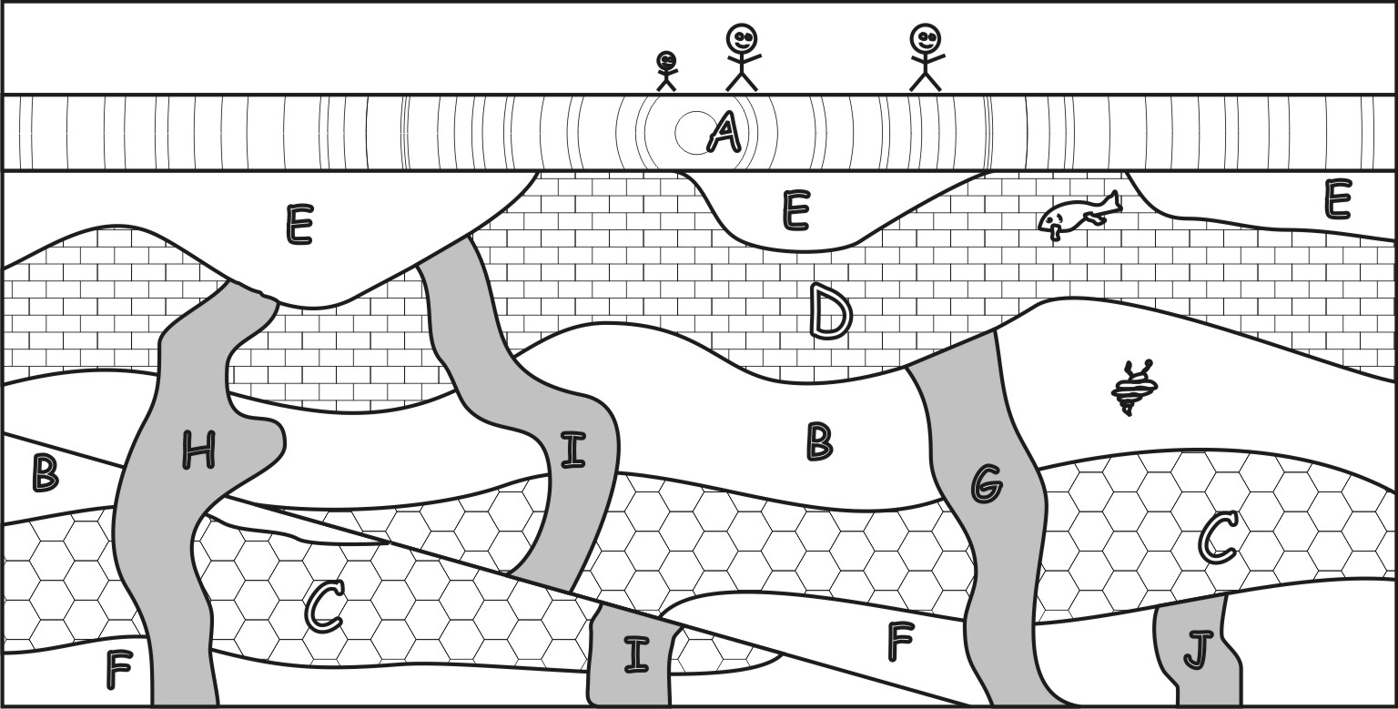
2. Complete the graph below, using a half-life of 1.5 billion years for K-40.

3. According to your graph, approximately how old is a rock if it has 15% of its parent atoms remaining?

1by 2by 3by 4by 5by

4. Sample H contains 27 K-40 parent atoms and 17 Ar-40 daughter atoms.
a. What percentage of those atoms are parent atoms?
1% 21% 41% 61% 81%

b. Which of the following is closest to the age of Sample H?
1by 2by 3by 4by 5by

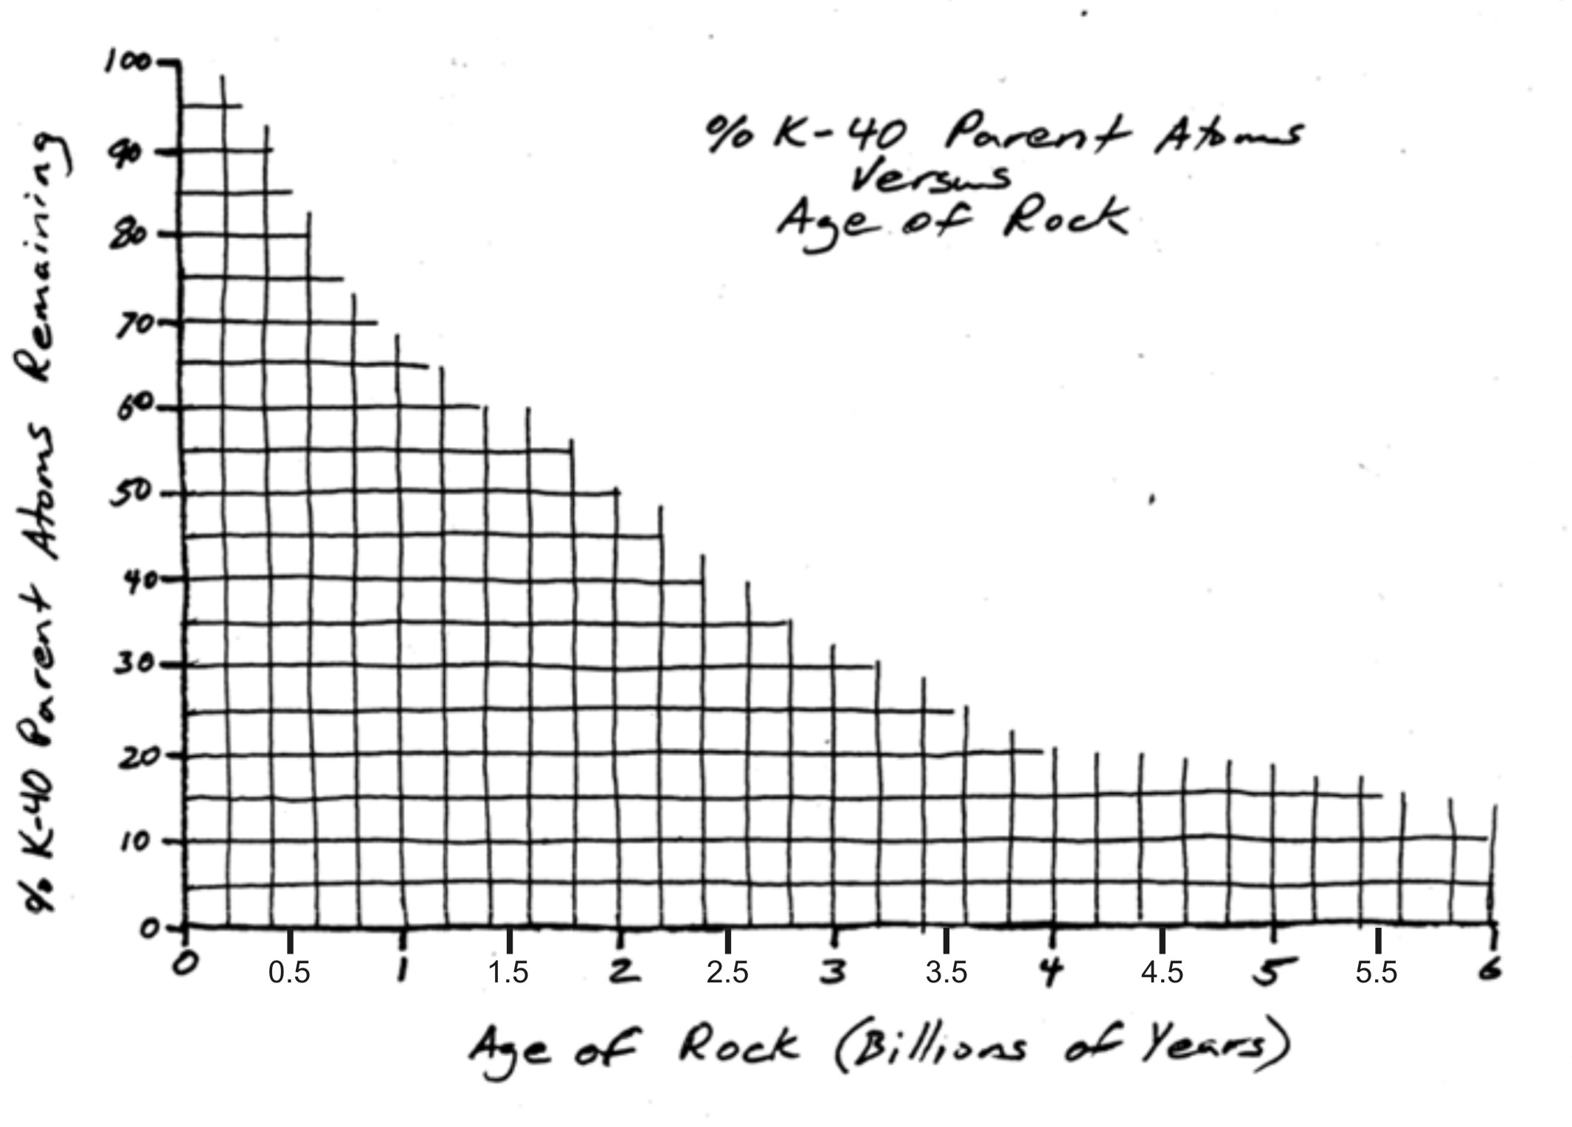
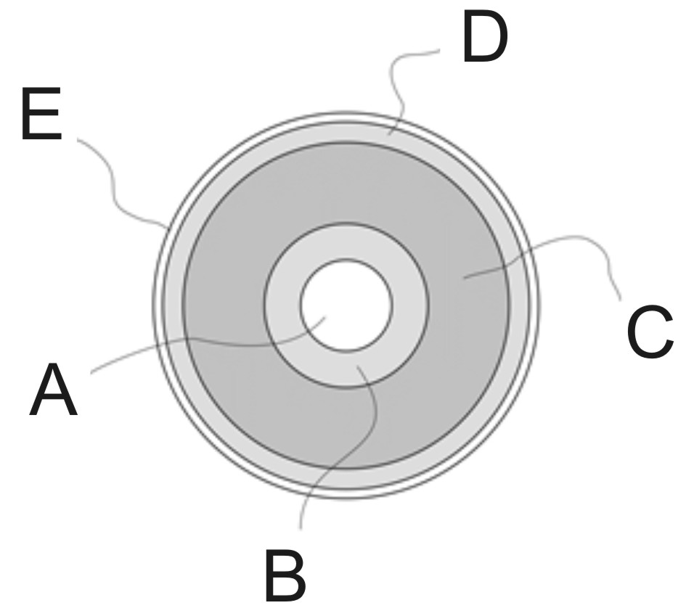
Part 2: Earth Layers and Convection Currents

For each layer name, darken the letter of the corresponding layer in the diagram.

5. Lithosphere/Crust A B C D E
6. Lower Mantle A B C D E

For each description, darken the name of the layer that it describes. Answers may be used more than once

7. Least dense layer: Inner Core Outer Core Crust/Lithosphere Mantle
8. Hot, Flowing Rock: Inner Core Outer Core Crust/Lithosphere Mantle
9. Solid rock: Inner Core Outer Core Crust/Lithosphere Mantle

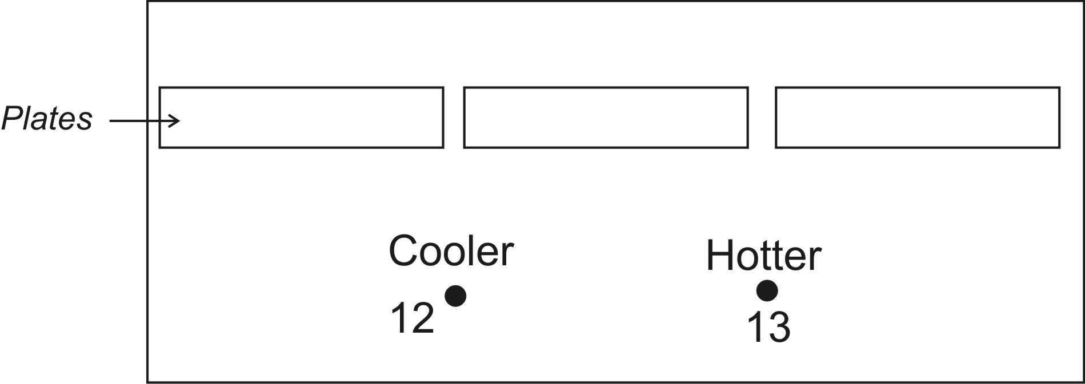
On the diagrams below, add arrows to show the circulation pattern of the plates and mantle. Then answer the questions.

10. Darken rcle the direction of current movement at number 13.
↑ ↓ ← →
11. Darken the direction of movement at number 14.
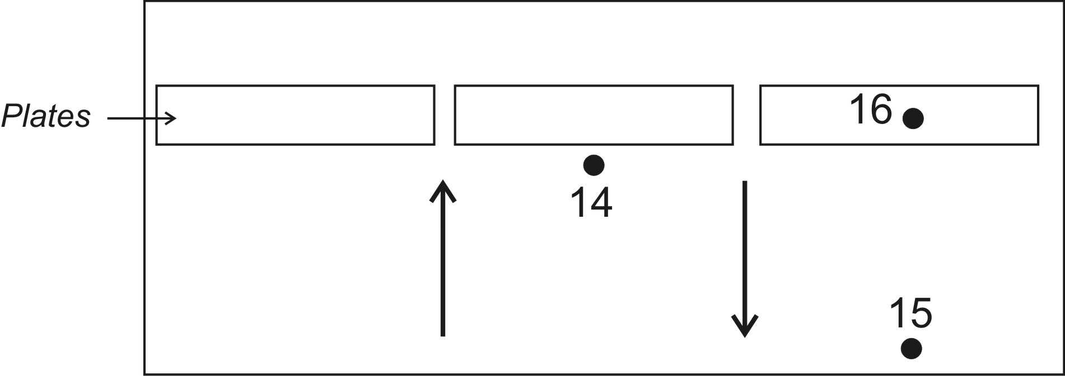
↑ ↓ ← →
12. Darken the direction of movement at number 16.
↑ ↓ ← →
13. What type of plate boundary is shown at number 18?
Convergent Divergent Transform

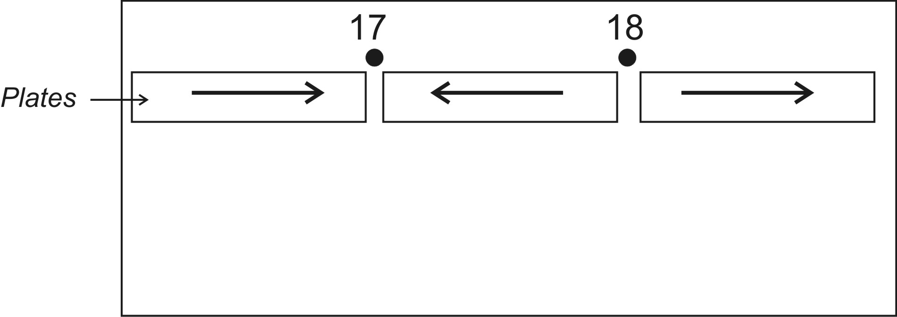
14. Why is the inside of the Earth hot? Provide two reasons.

Part 3: Mafic and Felsic Materials

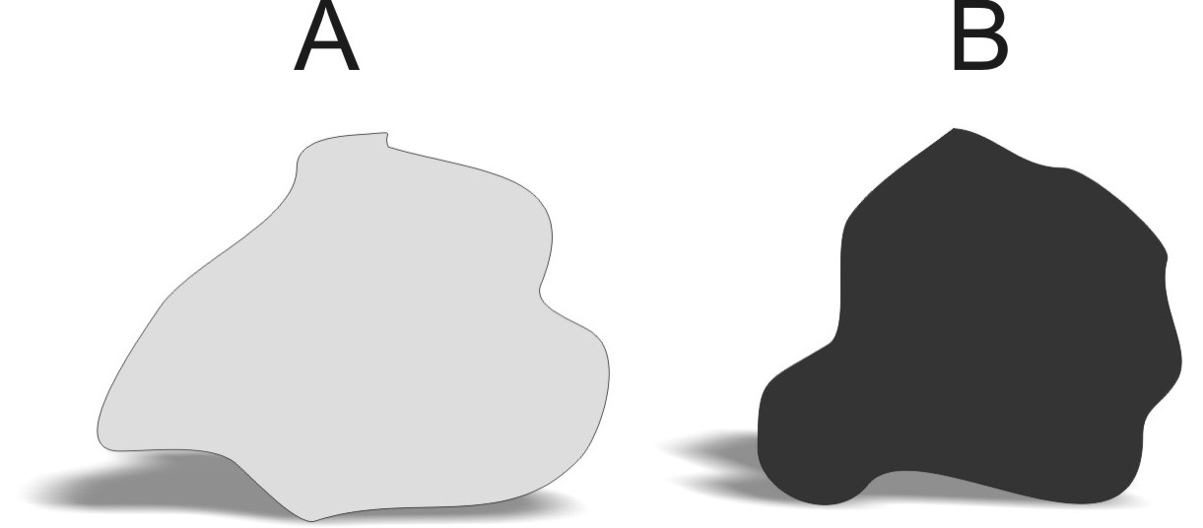
The two rocks on the right represent typical rocks found in different types of Earth crust.

15. Which of the rocks on the right is likely to be basalt? A B
16. Which rock is less viscous (runnier) when it is melted into magma or lava? A B
17. Which type of rock is most similar to the material in the Earth's mantle? A B
18 . Which rock is classified as felsic? A B
19. When these rocks are melted into lava, which one causes the most explosive eruptions? A B

Part4: Plate Tectonic Features
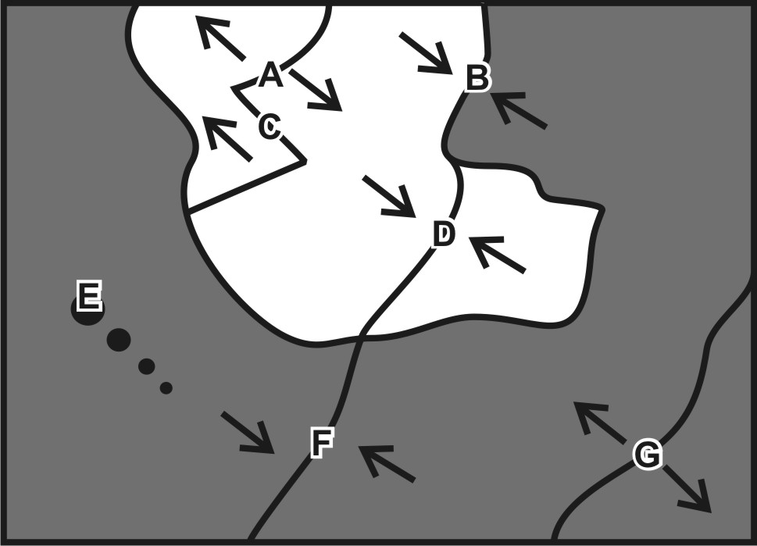
Match each feature name to the corresponding feature on the plate map on the right.

20. A B C D E F G Transform Boundary
21. A B C D E F G Ocean/Continent Convergent
22. A B C D E F G Ocean/Ocean Convergent

Each of the real-world locations below forms in an area that is similar to one of the lettered locations on the map. Match each real-world location to its corresponding map location.

23. A B C D E F G East Africa
24. A B C D E F G Andes Mountains (South America)
25. A B C D E F G Himalayas (Mt. Everest).

Part II: For each lettered feature on the map above, darken all of the descriptions below that apply. [Suggestion: start with letter A. Darken that letter for all of the descriptions that apply to location A on the map. Continue the process one map feature at a time. For each letter, sketch a cross-section diagram.]

26. Where can shield cone volcanoes be found? A B C D E F G
27. Where can deep-focus earthquakes be found? A B C D E F G
28. Which location has nothing but shallow-focus earthquakes? A B C D E F G
29. Where are there very tall mountains, but no volcanoes? A B C D E F G
30. Where are steep, composite cone volcanoes found? A B C D E F G
31. Where is there a rift valley? A B C D E F G

Part V: The Rock Cycle

32. Which rock type is created when existing rock is smashed or heated or both, but not entirely melted?
A. Igneous B. Metamorphic C. Sedimentary

33. Which rock type is created when rock is melted and then allowed to cool again, returning to solid form?
A. Igneous B. Metamorphic C. Sedimentary

34. Which type of rock can be dated using radiometric methods?
A. Igneous B. Metamorphic C. Sedimentary

35. Which rock type is created when rock is crushed to little bits and then those little bits are compressed together? A. Igneous B. Metamorphic C. Sedimentary

