EPS 100 Name: _____________________________________

Practice Test: Plate Tectonics

**For multiple choice questions, PLEASE DARKEN THE CORRECT ANSWER CHOICES.**

The following questions refer to the diagram on the right.



1. Which layer is made of solid iron?

A B C D E

2. Which layer is the lower mantle?

A B C D E

3. Which layer is least dense?

A B C D E

4. Which layer is the lithosphere?

A B C D E

5. Which layer has convection currents that cause the Earth’s plates to move?

A B D E

6. Why is the inside of the Earth hot? Provide one reason.

The diagram below shows several plates that are floating on the Earth’s surface. The gap between each plate represents a plate boundary. Material flowing below the Earth’s surface cannot pass beneath the bottom line. Sketch the plate and mantle movements and then answer the questions.

7. In which direction is the plate moving at position 7? ↑ ↓ ← →

8. What type of plate boundary exists at position 8? a. convergent b. divergent c. transform

9. In which direction is the plate moving at position 9? ↑ ↓ ← →

10. What type of plate boundary exists at position 10? a. convergent b. divergent c. transform



11. In which direction is the earth material flowing at position 11? ↑ ↓ ← →

12. In which direction is the earth material flowing at position 12? ↑ ↓ ← →



13. The diagram on the right shows chunks of two types of crust. One represents continental crust, and the other represents ocean crust. Label them correctly.

Match each description to the appropriate type of crust. Choices: **A= Continental Crust B = Ocean Crust**

14. A B Lighter in color/shade

15. A B This is the densest type of crust.

16. A B Melts to become high viscosity (gooey) lava.

17 A B Lava of this type does not pile up. It forms low, rounded volcanoes.

18. A B An example of this rock type is called granite.

19. A B The most explosive volcanoes have some of this type of lava.

20. A B This type of lava can pile up to form steep volcanoes.

21. A B Seafloor sediment contains a lot of this type of material.

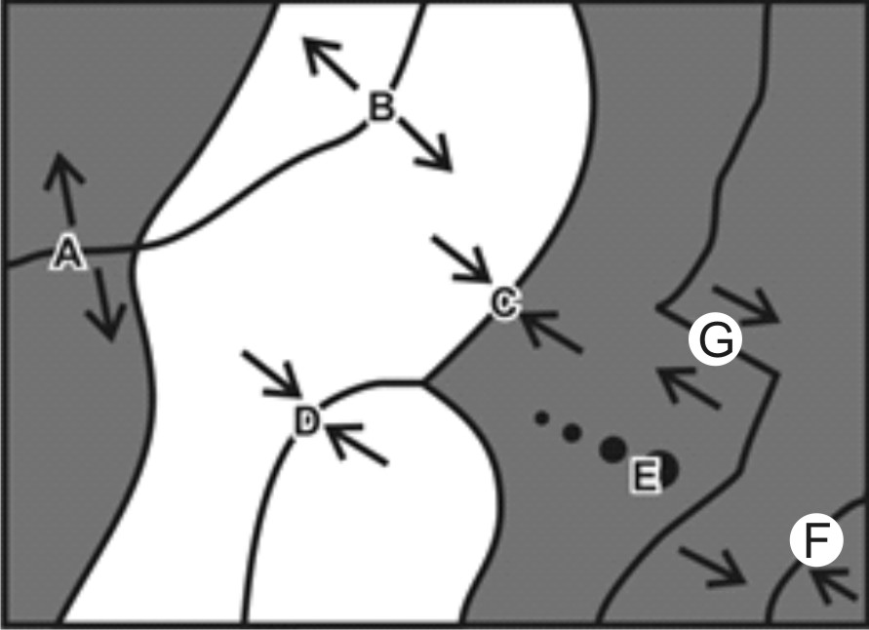Match each feature name to the corresponding feature on the plate map on the right. You can also refer to the incomplete plate drawings on page 3.

22. A B C D E F G Transform Boundary

23. A B C D E F G Hotspot

24. A B C D E F G Continent/Continent Convergent

25. A B C D E F G Continent/Continent Divergent

26. A B C D E F G Ocean/Continent Convergent

27. A B C D E F G Ocean/Ocean Convergent

28. A B C D E F G Ocean/Ocean Divergent

Each of the real-world locations below forms in an area that is similar to one of the lettered locations on the map. Match each real-world location to its corresponding map location.

29. A B C D E F G Mid-Atlantic Ridge

30. A B C D E F G Himalayas (Mt. Everest)

31. A B C D E F G Japan

32. A B C D E F G Andes Mountains (South America)

33. A B C D E F G East Africa

34. A B C D E F G Hawaii

35. A B C D E F G San Andreas Fault, California

The descriptions below refer to the plate features on the page 2 plate map. The unfinished plate drawings at the bottom of this page match those features and are provided to help you think about these questions. *There is no provided diagram for letter G*. Before completing the questions below, quickly complete the diagrams by sketching the landforms that will be created. Then use your knowledge and sketches to answer the questions. There will only be one correct answer for each question.

36. There is an ocean trench in this location. A C E G

37. This is located over a cool part of the mantle. A D E G

38. There are steep, composite cone volcanoes that can be either explosive or gentle.

A F D E

39. This is a valley that will eventually become an ocean. B C D E

40. This is a long ridge at the bottom of an ocean that is growing larger. A B C G

41. There are low, rounded “shield” cone volcanoes that have gentle eruptions.

C D E F

42. There are very tall mountains, but there are no volcanoes. B D C E

43. Both dark and light lava can flow in this location. A D E F

44. There can be deep-focus earthquakes in this location. A B C D

45 There are no mountains and no lava, but there are shallow earthquakes.

B C D G

46 Here there is at least one island that is a volcano. A C F G

47. New ocean crust is being created here. B C D G

