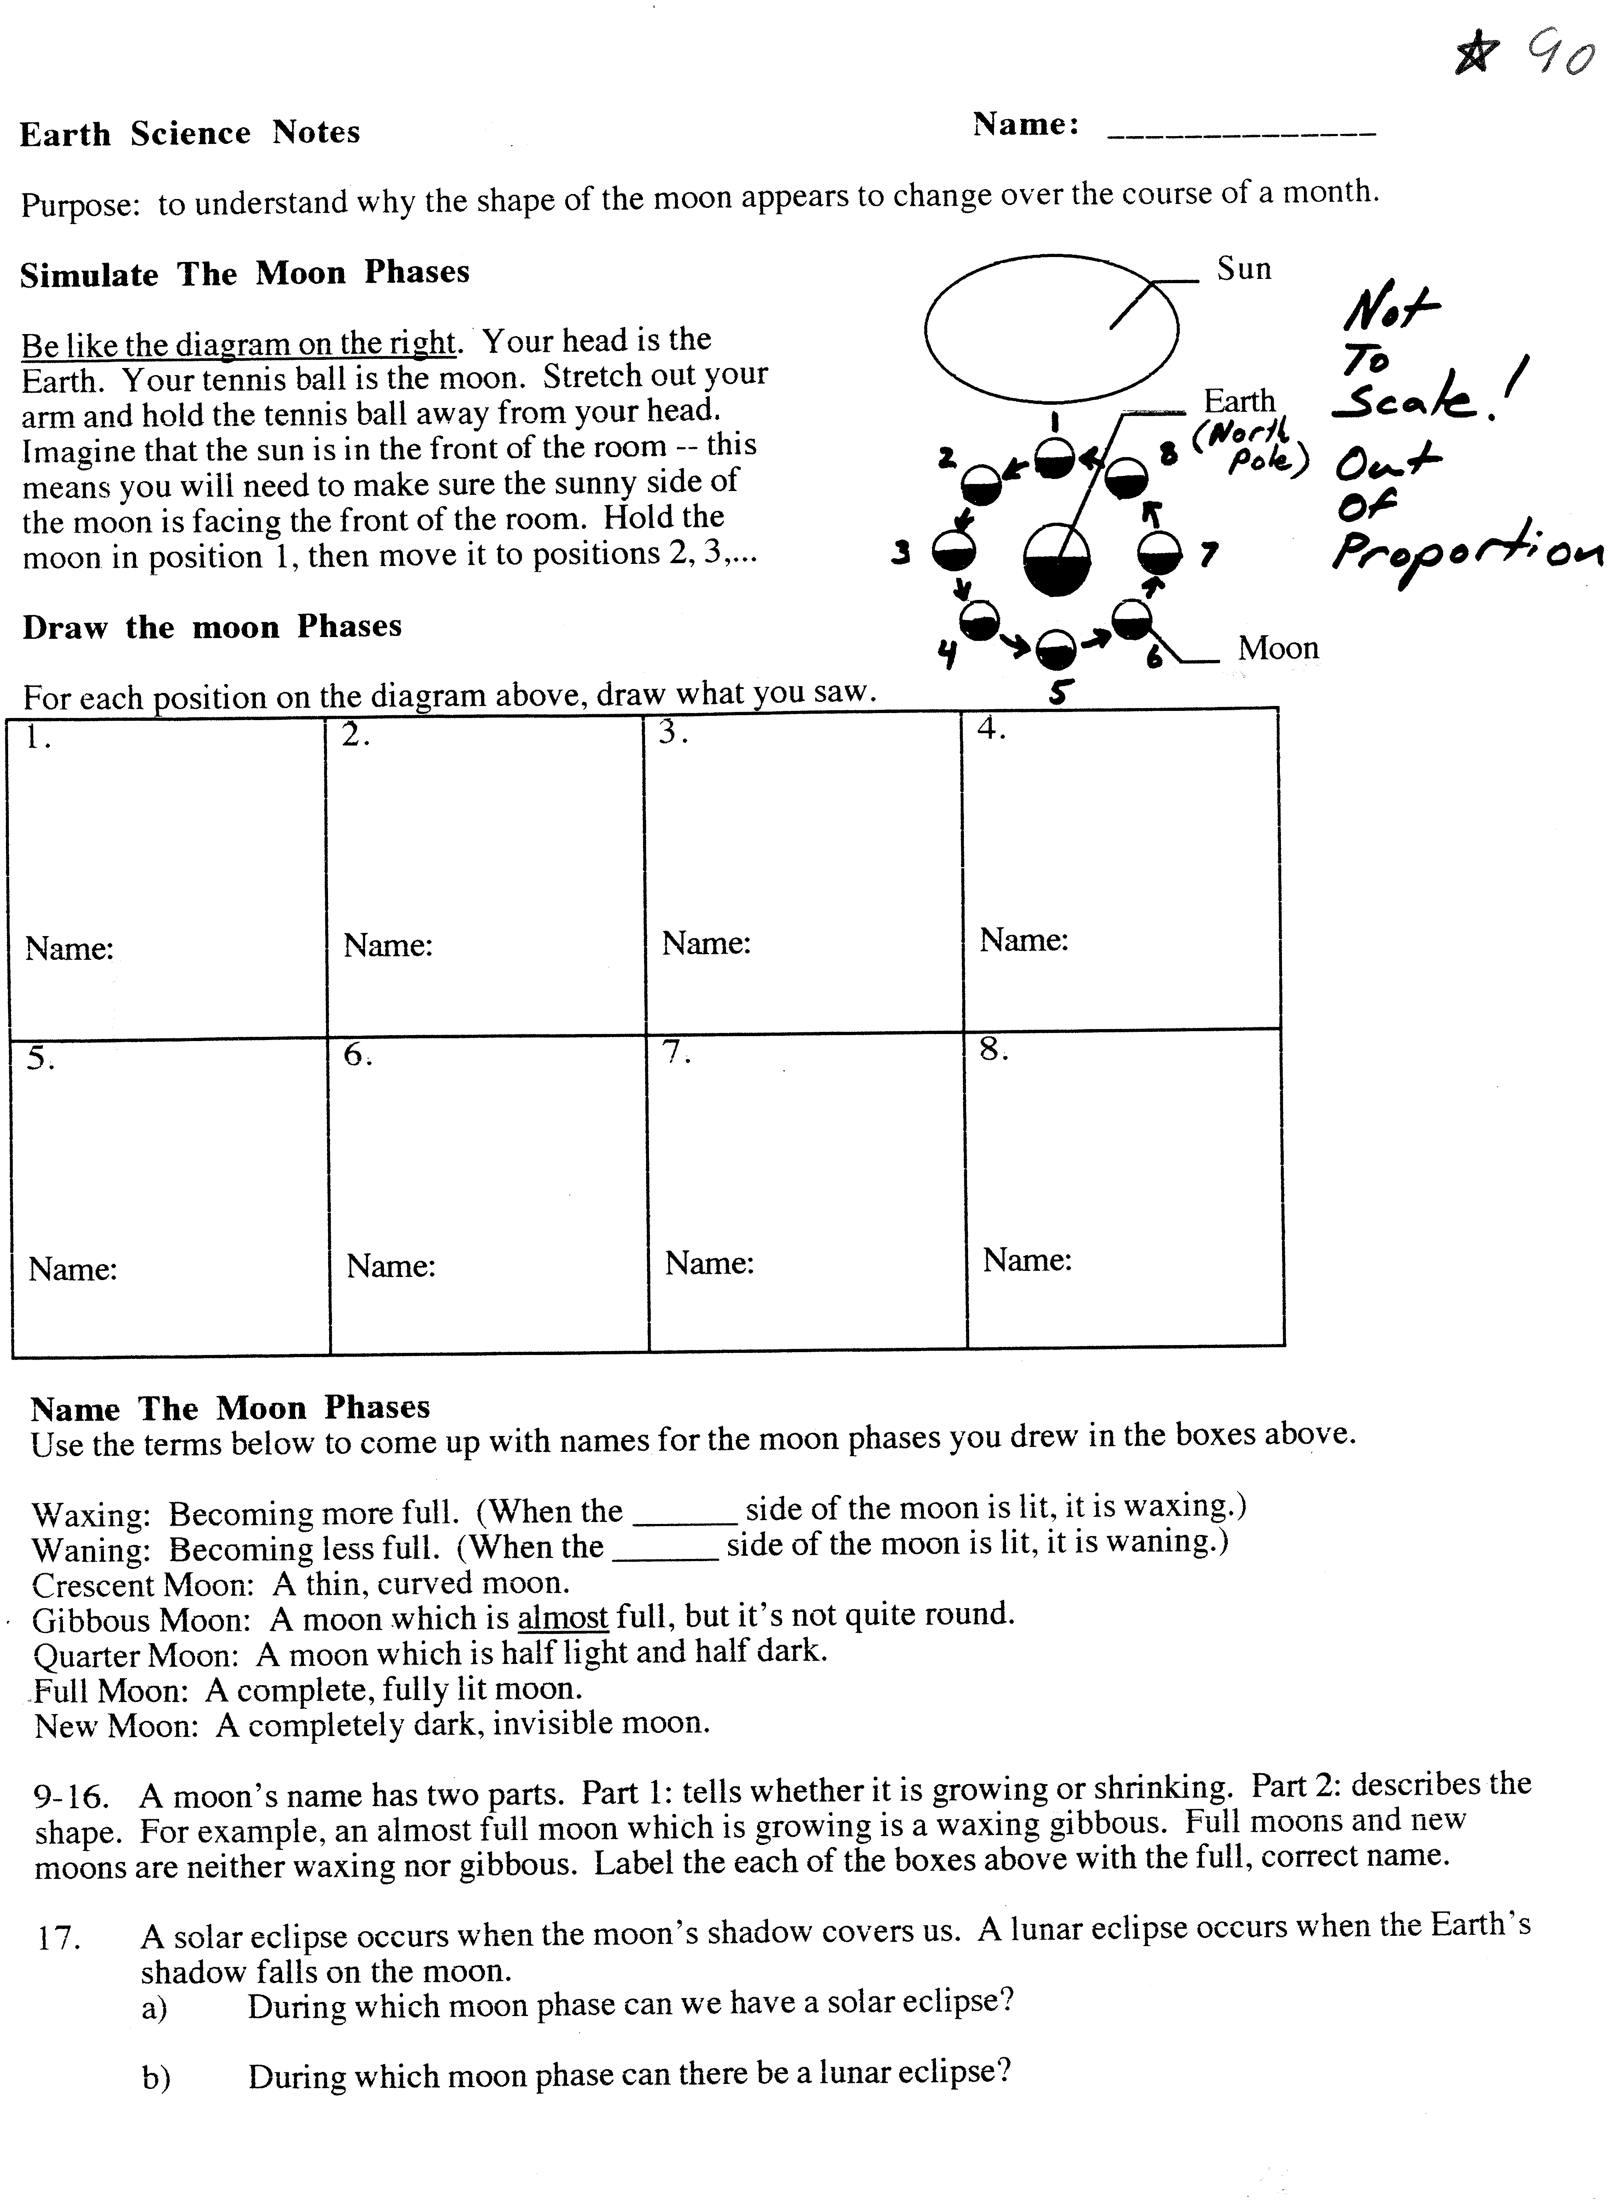
EPS 100 Name: _______________________
Moon Phases and Time of Day

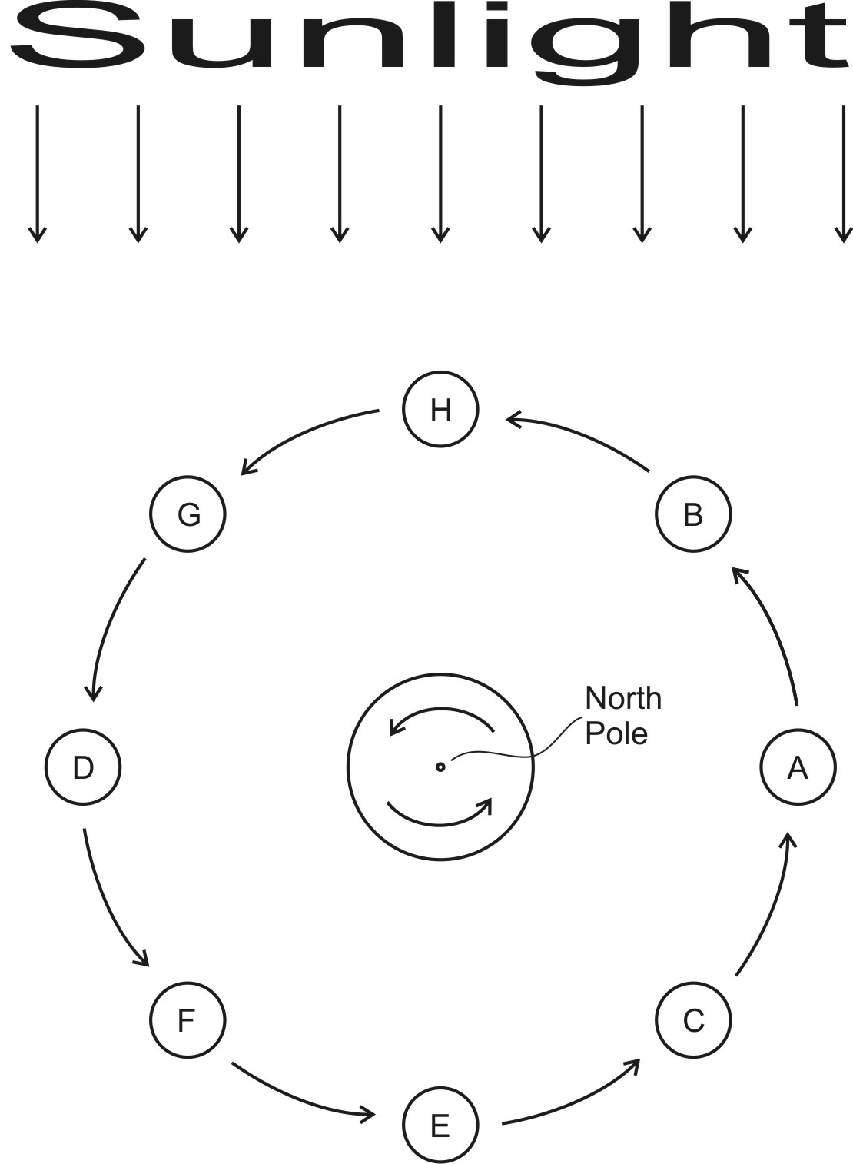
18. Shade the Earth and each of the moons in the diagram.

19. Name each of the moons:

A:

B:

C:

D:

E:

F:

G:

H:

12. For each of the moons, give the approximate times when it rises and sets. Also determine the time when it is at its highest point in the sky. For times, choose 3, 6, 9, or 12 AM or PM.

Moon | Time of Moonrise | Time when Moon is at its zenith (highest in the sky) | Time of Moonset
A
B
C
D
E
F
G
H

