EPS 100 Name: _______________________________
Solar Oven Project
Testing Modifications (Sheet 2)

Testable Question #1: How will adding a ________________ liner affect the oven’s temperature

Hypothesis:

Explain the reasoning for your hypothesis:

Describe the experimental variable (what you are changing):

List some controlled variables (things you must keep the same):

Data: Highest temperature reached by cooker

Cooker with _______________ liner: _________ Time to reach this temperature: __________

Cooker with _______________ liner: _________ Time to reach this temperature: __________

Conclusion (Use your data to provide an answer to the testable question above.):

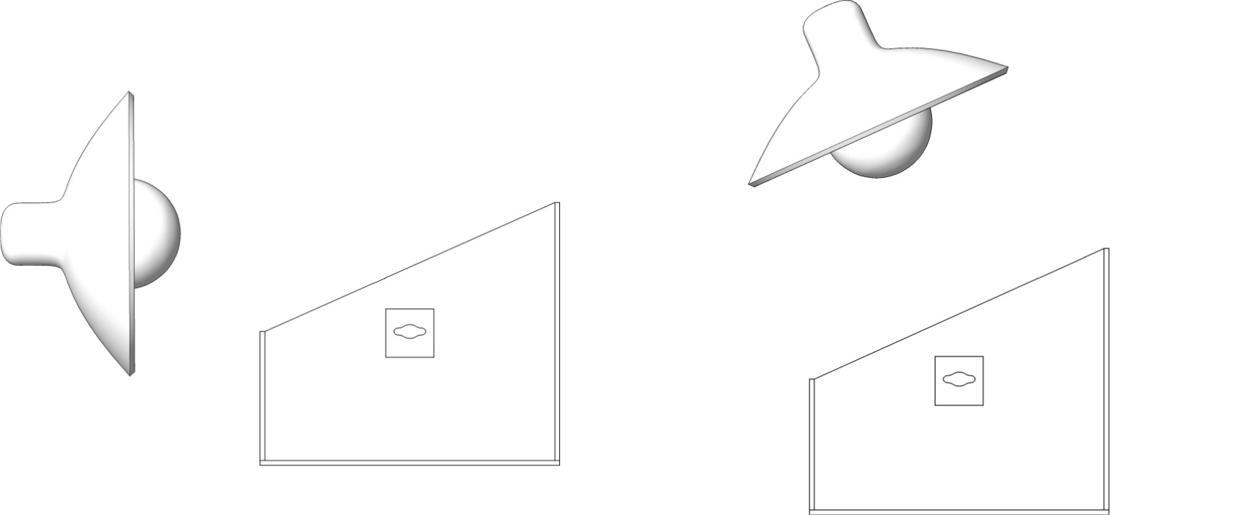
Testable Question #2: How will changing the angle of sunlight (horizontal vs perpendicular) affect the oven’s temperature?

Hypothesis:

Explain the reasoning for your hypothesis:

Describe the experimental variable (what you are changing):

List some controlled variables (things you must keep the same):

Data: Highest temperature reached by cooker

Cooker with horizontal light: _________ Time to reach this temperature: __________

Cooker with perpendicular light: _________ Time to reach this temperature: __________

Conclusion (Use your data to provide an answer to the testable question above.):

