EPS 100 (Stapleton) Name: _______________________________________
Solar Oven Modifications

The purpose of a solar oven is to create a high temperature environment for cooking food. You have been provided with a basic oven design, but that design needs improvement. We need to find ways to capture more solar energy and raise the oven’s temperature as high as possible. Find three different ways to improve our basic solar oven design. Each improvement must be something that we can add to our existing solar ovens. Share your three ideas by completing this sheet:

1) Describe the improvement.
2) Sketch your improvement on the diagram of the existing oven.
3) Use complete sentences to explain how your improvement will increase the temperature inside the oven.

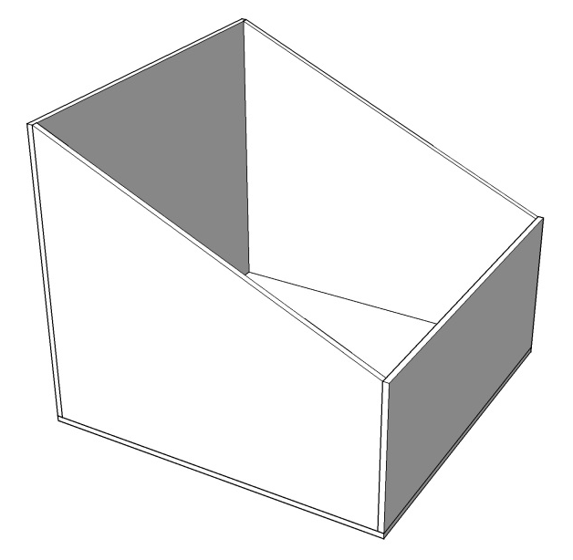
Short Description -- Improvement Idea #1:

Explanation -- How idea #1 will increase the temperature inside the oven:

Short Description -- Improvement Idea #2:

Explanation -- How idea #1 will increase the temperature inside the oven:

Short Description -- Improvement Idea #3:

Explanation -- How idea #1 will increase the temperature inside the oven:

