EPS 100 (Stapleton) Name: ___________________________

Star Lifetimes Part 1

1. What is the general name that includes gamma rays, x-rays, ultraviolet, visible light, infrared, microwaves, and radio waves?

2. a. Draw and label two waves, one with a longer wavelength, and one with a shorter wavelength.

b. Which waves have the most energy? [Hint: think of the waves as ropes that are being shaken.]

3. List the colors of the visible spectrum from longest wavelength to shortest wavelength.

4. Rank these star colors from hottest to coolest. Orange, Red, Yellow, Blue, White

5. a. Which stars are the hottest, larger stars or smaller stars?

b. Why?

6. Stars get their energy from a process called ____________________________________. In this

process, _____________________ are combined by ____________________ to form

______________________ . In this process, mass is _______________________. This

________________mass is converted into energy.

7. a. When elements fuse in a star, lighter elements fuse to become heavier elements. Where do these heavier elements go?

b. Why?

8. In our sun, the main source of energy is the fusion of ________________ into

_____________________.

9. What is the heaviest element that can be created by fusion in a very large star?

10. In our sun, there is a balance between pressure pushing outward from the inside of the star and pressure pushing inward from the outside of the star.

1. What is the source of the pressure that squeezes the star inward?
2. What is the source of the pressure pushing outward from the inside of the star?

11. a. At some point, our sun will run out of hydrogen that it can fuse. When this happens, the

next fuel that will fuse is ________________________

b. At this point, the sun will expand, and its color will shift to ______________________ because the surface will be cooler than before. At this point, the sun will be called a

___________________ _____________________

12. a. After all nuclear fusion ceases in our sun, it will ___________ (expand or shrink).

b. This change in size will cause the sun’s temperature to _______________.

c. This change in temperature will cause its color to change from _____________ to

___________.

1. At this point, the sun will be called a _____________ _______________.

13. The early universe was about 75% hydrogen and 25% helium. Where did the rest of the elements come from?

a. Where did the lighter elements come from (up to the mass of iron)?

b. Where did the heavier elements (heavier than iron) originate?

14. “One solar mass” means…

15. After a supernova, the material left over from a very large star can have three different fates:

2. If the leftover material is between 1 and 3 solar masses, it can become a:
3. If the leftover material is over 3 solar masses, it can become a:

EPS 100 (Stapleton) Name: ___________________________

Star Lifetimes Part 2

**Use the Hertzsprung-Russel diagram (H-R diagram) below to answer the following questions. Mark the correct letter as indicated on the chart. The boxes represent stars**

**High**

A

D

**Brightness**

E

**(brightness units)**

C

B

**Low**

**High Low**

**Temperature (o C)**

16. What is the name of this type of diagram?

17. Where are the hottest stars in the diagram?

18. Where are the brightest stars?

19. Which of the stars are *main sequence* stars?

20 What do all *main sequence* stars have in common?

21. Which star is the brightest?

22. Which star would be considered a red giant?

23. What star is the faintest, or dimmest?

24. Which star has the hottest surface temperature?

25. Which letter could represent the present day Sun?

26. Which star is most likely to be blue?

27. According to current scientific understanding, the universe came into existence in an event called the ________________________.

a. How large was the universe at the moment of this event?

b. How long ago did this happen?

c. How do we know the age of the universe?

28. Briefly describe [three pieces of evidence that support the Big Bang theory](http://www.schoolsobservatory.org.uk/astro/cosmos/bb_evid).



**The Doppler Effect:** How we know that all (almost) other galaxies are moving away from us and that the Universe is therefore expanding.

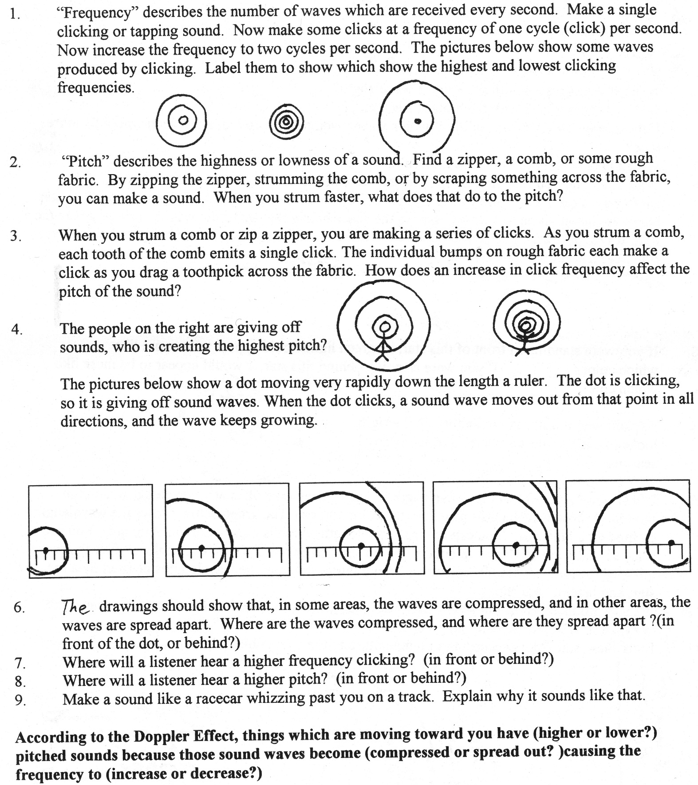

5. One of the diagrams below shows a sound source moving to the right. The other shows the sound source moving to the left. Label them appropriately. Then show the locations where a listener would hear a high pitch sound and a low pitch sound.

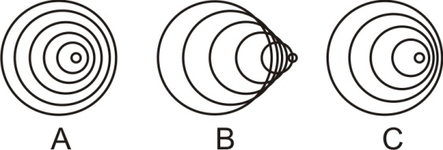

6. What happens to waves in front of a moving object? Are they compressed or stretched out?

7. When we listen to a train that is approaching, we hear a sound that is shifted __________ (higher or lower) than the actual sound of the train.

8. One of the waves below represents blue light, and the other represents red light. Label them appropriately.



9 The diagrams below show three white stars and light leaving those stars. For each star, show its direction of movement (if any). Then tell whether the observer would see a white star, a slightly bluer star, or a slightly redder star.

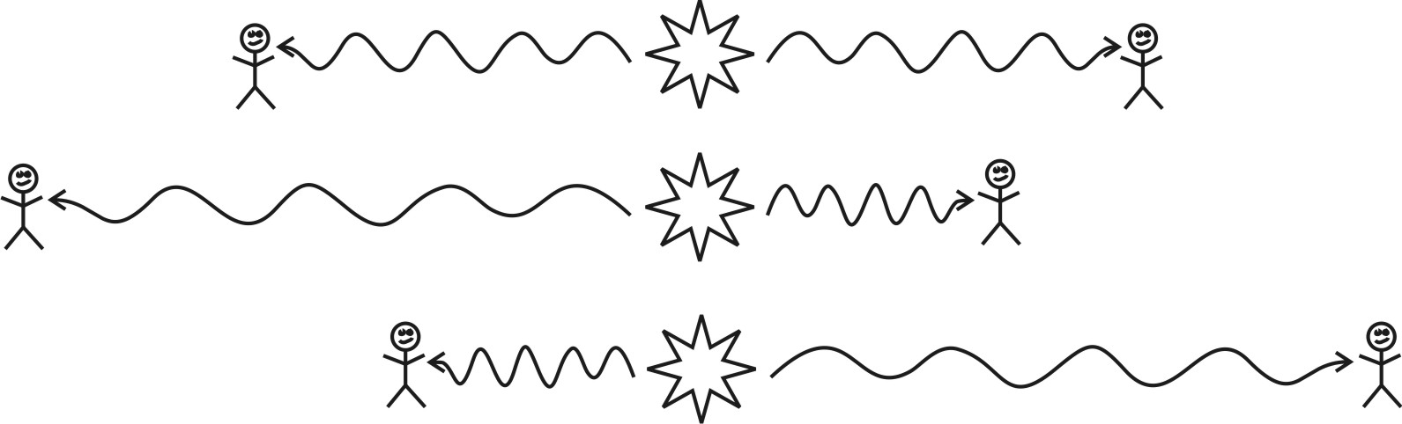

10. When we point our telescopes at stars in very distant galaxies, we can tell that those galaxies are moving

away because the light from those stars is ___________________ (red-shifted or blue-shifted). This

provides evidence for the Big Bang because it shows that the Universe is _________________________.