ESS 100 (Stapleton)
Ages of Rocks and Earth History, Part 2
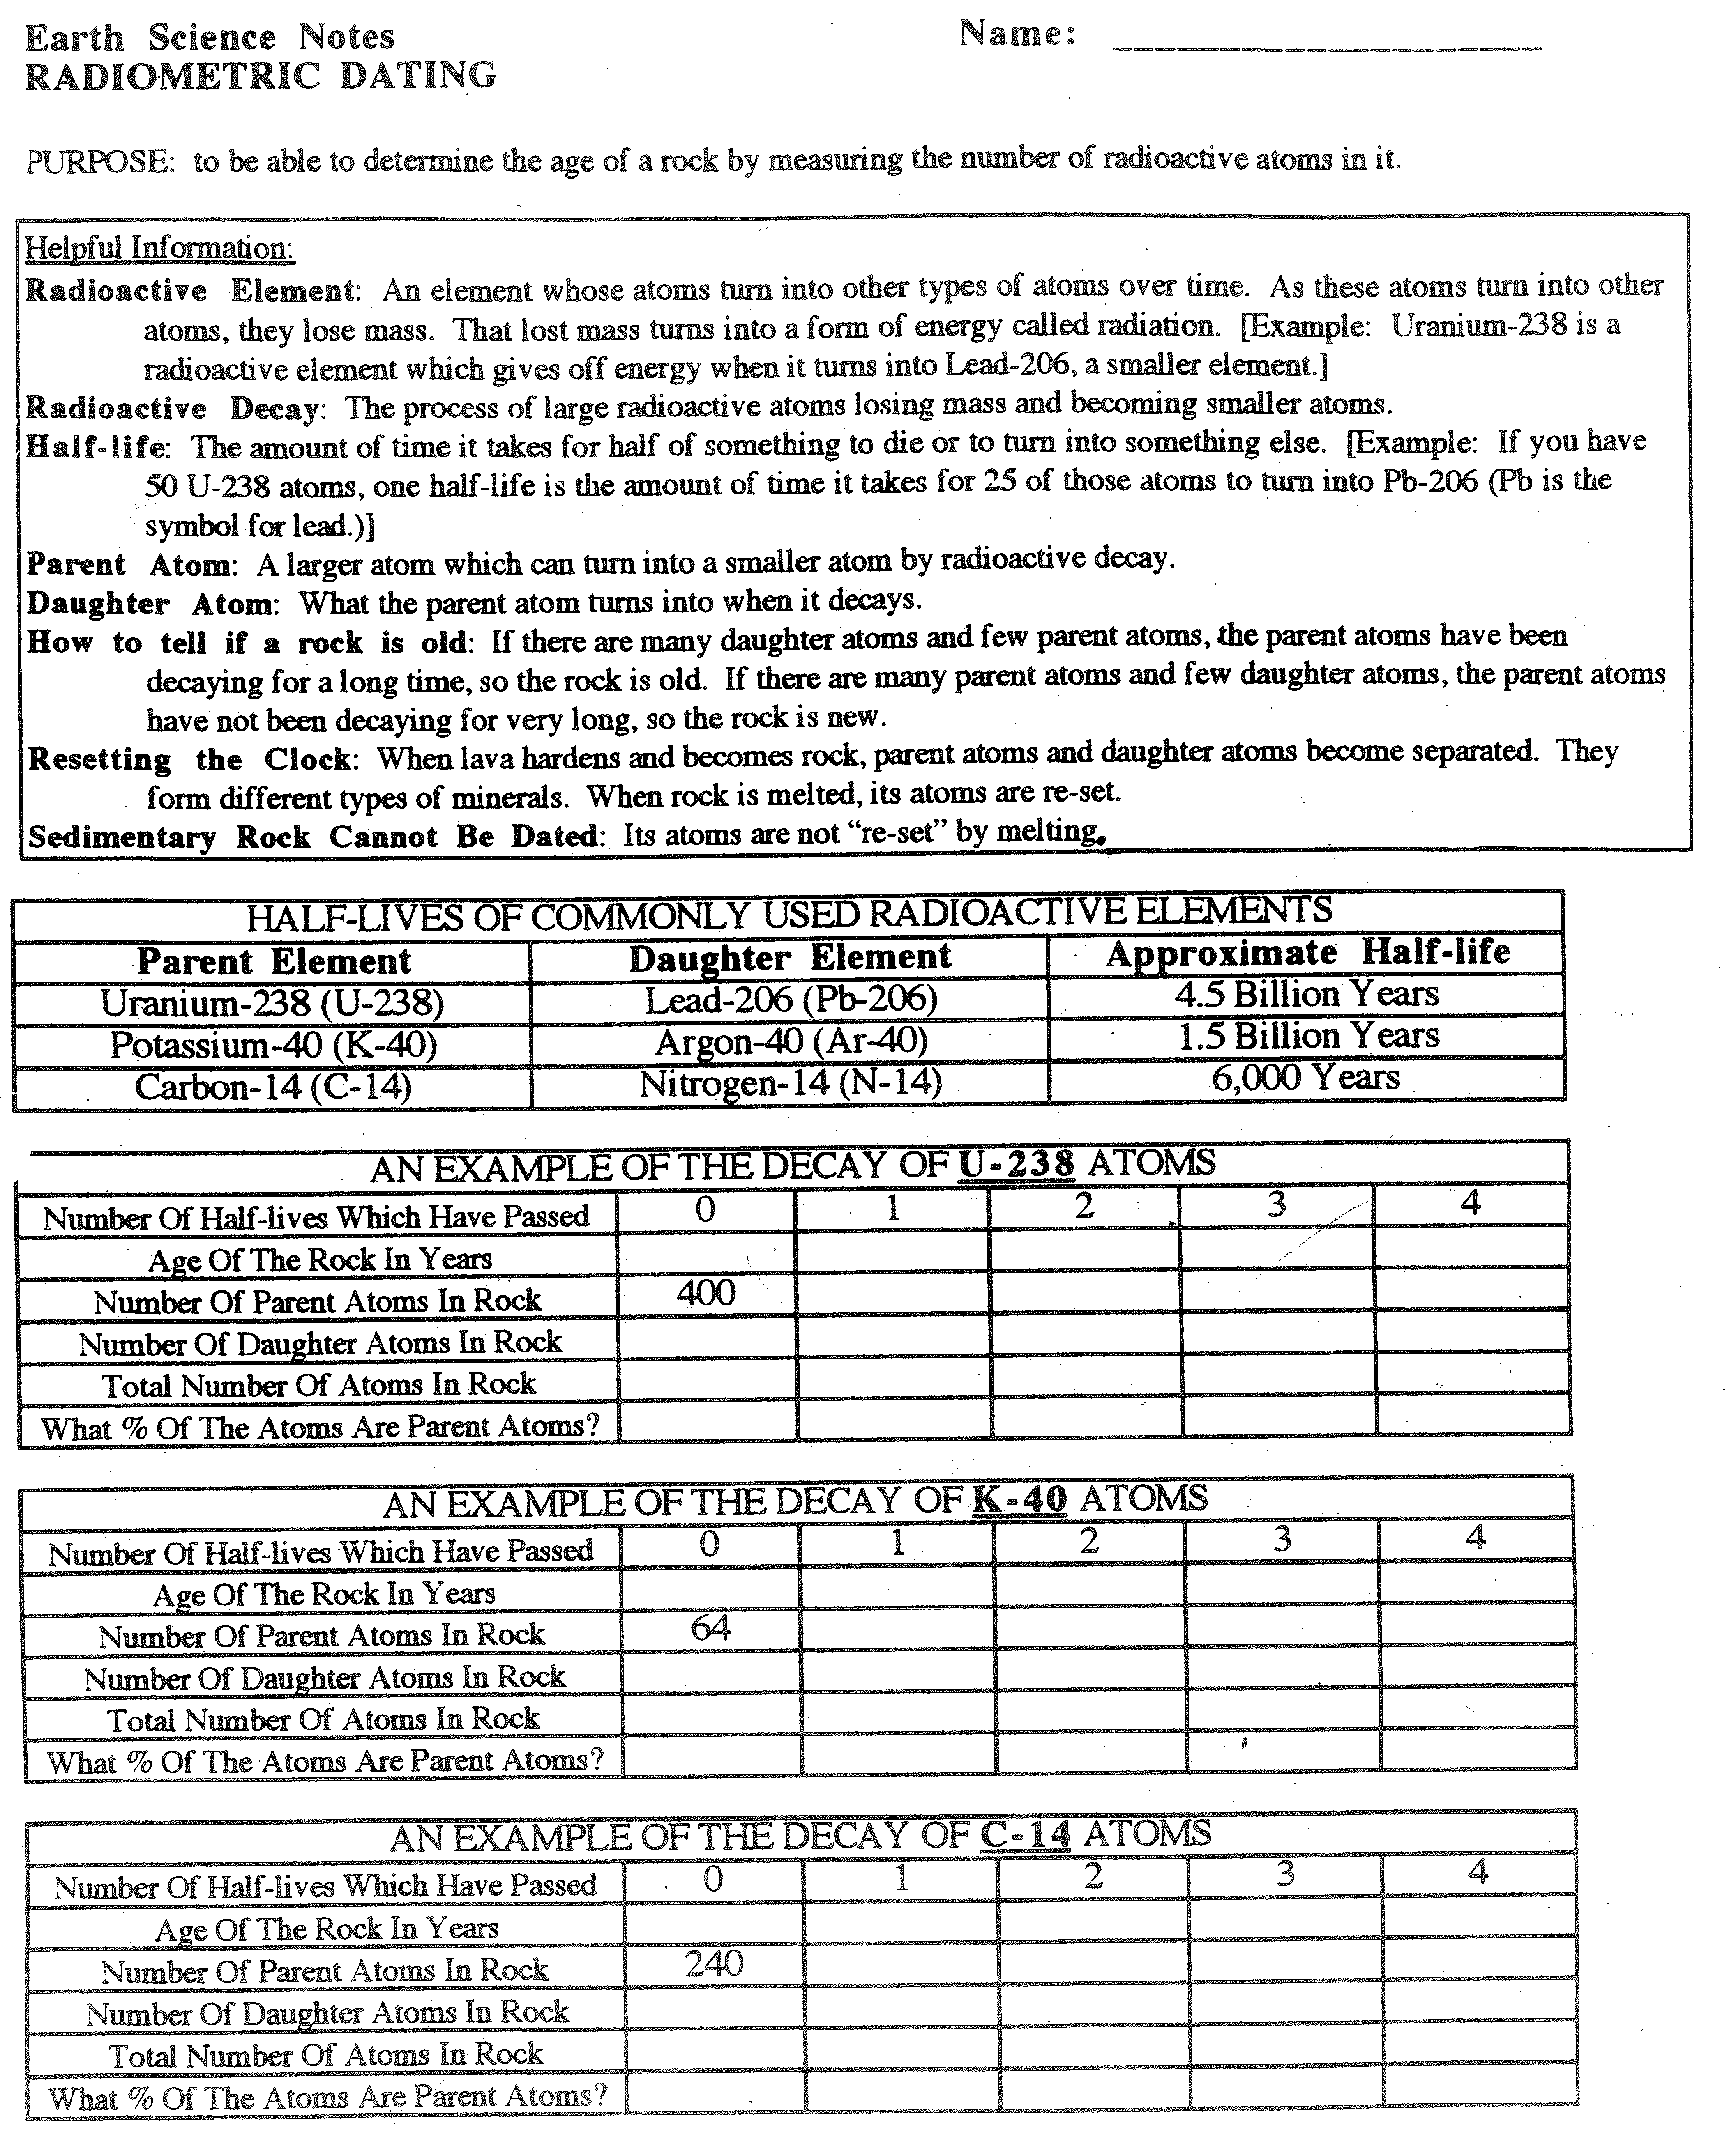

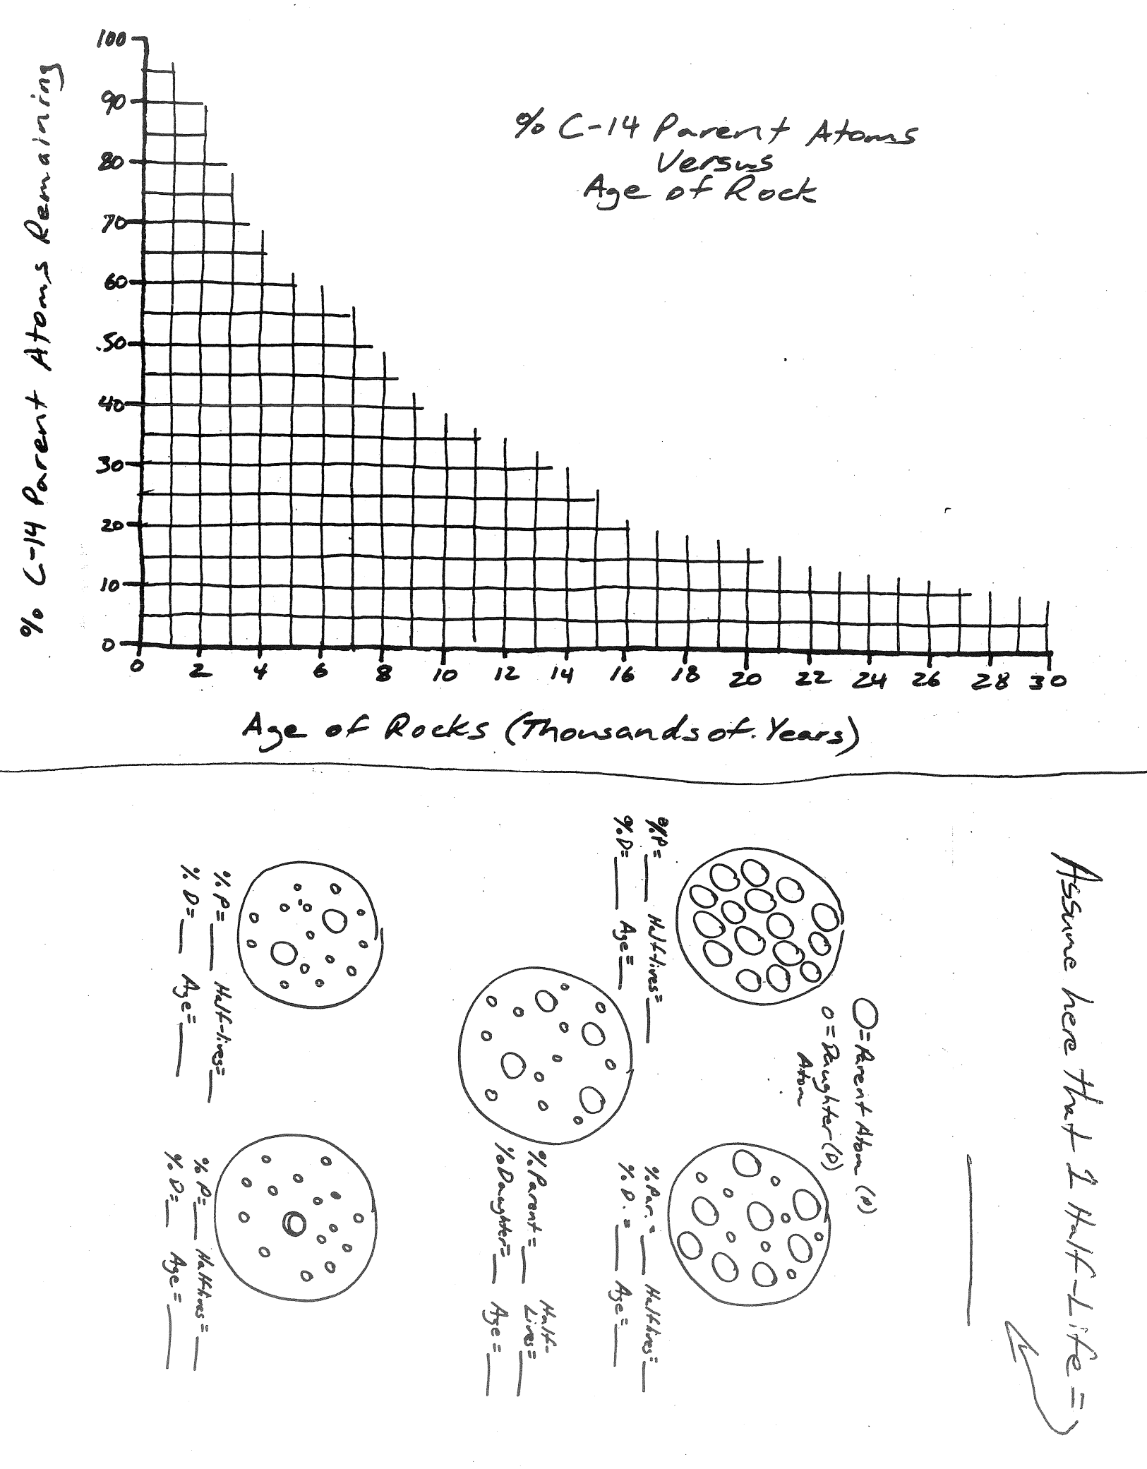
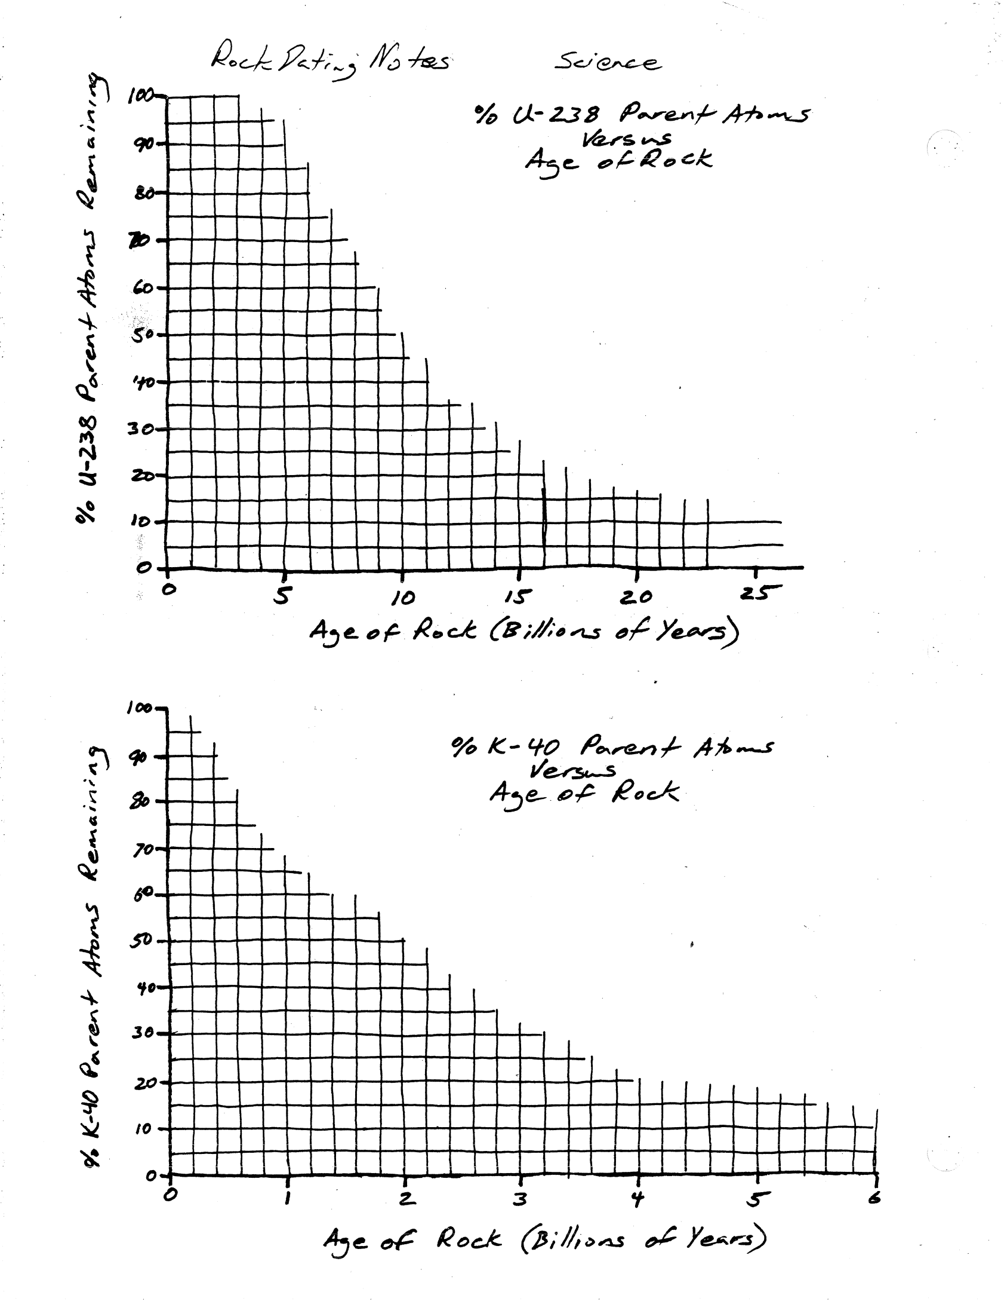

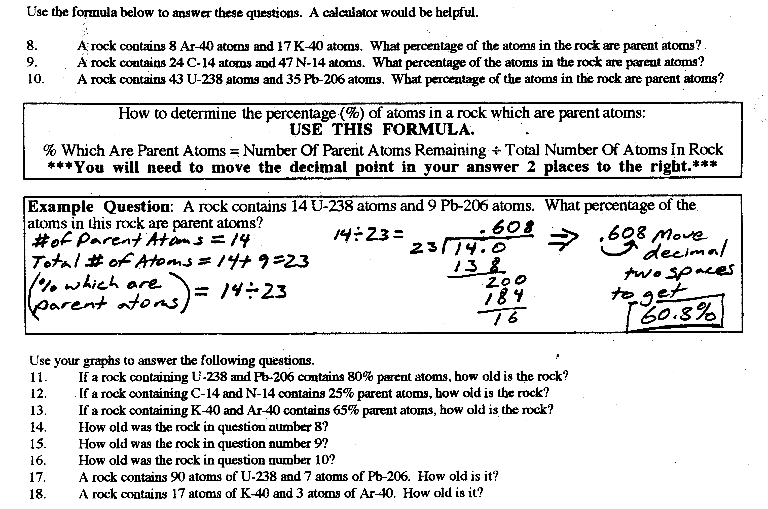

Practice Test – Ages of Rock
Organize the lettered rock samples from oldest to youngest. Then make a mark where the earthquake occurred in the sequence.

Oldest Newest
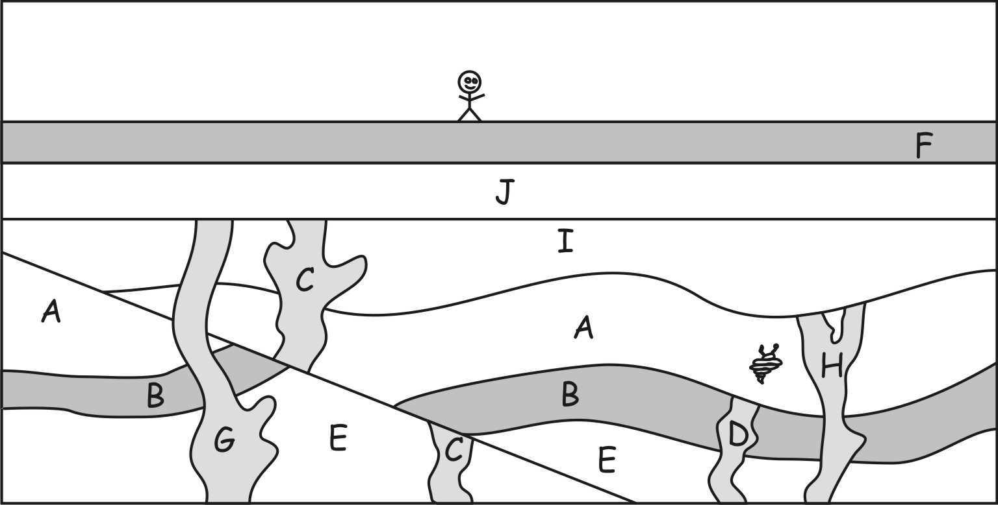
1. Sample C contains 50 K-40 parent atoms and 150 Ar-40 daughter atoms.
a. What is the total number of parent + daughter atoms?

b. What percentage of those atoms are parent atoms?

c. Which of the following is closest to the age of Sample C?
0by 1by 2by 3by 4by 5by 6by 7by 8by

2. Sample G contains 150 K-40 parent atoms and 228 Ar-40 daughter atoms.
a. What percentage of those atoms are parent atoms?

b. Which of the following is closest to the age of Sample G?
0by 1by 2by 3by 4by 5by 6by 7by 8by

3. Which of the following is closest to the age of the fault created by the earthquake?
0-1by 1-2by 2-3by 3-4by 4-5by 5-6by 6-7by 7-8by

4. Sample D contains 90 K-40 parent atoms and 820 Ar-40 daughter atoms.
a. What percentage of those atoms are parent atoms?

b. Which of the following is closest to the age of Sample D?
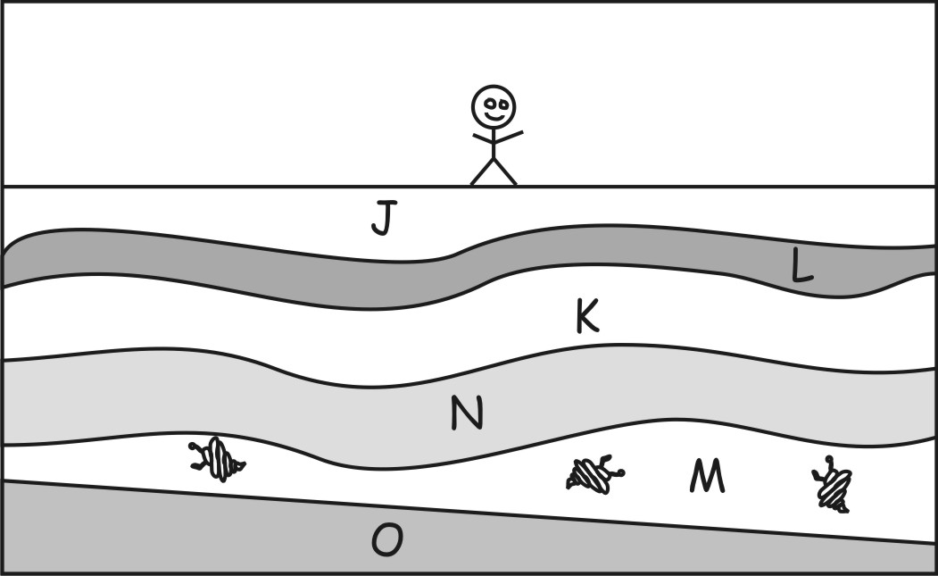
0by 1by 2by 3by 4by 5by 6by 7by 8by

5. Sample H contains 50 K-40 parent atoms and 215 Ar-40 daughter atoms.
a. What percentage of those atoms are parent atoms?

b. Which of the following is closest to the age of Sample H?
0by 1by 2by 3by 4by
5by 6by 7by 8by

6. The diagram on the right shows rock samples from another location on Earth. Choose the most likely age range for layer M, in that diagram.
0-1by 1-2by 2-3by 3-4by 4-5by 5-6by 6-7by 7-8by

