ESS 100 Name: ________________________
Practice Quiz: Temperature and Pressure
Suppose you have some air trapped in a sealed jar. Air cannot leave the jar, and air cannot enter the jar.

1. If you cool down the jar, what happens to the speed of the air molecules in the jar?
a. They speed up b. They slow down c. No change

2. If you heat up the jar, what happens to the speed of the air molecules in the jar?
a. They speed up b. They slow down c. No change

3. If you heat up the jar, what happens to the air pressure inside the jar?
a. Air pressure increases b. Air pressure decreases

4. What causes the air pressure to change when the jar heats up?
a. The air molecules push against the jar with more force.
b. The air molecules push against the jar with less force.
c. The air molecules get heavier
d. The air molecules get lighter

Suppose you blow up a balloon and tie it off. No air can leave the balloon, and no air can enter it. What will happen the balloon if you put the balloon in freezer and cool the balloon? Assume that the balloon does not pop.
5. What will happen to the pressure inside the balloon when it is in the freezer?
a. It will increase b. It will decrease c. It will stay the same

6. What will happen to the overall mass of the balloon while it is in the freezer?
a. It will increase b. It will decrease c. It will stay the same

7. What will happen to the overall volume of the balloon?
a. It will increase b. It will decrease c. It will stay the same

8. What will happen to the overall density of the balloon?
a. It will increase b. It will decrease c. It will stay the same

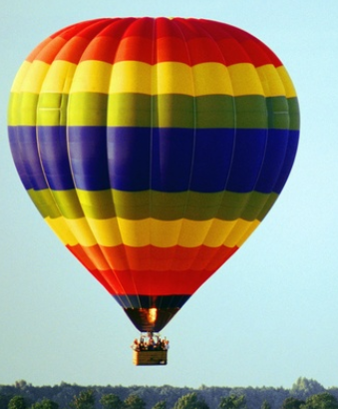
A hot air balloon flying over Essex has a big hole in its bottom (all hot air balloons have holes). A flame heats the balloon, and then the flame shuts off, leaving the balloon hotter than before. Assume that the hot air balloon cannot get bigger.

9. What happens to the speed of the air molecules when the balloon heats up?
a. They speed up b. They slow down c. No change

10. What happens to the overall volume of the balloon when it is heated?
a. It increases b. It decreases c. It stays about the same

11. What happens to the overall mass of the balloon when it is heated?
a. It will increase b. It will decrease

12. What happens to the overall density of the balloon when it is heated?
a. It increases b. It decreases c. It stays about the same

There are many differences between an inflated rubber balloon and a hot air balloon. One big difference is that the hot air balloon has a big hole in it, but the rubber balloon doesn’t. Air can leave or enter the hot air balloon. Air cannot leave or enter the rubber balloon.
13. Which is true about an inflated rubber balloon, like the one on the right? The balloon is tied off, and it does not have any holes.
a. There’s stronger air pressure outside the balloon than inside the balloon.
b. There’s stronger air pressure inside the balloon than outside the balloon.
c. The pressure inside and the pressure outside are equal.

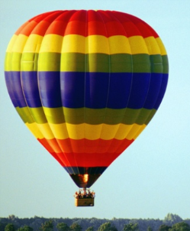
14. A hot air balloon has a big hole in it. Which of these is true about a hot air balloon?
a. The air pressure inside the balloon is usually higher than the pressure outside.
b. The air pressure outside the balloon is usually higher than the pressure inside.
c. The air pressures inside and outside of the balloon are usually about equal.

15. Optional Bonus: How is a hot air balloon like the film canister submarines that we made?

