ESS 100 (Stapleton) Name: __________________________________

Structure of Matter (especially water)

Part 1

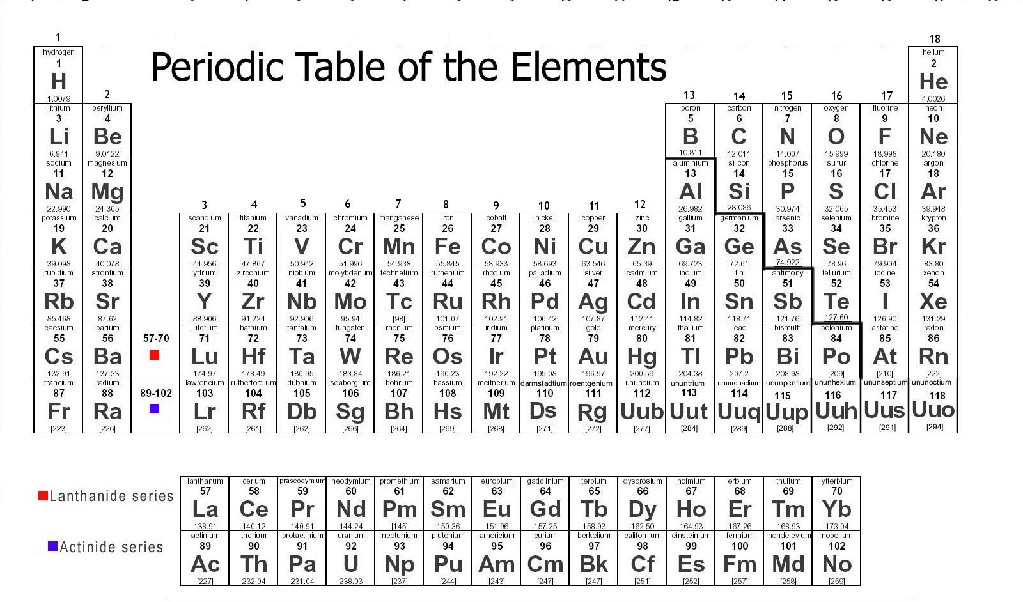

**Element:** a substance that cannot be chemically broken down into a simpler substance; a type of atom

**Atomic Symbol**: A two letter symbol representing an element.

**Atom:** the basic unit of a chemical element; the smallest particle of an element that is still considered to be that element

**Periodic Table of The Elements:** a table organizing all of the known elements by atomic masses and other characteristics.

**Molecule:** a group of atoms bonded together by sharing electrons (electron sharing is indicated in Mr. Stapleton’s drawings by lines connecting atoms)

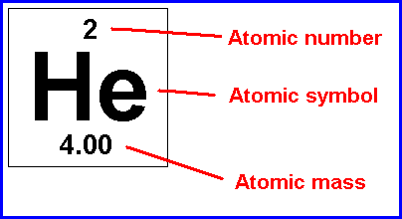**Chemical Compound:** more than one type of element chemically combined

**Ion:** a charged atom or molecule; charge may be + or -

**Ionic Compound:** multiple types of atoms held together by opposite charges

**Polar Molecule:** A molecule that does not have an overall charge (it is not + or -), but which has one end that is more positive and one end that is more negative.

**Non-Polar Molecule:** A molecule that does not have a positive and a negative end.

**Chemical formula:** a shorthand way of listing the numbers of atoms of each element in a compound. The symbol of each element in the substance is followed by the number of atoms of that element.

**Draw a water molecule:**

1. How many elements are in water? What are they?

2. Is water a molecule? Explain.

3. Is water a compound? Explain.

4. How many atoms are in a water molecule?

5. Is water polar or non-polar? Explain. What causes it to be this way?

6. What is the chemical formula for water?

**Vocabulary Practice:**

1. How many atoms are shown in the diagrams below?

2. How many elements?

3. How many molecules?

4. How many compounds?

5. How many ions?

6. Which lettered items are compounds but not molecules?

7. Which lettered items are molecules but not compounds?

8. Which items are neither molecules nor compounds?

9. What is the molecular formula for the substance lettered “G?”

10. Which item is water?

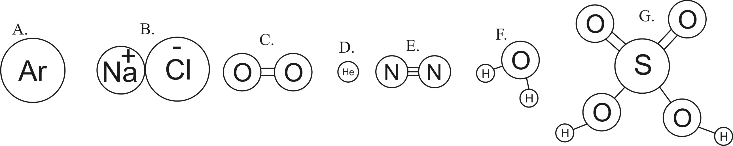

11. For each of the items above, tell what a chemist might call the item.

A.

B.

C.

D.

E.

F.

G.

ESS 100 Name: _______________________________

Structure of Matter – Vocabulary Practice

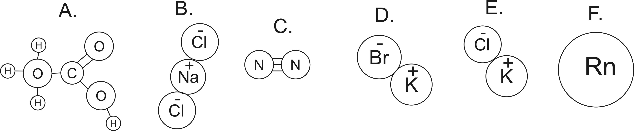

C

1. How many atoms are shown in the diagrams above?

2. How many elements are shown in the diagrams above?

3. How many ions are shown in the diagrams above?

4. Which lettered items are molecules?

5. How do you know that those are molecules? What makes them molecules?

6. Which lettered items are compounds?

7. How do you know that those are compounds? What makes them compounds?

8. Which items are neither molecules nor compounds?

9. Which (if any) of the substances are in the top three most common particles found in “air?” (**darken** all that apply)

10. Write the molecular formula for substance A, above.