ESS 100 Name: ________________________
Quiz: Temperature and Pressure
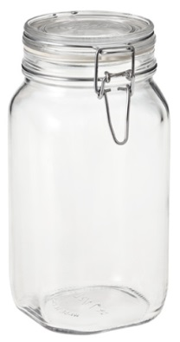
1-3. Suppose you have some air trapped in a sealed jar. Air cannot leave the jar, and air cannot enter the jar.

1. If you cool down the jar, what happens to the speed of the air molecules in the jar?
a. They speed up b. They slow down c. No change

2. If you heat up the jar, what happens to the speed of the air molecules in the jar?
a. They speed up b. They slow down c. No change

3. If you heat up the jar, what happens to the air pressure inside the jar?
a. They speed up b. They slow down c. No change

4-7. Suppose you blow up a balloon and tie it off. No air can leave the balloon, and no air can enter. What will happen the balloon if you leave the balloon outside and the air inside the balloon cools down?

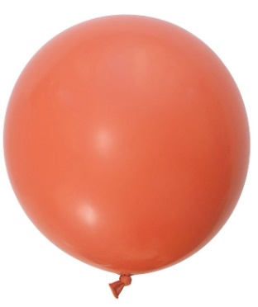
4. What will happen to the overall mass of the balloon?
a. It will increase b. It will decrease c. It will stay the same

5. What will happen to the overall volume of the balloon?
a. It will increase b. It will decrease c. It will stay the same

6. What will happen to the overall density of the balloon?
a. It will increase b. It will decrease c. It will stay the same

7. What will happen to the pressure inside the balloon?
a. It will increase b. It will decrease c. It will stay the same

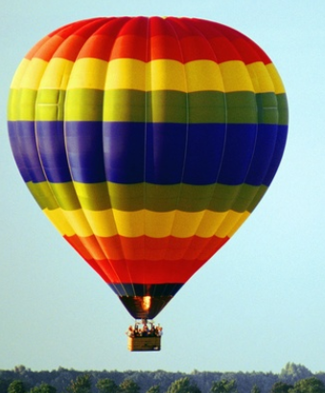
8-11. A hot air balloon flying over Essex has a big hole in its bottom (all hot air balloons have holes). A flame heats the balloon, and then the flame shuts off, leaving the balloon hotter than before. Assume that the hot air balloon cannot get bigger.

8. What happens to the overall volume of the balloon when it is heated?
a. It will increase b. It will decrease c. It will stay the same

9. What happens to the overall mass of the balloon when it is heated?
a. It will increase b. It will decrease

10. Give a reason for your answer to number 9. Explain why the mass changes in this way.

11. What happens to the overall density of the balloon when it is heated?
a. It will increase b. It will decrease c. It will stay the same

12. What happens to the overall pressure of the balloon when it is heated?
a. It will increase b. It will decrease c. It will stay the same

