ESS 100 (Stapleton) Name: ___________________________

Star Lifetimes, Part 2

**Use the Hertzsprung-Russel diagram (H-R diagram) below to answer the following questions. Mark the correct letter as indicated on the chart. The boxes represent stars**

A

**High**

D

**Brightness**

E

**(brightness units)**

C

B

**Low**

**High Low**

**Temperature (o C)**

16. What is the name of this type of diagram?

17. Where are the hottest stars in the diagram?

18. Where are the brightest stars?

19. Which of the stars are *main sequence* stars?

20 What do all *main sequence* stars have in common?

21. Which star is the brightest?

22. Which star would be considered a red giant?

23. What star is most likely to be a white dwarf?

24. Which star has the hottest surface temperature?

25. Which letter could represent the present day Sun?

26. Which star is most likely to be blue?

27. According to current scientific understanding, the universe came into existence in an event called the

________________________.

a. How large was the universe at the first moment of this event?

b. How long ago did this happen?

c. How do we know the age of the universe?

28. Briefly describe [three pieces of evidence that support the Big Bang theory](http://www.schoolsobservatory.org.uk/astro/cosmos/bb_evid).



**The Doppler Effect:** How we know that all (almost) other galaxies are moving away from us and that the Universe is therefore expanding.

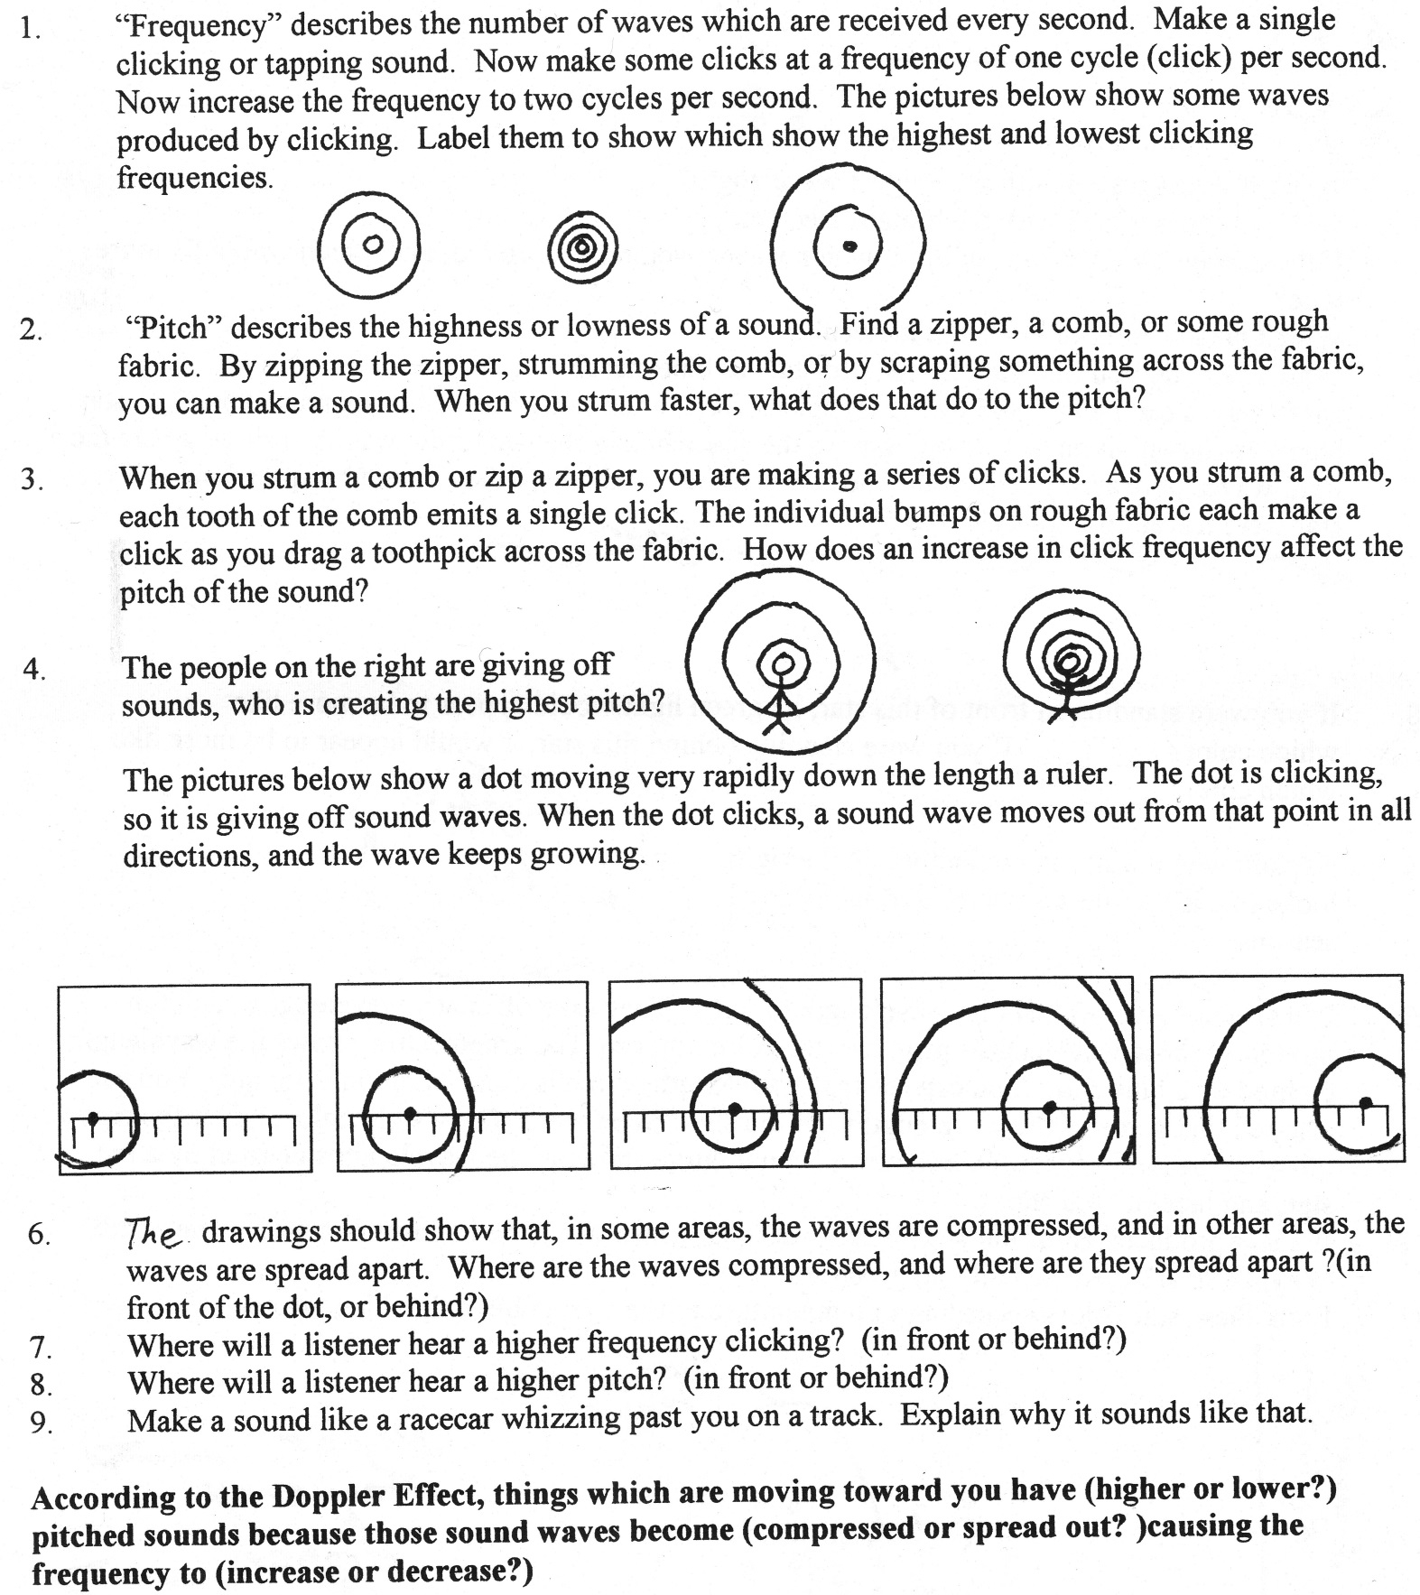

5. One of the diagrams below shows a sound source moving to the right. The other shows the sound source moving to the left. Label them appropriately. Then show the locations where a listener would hear a high pitch sound and a low pitch sound.

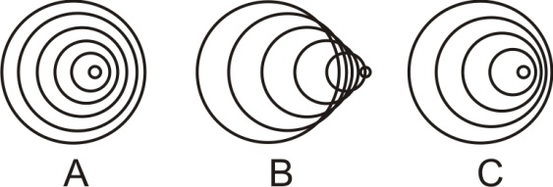

6. What happens to waves in front of a moving object? Are they compressed or stretched out?

7. When we listen to a train that is approaching, we hear a sound that is shifted __________ (higher or lower) than the actual sound of the train.

8. One of the waves below represents blue light, and the other represents red light. Label them appropriately.



9 The diagrams below show three white stars and light leaving those stars. For each star, show its direction of movement (if any). Then tell whether the observer would see a white star, a slightly bluer star, or a slightly redder star.

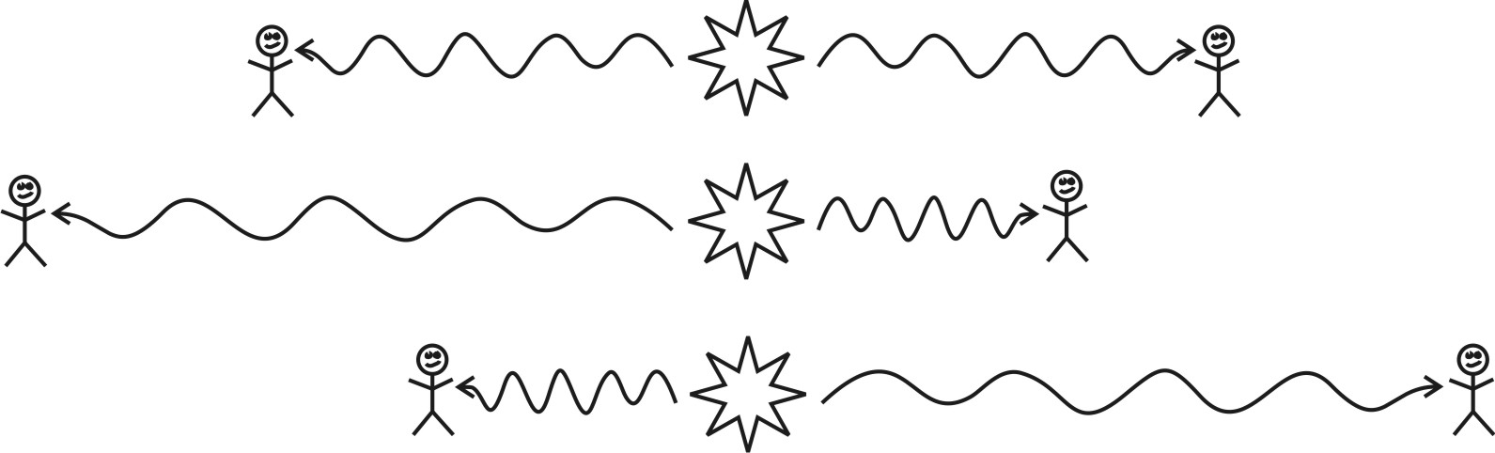

10. When we point our telescopes at stars in very distant galaxies, we can tell that those galaxies are moving

away because the light from those stars is ___________________ (red-shifted or blue-shifted). This

provides evidence for the Big Bang because it shows that the Universe is _________________________.