Quiz #2 – You may not use a note card, but all that you are allowed to write on the card is the names of videos that you find most helpful. You may watch those videos during this quiz.

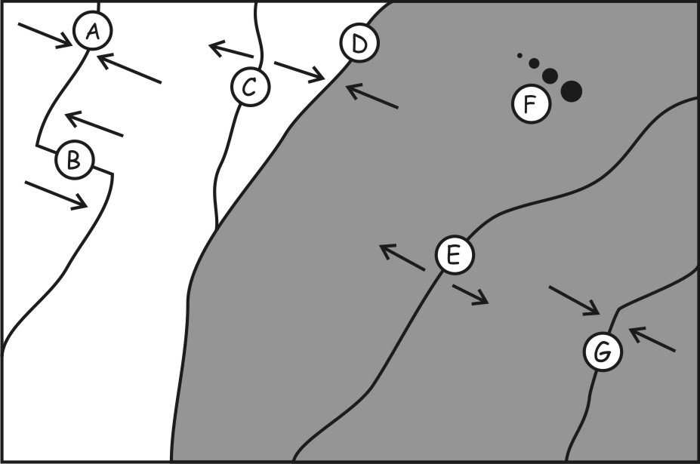
Match each feature name to the corresponding feature on the plate map on the right.

1. A B C D E F G Continent/Continent Convergent
2. A B C D E F G Transform Boundary
3. A B C D E F G Ocean/Continent Convergent
4. A B C D E F G Ocean/Ocean Divergent
5. A B C D E F G Continent/Continent Divergent
6. A B C D E F G Hotspot
7. A B C D E F G Ocean/Ocean Convergent

Each of the real-world locations below forms in an area that is similar to one of the lettered locations on the map. Match each real-world location to its corresponding map location.

8. A B C D E F G Hawaii
9. A B C D E F G San Andreas Fault, California
10. A B C D E F G Mid-Atlantic Ridge
11. A B C D E F G Andes Mountains (South America)
12. A B C D E F G Himalayas (Mt. Everest).
13. A B C D E F G East Africa
14. A B C D E F G Japan

Part II: For each lettered feature on the map above, darken all of the descriptions below that apply. [Suggestion: start with letter A. Darken that letter for all of the descriptions that apply to location A on the map. Continue the process one map feature at a time. For each letter, sketch a cross-section diagram.]

15. A B C D E F G Some mafic magma may reach the surface.
16. A B C D E F G Some felsic magma may reach the surface.
17. A B C D E F G Steep, composite cone volcanoes exist here.
18. A B C D E F G Rounded, shield volcanoes exist here.
19. A B C D E F G Relatively violent eruptions may occur.
20. A B C D E F G Relatively gentle eruptions may occur.
21. A B C D E F G Shallow-focus earthquakes may occur.
22. A B C D E F G Deep-focus earthquakes may occur.
23. A B D E F G New ocean crust is being created here.
24. A B C D E F G There is an ocean trench nearby.
25. A B C D E F G Situated over a relatively cold part of the mantle
26. A B C D E F G There are tall mountains but no volcanoes.

