ESS 100 Name: __________________________________
Mafic and Felsic Practice Quiz
Darken each correct answer choice.

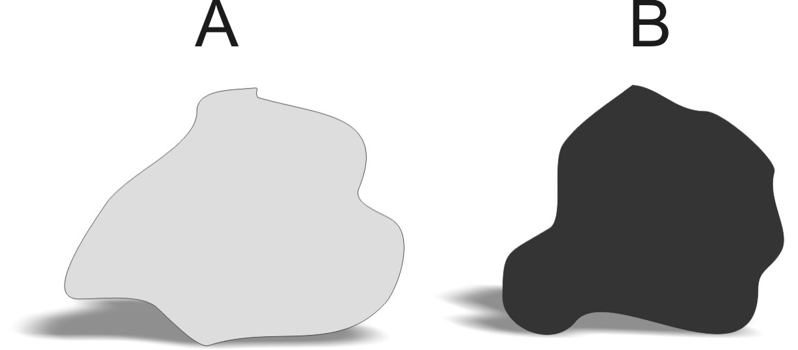
The two rocks on the right represent typical rocks found in different types of Earth crust.

1. Which of the rocks on the right is likely to be granite?
A B
2. Which rock is more dense? A B
3. Which rock is less viscous (runnier) when it is melted into magma or lava? A B
4. Which type of rock is most similar to the material in the Earth's mantle? A B
5. Which type of rock is most often found in ocean crust? A B
6. Which rock is classified as felsic? A B
7. Which type of rock is most similar to the sediment that exists on the ocean floor? A B
8. When these rocks are melted into lava, which one forms rounder, flatter volcanoes? A B
9. When these rocks are melted into lava, which one causes the most explosive eruptions? A B

