ESS 100 Name: ___________________________
Ages of Rocks, Part 1

Unit Goals:
- Know and apply the four principles of relative dating (box below) to put rocks, fossils, and events in order according to their age.
- Know and apply the principles of absolute dating to estimate the ages of rocks based on their radioactive isotope content.
- Define atom, element, electron, proton, neutron, isotope, and radioactive isotope, and understand how these terms relate to absolute dating.

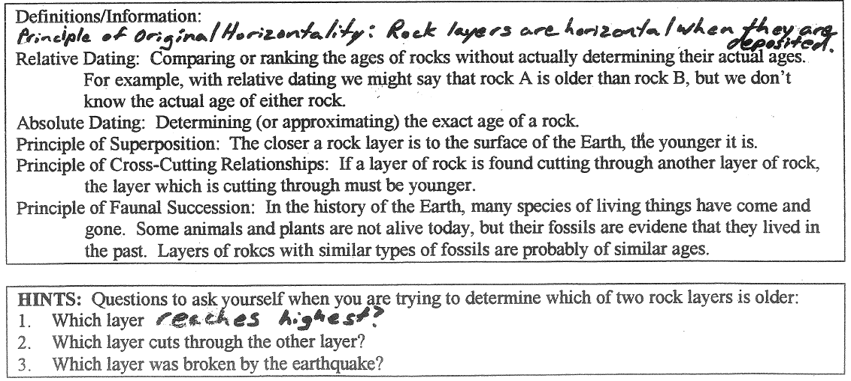

Practice #1. Rank the rocks in the diagram from oldest to youngest.
Oldest Youngest
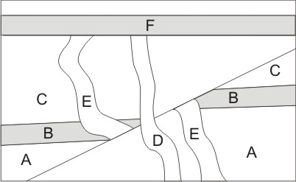

Practice #2. Rank the rocks in the diagram from oldest to youngest.

Oldest Newest

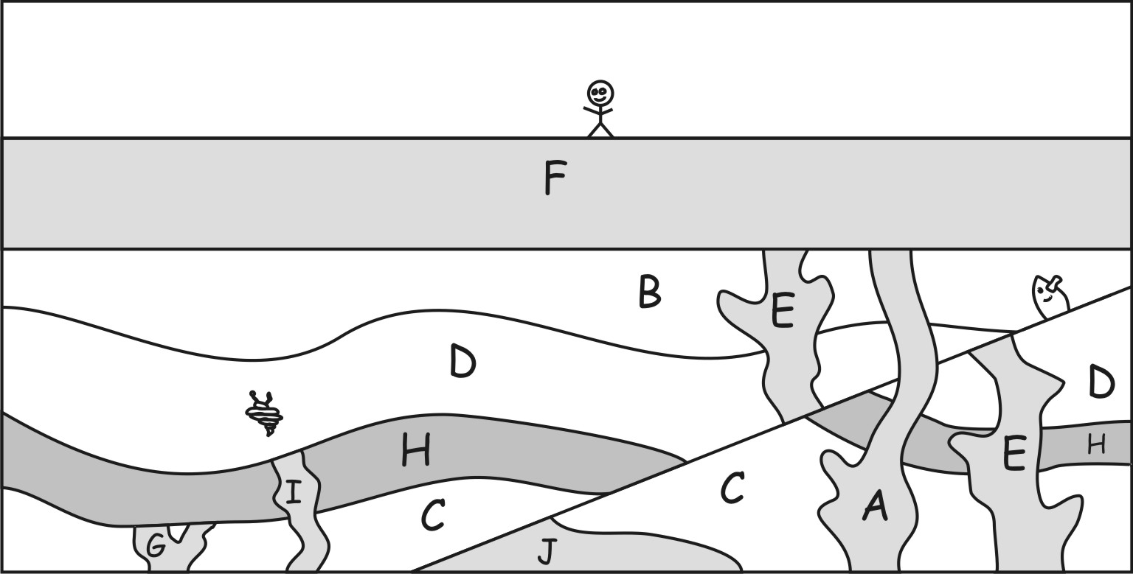

Oldest Newest

Practice #3. Rank the rocks in the diagram from oldest to youngest.
