EPS 100 (Stapleton) Name: _______________________________
Plate Tectonics, Part 3

Goals:
- Know some differences between ocean crust and continental crust
  - Density
  - Color (Shade)
  - Viscosity
- Match real-world locations to the plate boundary types below.
- Know the features associated with each of the following lithospheric situations:
  - Ocean-Ocean Divergent Plate Boundary
  - Continent-Continent Divergent Plate Boundary
  - Ocean-Continent Convergent Plate Boundary
  - Ocean-Ocean Convergent Plate Boundary
  - Continent-Continent Convergent Plate Boundary
  - Ocean Hotspot
  - Transform Plate Boundary

Continental Crust:
- Light in color
- Not dense
- High Viscosity (gooey) when turned to magma
  - Builds up pressure and makes volcanoes more explosive
  - Piles up, so it makes volcanoes steeper
- Example Rock -- Granite
Ocean Crust (similar to mantle):
- Dark in color
- Dense
- Low Viscosity (runny) when turned to magma
  - Does not build up high pressure, so it roduces gentler eruptions
  - Does not pile up, so volcanoes are lower and rounder
- Example Rock -- Basalt
Mantle (similar to ocean crust):
- Dark in color
- Very Dense
- Low Viscosity (runny) when turned to magma
- When mantle material melts and solidifies, it turns into ocean crust.
Seafloor Sediment:
- Similar to Continental Crust
- Thicker over older ocean crust. Thinner over younger ocean crust.
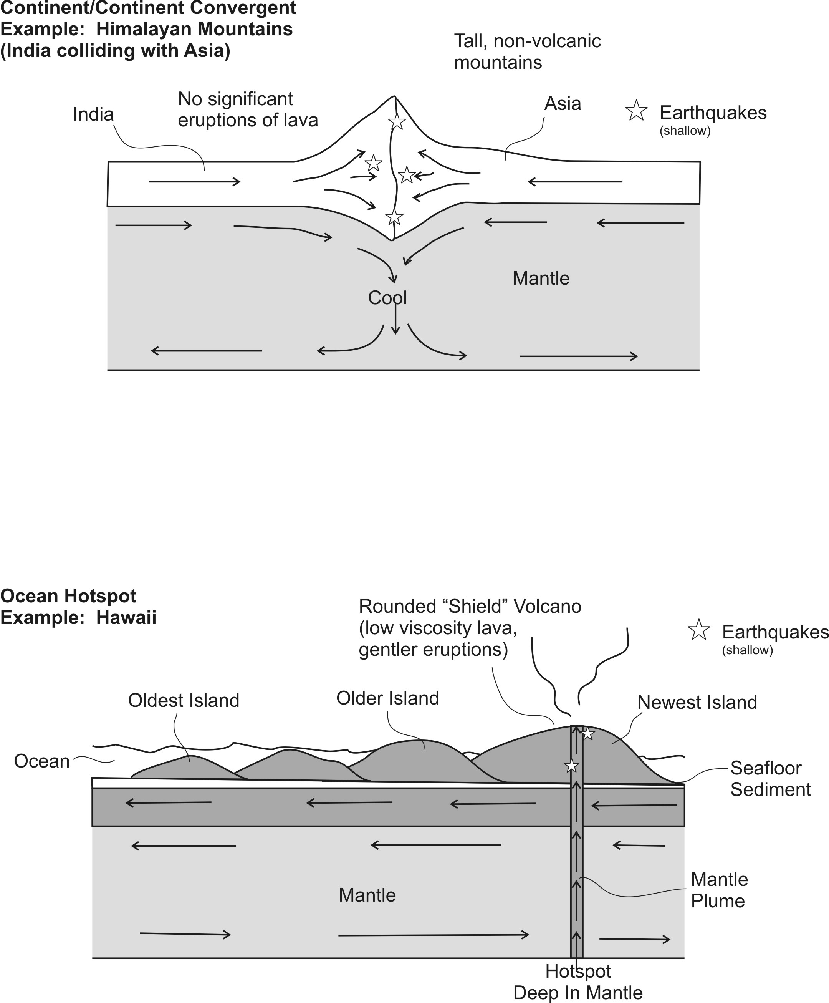

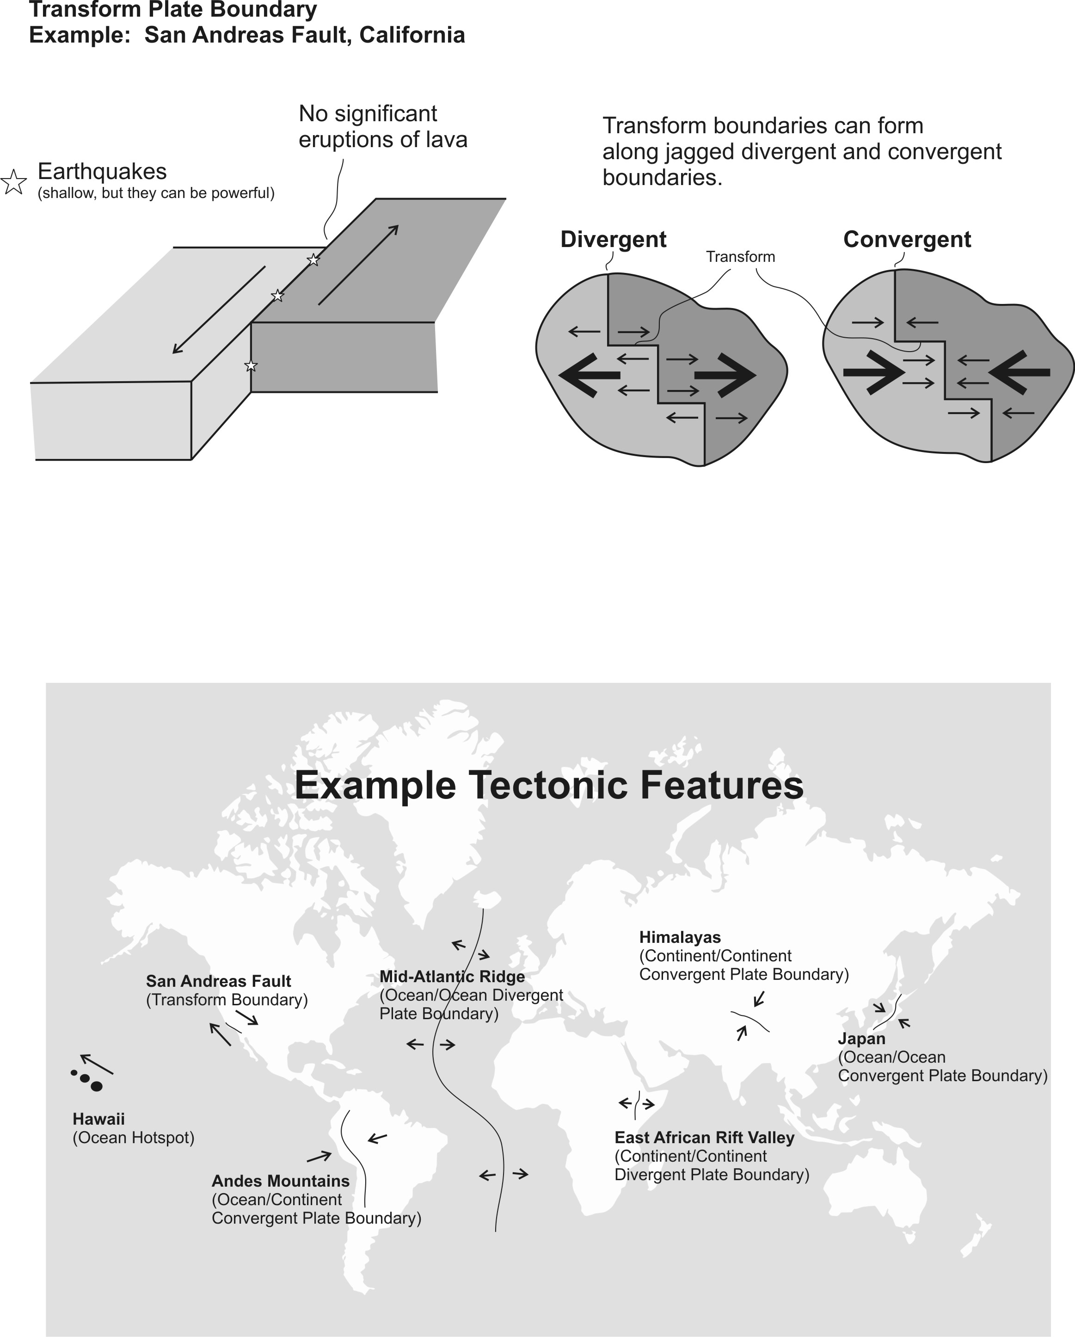

Practice 3

PLEASE DARKEN THE CORRECT ANSWER CHOICES.

Match each description to the appropriate crust type. Choices: A= Continental Crust B = Ocean Crust

1. A B Relatively light in color/shade
2. A B Relatively high viscosity (runny) when molten=
3. A B Similar to the material in the mantle
4. A B The most explosive volcanoes have this type of rock.
5. A B When this type of lava creates volcanoes, those volcanoes are steep.
6. A B An example of this rock type is called basalt.

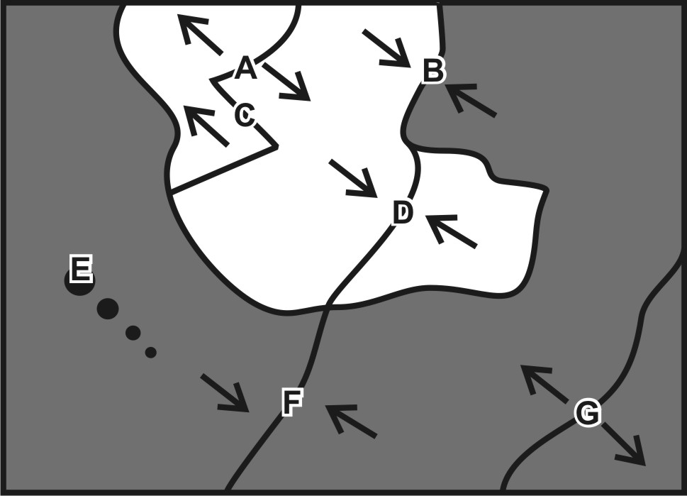
Match each feature name to the corresponding feature on the plate map on the right.

7. A B C D E F G Ocean/Continent Convergent
8. A B C D E F G Transform Boundary
9. A B C D E F G Continent/Continent Convergent
10. A B C D E F G Hotspot
11. A B C D E F G Ocean/Ocean Divergent
12. A B C D E F G Ocean/Ocean Convergent
13. A B C D E F G Continent/Continent Divergent

Each of the real-world locations below forms in an area that is similar to one of the lettered locations on the map. Match each real-world location to its corresponding map location.

14. A B C D E F G Mid-Atlantic Ridge
15. A B C D E F G San Andreas Fault, California
16. A B C D E F G East Africa
17. A B C D E F G Andes Mountains (South America)
18. A B C D E F G Himalayas (Mt. Everest)
19. A B C D E F G Japan
20. A B C D E F G Hawaii

For each lettered feature on the map above, darken all of the descriptions below that apply. [Suggestion: start with letter A. Darken that letter for all of the descriptions that apply to location A on the map. Continue the process one map feature at a time.]

15. A B C D E F G Steep, composite cone volcanoes
16. A B C D E F G Relatively violent eruptions of lava can occur.
17. A B C D E F G Relatively gentle eruptions of lava can occur.
18. A B C D E F G Shallow earthquakes (in lithosphere – crust)
19. A B C D E F G Deep earthquakes (in mantle)
20. A B C D E F G Situated over a relatively cool part of the mantle
21. A B C D E F G New ocean crust is being created here.
22. A B C D E F G Situated over a relatively hot part of the mantle
27. A B C D E F G Tall mountains that are not volcanoes
23. A B C D E F G Rounded, shield volcanoes

