ESS 100 (Stapleton) Name: _______________________________
Plate Tectonics, Part 1

Goals:
- Identify Earth’s layers
- Describe the material in each layer, in terms of composition and rigidity
- Rank the layers according to density and temperature
- List the sources of Earth’s internal heat
- Identify convergent, divergent, and transform boundaries on a plate map showing directions of plate movement.
- On a plate map showing the directions of plate movement, identify plate boundaries that are associated with hotter and cooler areas in the mantle.
- On a cross-section diagram of the Earth’s upper mantle, lower mantle and crust, draw the convection currents, plate movements, and plate boundaries that result from temperature differences in the mantle.

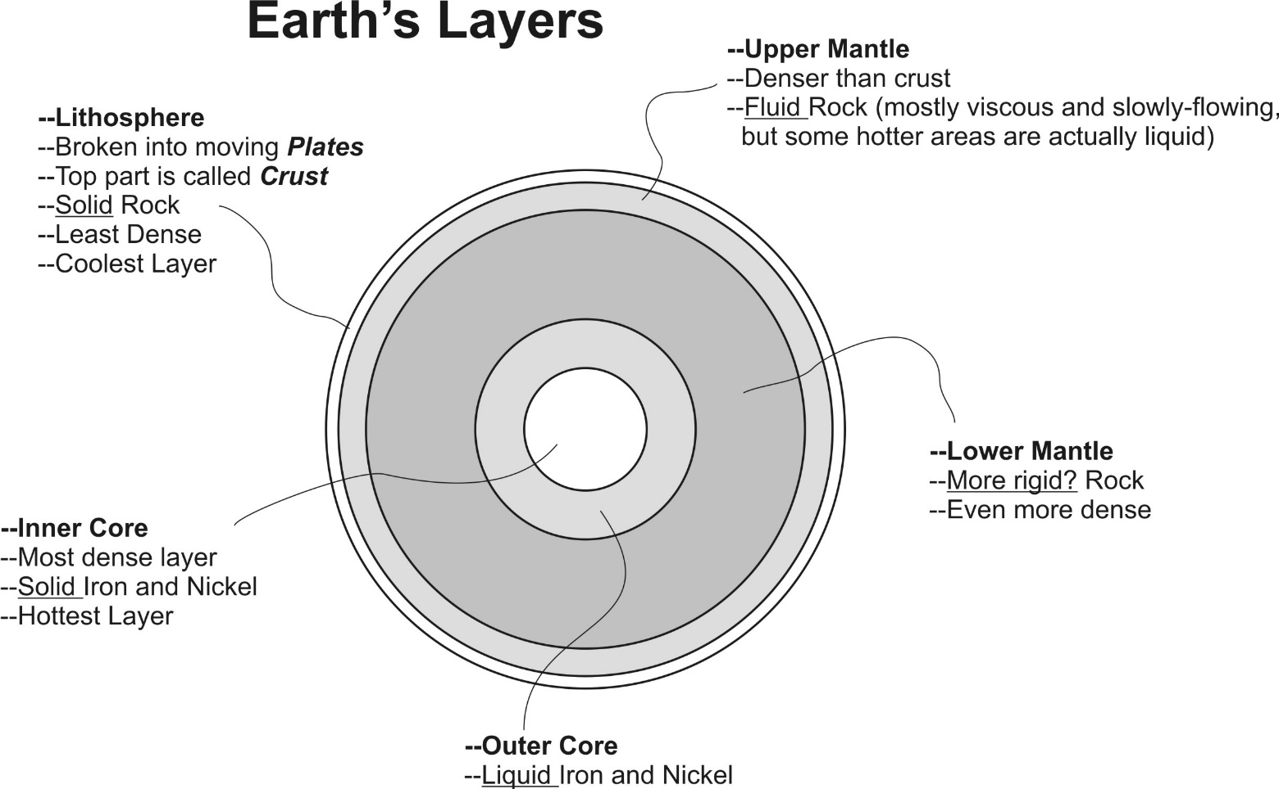

Why is the inside of the Earth Hot?
- Collisions during Earth’s formation (when many small pieces crashed into one another to form the Earth).
- Friction from heavier materials sinking to the center of the Earth, and rubbing against other materials on their way.
- Heat released by radioactive elements inside the Earth.
Plate: A piece of the Earth’s Lithosphere. If you crack an egg, each of the pieces of the fractured shell is like one plate.
Plate Boundary: where two plates meet
Plate Boundary Types:
- Convergent Boundary: →←
- Divergent Boundary: ←→
- Transform Boundary: ↑↓
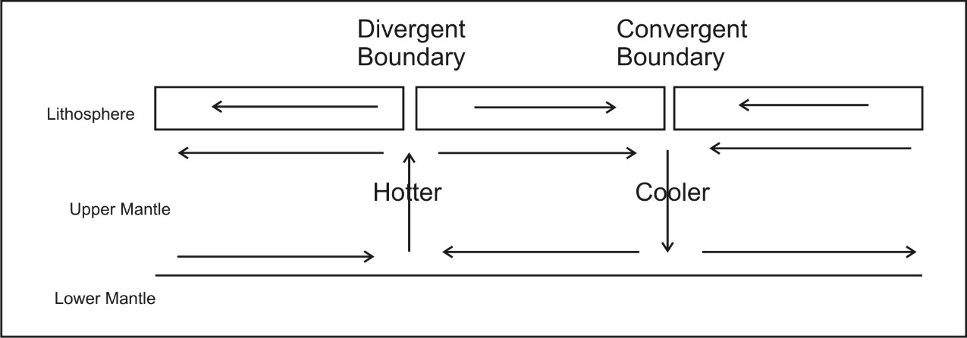

Convection Currents: Currents in the upper mantle that are caused by temperature differences. These currents cause the lithospheric plates to move. Convection currents begin when hot material rises and cooler material sinks.
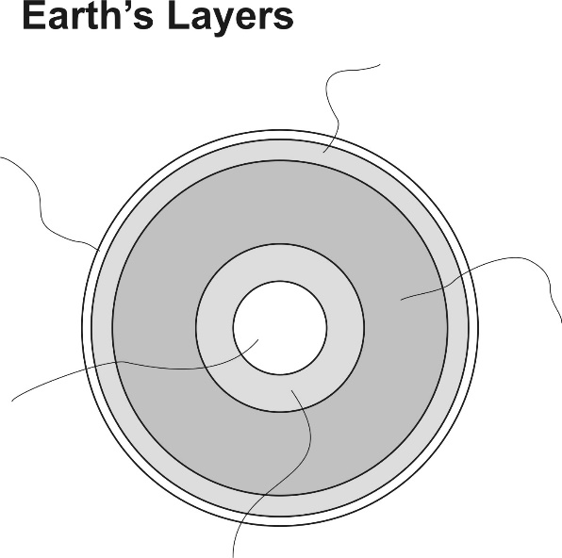
Practice:

1. Label the Earth’s layers on the diagram to the right. For each layer, indicate whether it is a solid or a fluid.
2. Which layer is most dense?

3. Which layer is least dense?

4. Which layer has convection currents that cause the Earth’s plates to move?

5. a. Which two layers are not made of rock?

b. What materials are found in those layers?

6. Why is the inside of the Earth hot? Give 3 reasons.
1.

2.

3.

7. On the plate boundary map below, find, circle, and label at least one convergent plate boundary, one divergent plate boundary, and one transform plate boundary.
8. On the plate boundary map below, find at least one plate boundary that is situated on top of an especially hot part of the mantle. Label it “hot.”
9. On the plate boundary below, find at least one plate boundary that is situated on top of an especially hot part of the mantle. Label it “cool.”

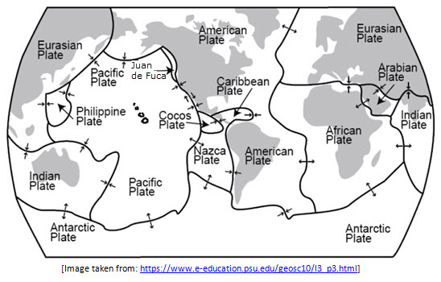
10. On the cross-section diagram below, use arrows to show the convection currents and plate movements that result from temperature differences in the mantle. Then identify and label the three plate boundaries in the picture.
