ESS 100 (Stapleton) Name: ___________________________
Practice: Waves and The Big Bang

1. List all of the colors of light, in order of wavelength.

2. Does your list go from shortest to longest wavelength or from longest to shortest?

On the wave diagram below…
3. Show and label a wavelength. 4. Label a crest 5. Label a trough

6. Rank these star colors from hottest to coolest (Hint: think about wavelengths).

White , Red, Yellow, Blue, Orange

Hottest : ___________ ___________ ___________ ___________ ___________ : Coolest

7. Black isn’t exactly a color of light. What is it?

8. White isn’t exactly a color of light. What is it?

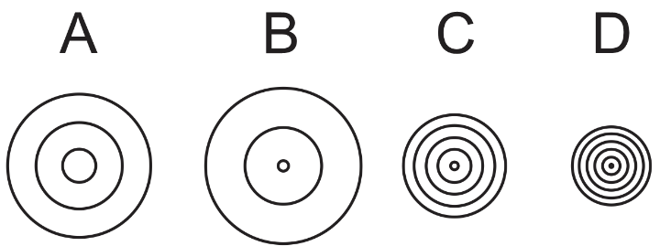
9. Which set of sound waves has the longest wavelength?
A B C D

10. Which set of sound waves has the highest frequency?
A B C D

11. Which set of sound waves has the highest pitch?
A B C D
12. Draw an object moving to the right and giving off sound waves. Make sure that you draw the waves that are in front of the object and behind it.

13. Draw an object moving to the left and giving off light waves. Make sure that you draw the waves that are in front of the object and behind it.

14. If an object has a red-shift, what does that tell us about the object?

15. What word goes with this definition?

_________________________ : An apparent change in the wavelength and frequency of waves, caused by movement of an object and or an observer. This can happen with sound or light.

16. What created all of the elements that we have in the Universe today?

a. The heaviest elements: Atoms of Gold, lead, mercury, and Uranium are all heavier than iron. None of these substances were created by the Big Bang. What created them?

b. The lightest element: Stars are made mostly of hydrogen. Where did the hydrogen come from? When was it created?

c. Medium Elements: What created the elements that are heavier than hydrogen and helium, but lighter than iron?

Part 4: The Big Bang theory

17. Very briefly describe how the size and temperature of the Universe has changed over time.

18. Briefly list three pieces of evidence supporting the Big Bang Theory

17. What does CMBR stand for?

18. Explain how the CMBR is evidence for the Big Bang theory?

19. Draw a diagram that shows how two observers of the same moving star can see different Doppler shifts – one observer seeing a red-shift, and the other seeing a blue-shift.

20. Describe Edwin Hubble’s discovery. What did he observe?

21. Explain how Edwin Hubble’s discovery provided evidence for the Big Bang theory.

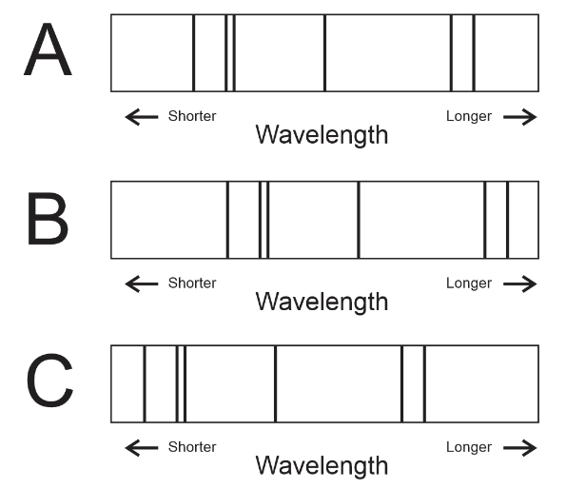
22. The diagram on the right shows the same group of spectral lines from three different stars that were observed from the Earth. One star is not moving, relative to the Earth. One is moving away from Earth, and one is moving toward Earth. Identify each star’s direction of movement. Tell whether it is “red shifted” or “blue shifted.”

A.

B.

C.

23. How old is the Universe?

