ESS 100 Name: ________________________________
System of the Earth, Moon, and Sun
Practice Test #2

Matching Moon Phase Terms. Some terms are used more than once:
A. Waxing B. Waning C. Crescent D. Gibbous E. Quarter F. New G. Full

1. _____ This describes any moon phase that is in the process of growing (the lighted part is getting bigger).
2. _____ A moon that is completely dark (the shaded side is facing Earth).
3. _____ In the Northern Hemisphere, this describes any moon that is lit only on the right side.
4. _____ A moon that is mostly lighted, with a curved slice of darkness on one side.
5. _____ This describes any moon phase that is in the process of shrinking (the lighted part is getting smaller).
6. _____ A moon phase that appears to be half light and half dark.
7. _____ A moon that is mostly dark, but with a curved, lighted slice on one side.
8. _____ In the Northern Hemisphere, this describes any moon that is lit only on the left side.
9. _____ A moon phase that is a completely-lit, bright circle.

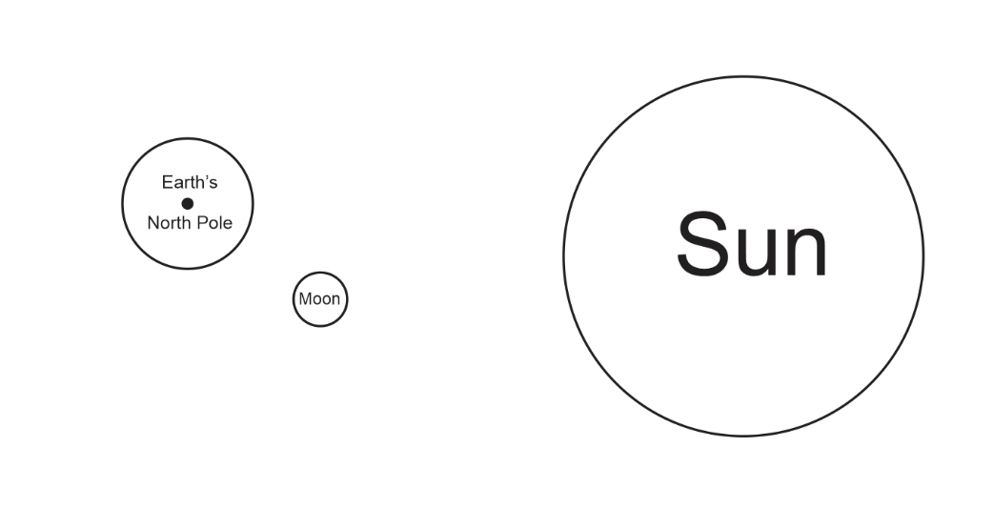
10. On the diagram to the right, use labeled arrows to demonstrate each of the following:
- Earth’s rotation
- Earth’s revolution
- The Moon’s rotation
- The Moon’s revolution

Causes of phenomena:
11. What causes tides to rise and fall each day?
a. Earth’s rotation
b. Earth’s revolution
c. Moon’s rotation
d. Moon’s revolution

12. What causes the strength of tides to change – from neap tides to spring tides, and back?
a. Earth’s rotation b. Earth’s revolution c. Moon’s rotation d. Moon’s revolution

13. What causes our seasons to change?
a. Earth’s rotation b. Earth’s revolution c. Moon’s rotation d. Moon’s revolution

14. What causes the time of day to change (from morning to afternoon to night…?
a. Earth’s rotation b. Earth’s revolution c. Moon’s rotation d. Moon’s revolution

15. What causes eclipses to begin and end?
a. Earth’s rotation b. Earth’s revolution c. Moon’s rotation d. Moon’s revolution

16. What causes the Moon’s phase to change?
a. Earth’s rotation b. Earth’s revolution c. Moon’s rotation d. Moon’s revolution

17. What causes the Moon to rise and set?
a. Earth’s rotation b. Earth’s revolution c. Moon’s rotation d. Moon’s revolution

On the diagram below…
18. Use arrows to show the direction of the Earth’s rotation and the Moon’s revolution.
19. Shade the dark side of the Earth and the dark side of each of the moons.

On the outside edge of the Earth, label each dot with the time.
20. What time is it at letter I?
12am 3am 6am 9am 12pm 3pm 6pm 9pm
21. What time is it at letter J?
12am 3am 6am 9am 12pm 3pm 6pm 9pm
22. What time is it at letter K?
12am 3am 6am 9am 12pm 3pm 6pm 9pm
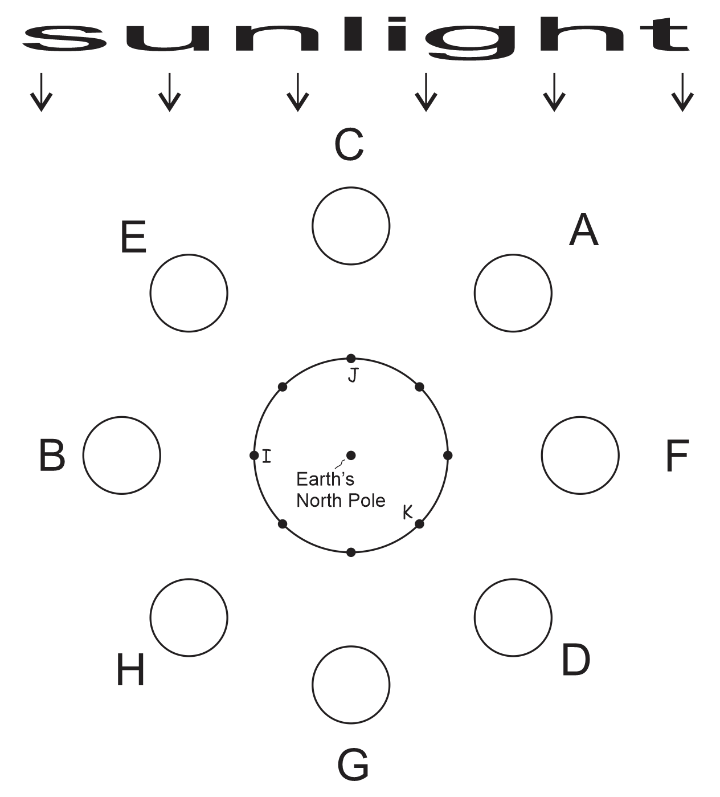
Use the diagram from the opposite page to answer these questions

23. During which moon phase is it possible to have have a solar eclipse?
A B C D E F G H
24. During which moon phase is it possible to have have a lunar eclipse?
A B C D E F G H

25. Consider Moon A…
a. Circle the picture that shows what this moon would look like from the Northern Hemisphere.
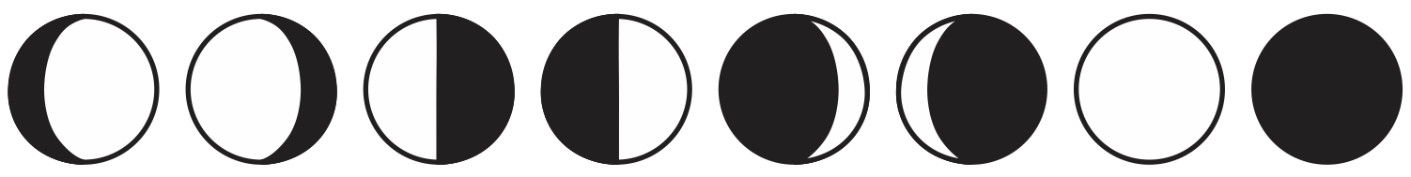
b. What is the shape of this moon phase?
Full New Gibbous Crescent Quarter
c. This moon is _______.
Waxing Waning Neither
d. How many weeks until the moon moves to position B?
0 .5 1 1.5 2 2.5 3 3.5 4
e. How many weeks until the moon phase is a waxing crescent?
0 .5 1 1.5 2 2.5 3 3.5 4
f. At what approximate time does this moon rise?
12am 3am 6am 9am 12pm 3pm 6pm 9pm
g. What type of tides can we expect during this moon phase?
Strong Tides Weak Tides Neither strong nor weak

26. Consider this moon: 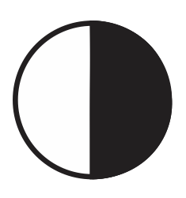
a. What is the shape of this moon phase?
Full New Gibbous Crescent Quarter
b. This moon is _______.
Waxing Waning Neither
c. Which moon in the diagram looks like this when viewed from Earth?
A B C D E F G H
d. How many weeks after this moon will the next full moon occur?
0 .5 1 1.5 2 2.5 3 3.5 4
e. How many weeks until the moon phase is a waning crescent?
0 .5 1 1.5 2 2.5 3 3.5 4
f. At what approximate time is this moon highest in the sky?
12am 3am 6am 9am 12pm 3pm 6pm 9pm
g. What type of tides can we expect during this moon phase?
Strong Tides Weak Tides Neither strong nor weak

27. Use a drawing compass and a straight edge, create a diagram showing a solar eclipse. There must be areas of partial eclipse, total eclipse, and no eclipse. Your diagram does not have to be drawn to scale. In your diagram…
a. Show, shade, and label both the umbra and penumbra.
b. Label the Sun, Earth, and Moon.
c. Label these areas:
- No eclipse
- Partial Eclipse
- Total Eclipse
Solar Eclipse

28. Use a drawing compass and a straight edge, create a diagram showing a partial lunar eclipse. Your diagram does not have to be drawn to scale. In your diagram…
a. Show, shade, and label both the umbra and penumbra.
b. Label the Sun, Earth, and Moon.

Partial Lunar Eclipse

