EPS 200 Name: ________________________________
System of the Earth, Moon, and Sun
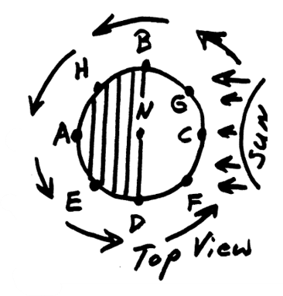
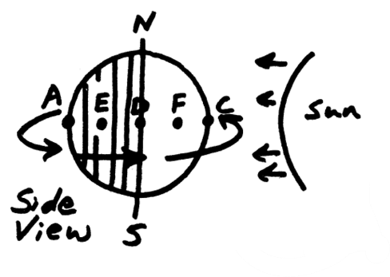
Part 1: Time of Day
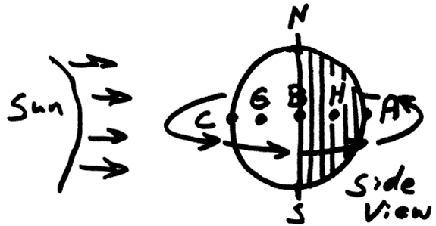

1. How much of the Earth is always dark (approximately)? ______

2. Which side of the Earth is dark? ___________________________________

3. a) In the pictures, which point is entering darkness? ______

b) What is that time of day called? ________________________

c) What is the approximate time at that location?
12AM 3AM 6AM 9AM 12PM 3PM 6PM 9PM

4. a) Which point is exiting (leaving) darkness? ______

b) What is that time of day called? ________________________

c) What is the approximate time at that location?
12AM 3AM 6AM 9AM 12PM 3PM 6PM 9PM

5. a) At which point is the Sun directly overhead? ______

b) What is that time of day called? ________________________

c) What is the approximate time at that location?
12AM 3AM 6AM 9AM 12PM 3PM 6PM 9PM

6. a) Which point is in the middle of the night? ______

b) What is that time of day called? ________________________

c) What is the approximate time at that location?
12AM 3AM 6AM 9AM 12PM 3PM 6PM 9PM

7. What is the approximate time at letter F? 12AM 3AM 6AM 9AM 12PM 3PM 6PM 9PM
8. What is the approximate time at letter G? 12AM 3AM 6AM 9AM 12PM 3PM 6PM 9PM
9. What is the approximate time at letter H? 12AM 3AM 6AM 9AM 12PM 3PM 6PM 9PM
10. What is the approximate time at letter E? 12AM 3AM 6AM 9AM 12PM 3PM 6PM 9PM

11. We say that the Sun “rises,” “sets,” and “moves through the sky.” What really happens?

12. a) Define rotation:

b) Define revolution:

13. How long does it take Earth to complete 1 rotation?

14. How long does it take Earth to complete 1 revolution?

15 a. Which way does the Earth Rotate? Provide an answer that works from any vantage point. Draw a picture.

b. How can you prove that your answer is correct?

c. If we look down at the Earth from above the North Pole, which direction does it rotate?

Time of Day Practice:

The diagrams on the right show three different view of the Earth.
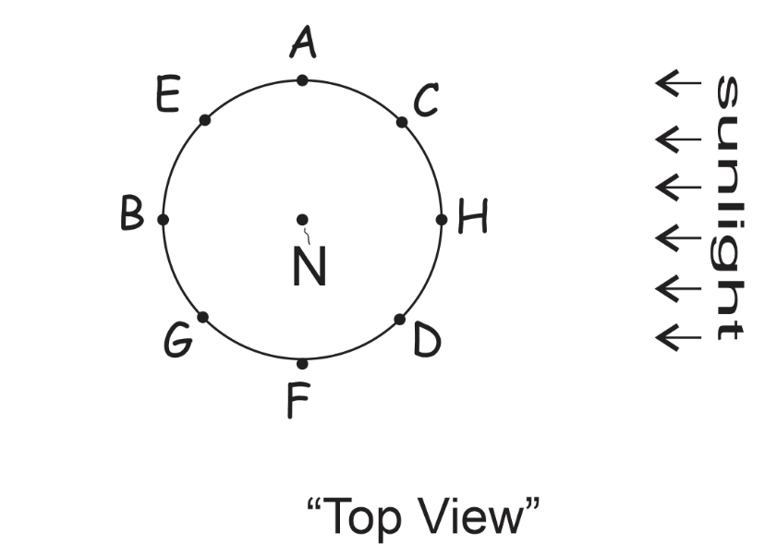
1. On all three diagrams, shade the dark part of the Earth, and draw arrows showing the Earth’s direction of rotation.
2. On the top view diagram, label the time at each letter. Use one of these choices:
12AM 3AM 6AM 9AM 12PM 3PM 6PM 9PM
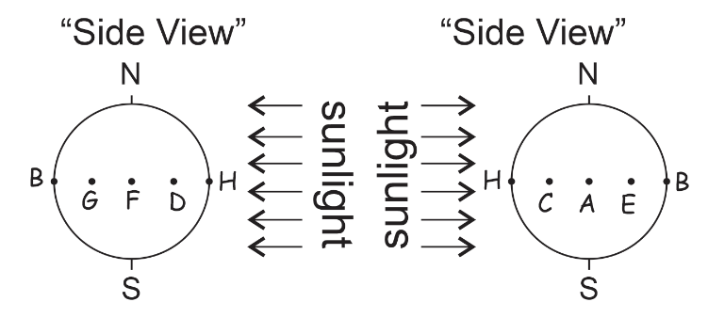
3. On the top view diagram, label midnight, sunrise, sunset, and noon.

