EPS 200 Name: ________________________________
System of the Earth, Moon, and Sun
Part 2: Moon Phases and Tides
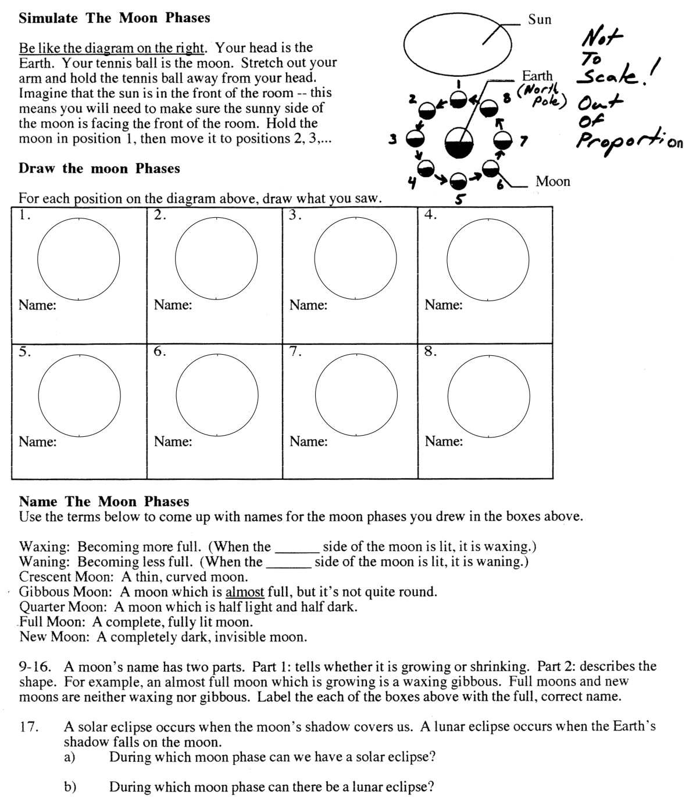

Helpful Information:
- Synodic Month (29.5 days; about 4 weeks): The time it takes for the Moon to go through one full lunar cycle (e.g. New Moon to the next New Moon).
- Sidereal Month (27 1/3 days): the time it takes for the Moon to make one complete revolution around the Earth.
- Lunar Eclipse: The Earth’s shadow falls on the Moon.
- Solar Eclipse: The Moon’s shadow falls on the Earth.
- Direction of the Moon’s revolution (looking down on Earth’s North Pole): ____________________________
- Zenith: the highest point in the sky reached by a celestial object (like the Sun or Moon)
- When viewed from above the Earth’s North Pole, all rotations and revolution of the Earth and Moon are in a

___________________________ direction.

Moon travel time questions:
Answer choices: 0 0.5 1 1.5 2 2.5 3 4

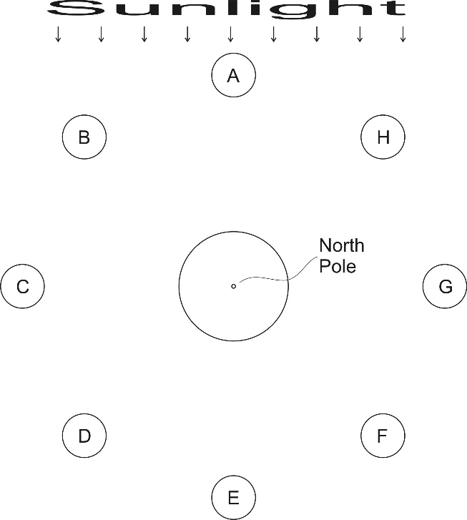
18. ________ Approximately how many weeks does it take the Moon to travel from position A, around the Earth, and back to position A?

19. ________ Approximately how many weeks does it take the Moon to travel from position A to position E?

20. ________ Approximately how many weeks does it take the Moon to travel from position A to position D?

21. ________ Approximately how many weeks does it take the Moon to travel from position H to position A?

22. ________ Approximately how many weeks does it take the Moon to travel from position B to position G?

23. ________ Approximately how many weeks does it take the Moon to travel from position D to position F?

Moonrise and Moonset: [**note that all of these times are approximate]

24. Shade the appropriate half of the Earth.

25. Label the Earth’s equator, and label these times on the Earth’s equator (3, 6, 9, and 12; AM and PM)

26. Moon A rises at ___________, sets at ___________, and is at it zenith at ____________.

27. Moon G rises at ___________, sets at ___________, and is at it zenith at ____________.

28. Moon D rises at ___________, sets at ___________, and is at it zenith at ____________.

29. Moon B rises at ___________, sets at ___________, and is at it zenith at ____________.

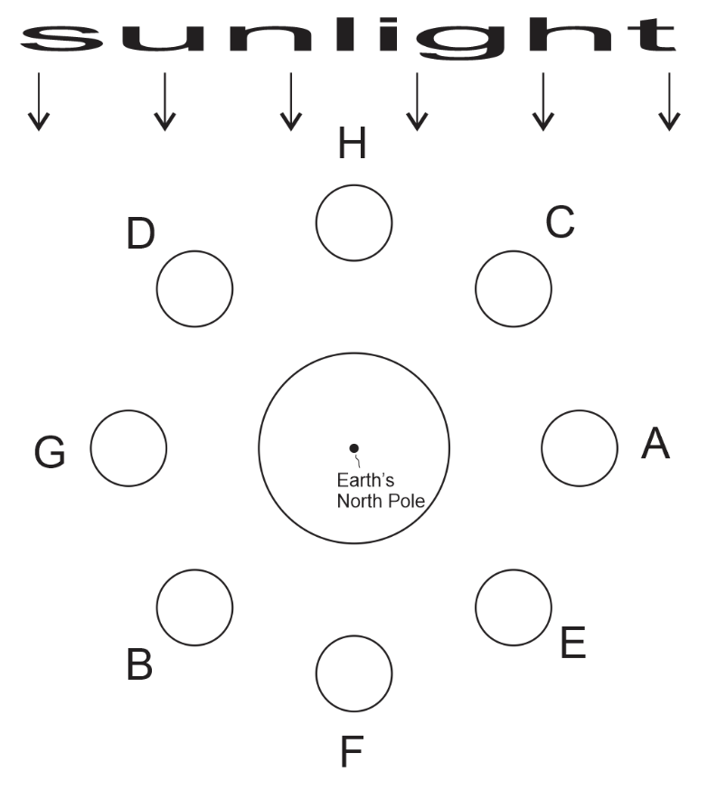
Moon Phases Practice:

1. Correctly shade the Earth and all of the Moons in the diagram.
2. Add arrows to show the directions of the Earth’s rotation and the Moon’s revolution.
3. Fill out the chart.
Letter | Name of Moon Phase | Drawing (appearance of Moon from Earth’s Northern Hemisphere) | Approximate time of moonrise | Approximate time of moon set | Weeks until the next possibility of an eclipse | Type of possible eclipse (from the previous column)
A
B
C
D
E
F
G

Tides :

More Helpful Information:
- Spring Tide: an especially strong tide that is produced when the Sun and Moon are “working together.”
- Neap Tide: An especially weak tide that is produced when the Sun and Moon are working against one another.

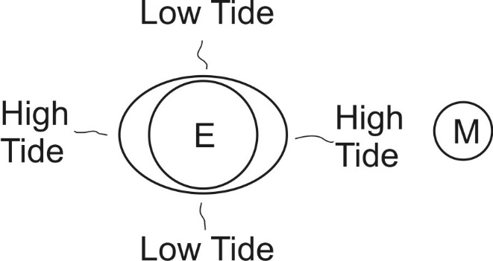
1. The Moon and Sun cause tides by the same process that a black hole would spagettify someone being pulled into the black hole. Explain.

2. Which celestial body exerts more gravitational force on our oceans -- the Moon or the Sun? Why?

3. Why does the moon cause more extreme tidal effects than the sun?

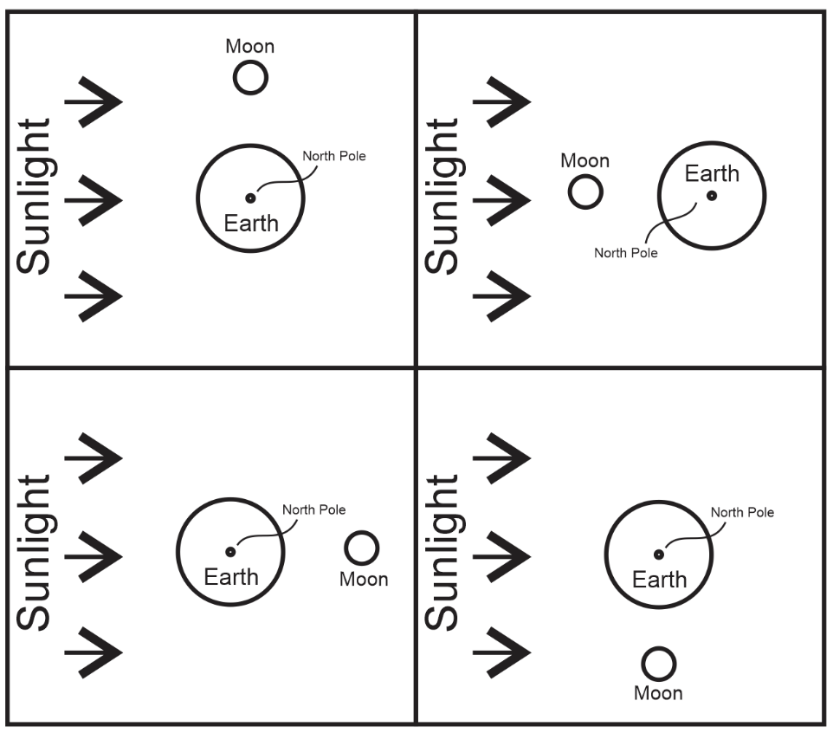
4. In each of the diagrams, write a capital H were the moon makes high tides, and write a capital L where it makes low tides. Since the Sun’s effects on tides are weaker, write a lowercase h wherever the Sun creates a high tide, and write a lowercase l where it makes a low tide.

5. Spring tides are especially strong tides that are caused by the Moon and Sun “working together.” Label the diagrams that show spring tides.

6. Neap tides are especially weak tides that are caused by the Moon and Sun “working against one another.” Label the diagrams that show neap tides.

7. Label each diagram with its moon phase

