Stirling Engine Questions, Part 1 Name: __________________________

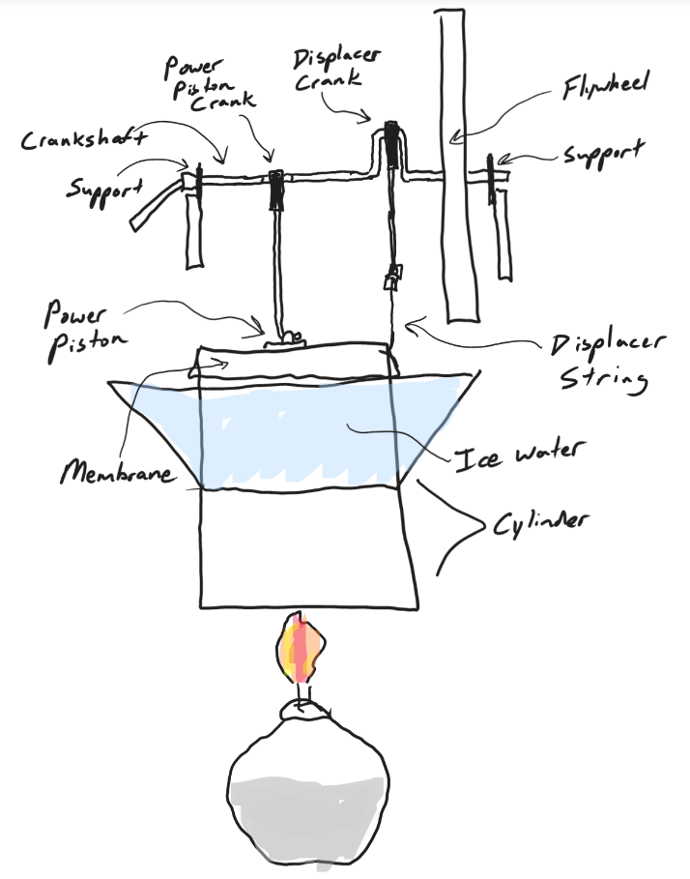
In diagram #1, on the right…
1. What is the position of the displacer crank? Highest Point Lowest Point Middle
2. Where in the cylinder is the displacer?
Top Bottom Middle
3. Where is most of the air in the cylinder?
Top Bottom Middle
4. What is happening to the motion of the air molecules in the cylinder?
Speeding up Slowing Down Nothing

5. Why is this happening to the air molecules in the cylinder?

6. What is happening to the power piston?
It’s being forced upward
It’s being forced downward
It’s not moving

7. Why is this happening to the power piston?

8. What is happening to the mass of the air inside the cylinder?
Increasing decreasing No change

9. Explain why this is happening to the mass?

10. What is happening to the volume of the air inside the cylinder?
Increasing decreasing No change

11. Explain why this is happening to the volume of the air in the cylinder?

12. What is happening to the density of the air in the cylinder?
Increasing decreasing No change

13. Explain why this is happening to the air’s density.

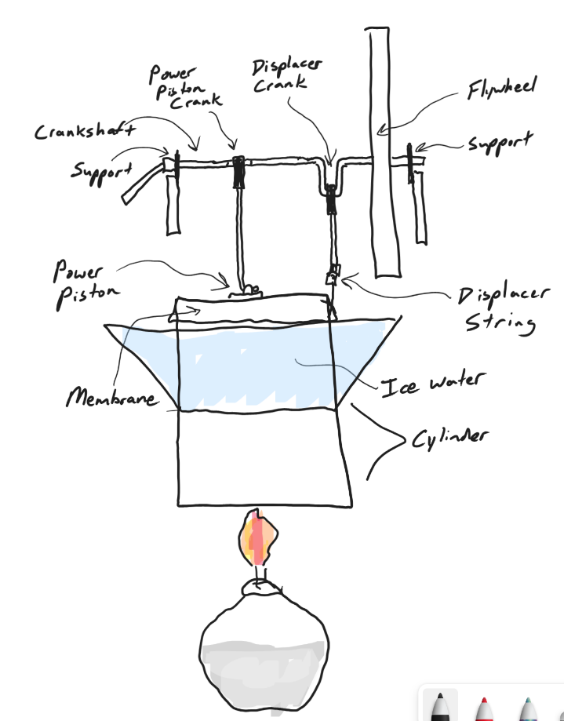
In diagram #2 (on the right)…
14. What is the position of the displacer crank? Highest Point Lowest Point Middle
15. Where in the cylinder is the displacer?
Top Bottom Middle
16. Where is most of the air in the cylinder?
Top Bottom Middle
17. What is happening to the motion of the air molecules in the cylinder?
Speeding up Slowing Down Nothing

18. Why is this happening to the air molecules in the cylinder?

19. What is happening to the power piston?
It’s being forced upward
It’s being forced downward
It’s not moving

20. Why is this happening to the power piston?

21. What is happening to the mass of the air inside the cylinder?
Increasing decreasing No change

22. Explain why this is happening to the mass?

23. What is happening to the volume of the air inside the cylinder?
Increasing decreasing No change

24. Explain why this is happening to the volume of the air in the cylinder?

25. What is happening to the density of the air in the cylinder?
Increasing decreasing No change

26. Explain why this is happening to the air’s density.

