ESS 100 (Stapleton) Name: ___________________________
Notes: Formation of Our Solar System Part 2 – formation of planets

The Nebula’s Temperature Continues To Change, and The Frost Line Forms

22. As time went by, the nebula’s temperature continued to _________________________________

Why?

23. What part of the nebula was the hottest?

24. Why was this the hottest part of the nebula?

25. The hot center of the forming solar system was called the ____________________________.

26. The nebula had been a rotating disk of ice (“frozen gas”) and dust. As the center heated up, the ice

(frozen gases) near the sun were ____________________________________________. This created a

boundary called the _________________ ________________. Beyond the boundary the “frozen gases” survived as ice, but inside they were turned to gas.

Drawing #3: The Solar Nebula (Around 4.55 Billion years ago)

- The ice that was located near the center of the nebula _________________________________ because

_____________________________________________________________________________________

15. The Sun’s energy comes from nuclear fusion.

a. Define “fuse.”

b. Draw a picture showing an atom’s protons, neutrons, and electrons. Label the parts, including the nucleus.

c. Nuclei (plural of nucleus) are very resistant to fusing. They can only be made to fuse at very high temperatures.

  - Why do nuclei resist fusing?

  - Why can very high temperatures make nuclei fuse?

e. The Sun was born when the ____________________ became so hot that

_____________________________________ began.

e. In the Sun, what is the main element that fuses, and what gets created when it fuses?

16. Why does fusion of Hydrogen into Helium produce so much energy? The answer is that it takes four hydrogen atoms to fuse into one helium atom, and one helium atom does not have as much mass as four hydrogen atoms. This means some mass gets “lost” during the fusion process. This mass isn’t really lost; it is turned into energy.

- The amount of energy that is produced by nuclear fusion can be calculated using the formula E=mc². E = the energy. m = the mass that is “lost.” c = the speed of light. c² = the speed of light, squared. Even if the lost mass is very small, an enormous amount of energy is produced by this process, because the speed of light is a very big number. The speed of light is 299,792,458m/s, or about 672 million miles per hour. Calculate the amount of energy produced when one gram of mass is turned to energy. One gram is the approximate mass of a large paper clip.

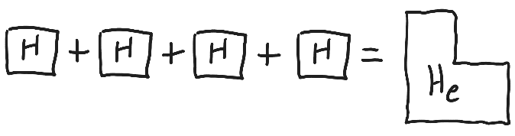
- Explain how this graphic explains the production of energy by nuclear fusion. [FYI, the diagram is exaggerated.]

- Use Einstein’s famous formula to show that “nuclear energy” (fusion or fission) is very powerful.

b. Why don’t we use nuclear fusion to create energy here on Earth?

Part 7: Planets Form and Continue To Orbit

19. In the earliest stages (when the planets were just tiny clumps of dust and ice), what force caused the dust and ice in the solar system to clump together?

. If you rub a balloon on your head, the balloon takes electrons from your head. This gives the balloon a

____________________________ charge and gives your head a _____________________________

charge. The balloon sticks to your head because __________________________________________

attract. This is another example of attraction due to __________________________________________.

. Once the planets reached a sized that was about ______________________ across, their

______________________ was strong enough to quickly pull in other clumps.

. Inside the frost line, the planets that formed were _________________________, because

______________________________________________________________________________________

______________________________________________________________________________________
. Beyond the frost line, the planets that formed were ____________________________________, because

______________________________________________________________________________________

______________________________________________________________________________________

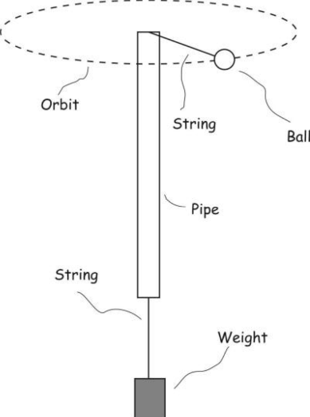
20. Today we have a solar system of planets that orbit the sun in relatively stable orbits. In a stable orbit, two opposing tendencies are in balance.

- The model on the right is similar to our solar system. If the pipe is swirled at just the right speed, the ball and weight will maintain their positions, as shown.

  - What keeps the ball from flying out into the room?

  - What keeps the ball from being pulled into the pipe?

- In our Solar system…

  - What prevents the planets from flying away from the Sun?

  - What prevents the planets from being pulled into the Sun?

21. The planets’ orbits are stable. Even if some meddling aliens increased or decreased Earth’s speed, our orbit would not change much.

- If some meddling aliens increased Earth’s speed…
  - How would our momentum change?

  - Would that change in momentum move us farther from or closer to the sun? (spread out or compress our orbit)

  - How would that movement change our speed?

  - What would that change in speed affect our momentum?

  - Would this cause our orbit to continue to change, or stop changing?

