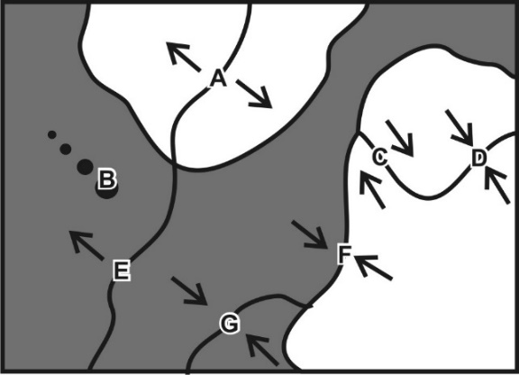
ESS (Stapleton)
Practice Quiz – Plate Boundary Names and Real-World Examples

Match each feature name to the corresponding feature on the plate map on the right.

1. A B C D E F G Ocean/Continent Convergent
2. A B C D E F G Transform Boundary
3. A B C D E F G Continent/Continent Convergent
4. A B C D E F G Hotspot
5. A B C D E F G Ocean/Ocean Divergent
6. A B C D E F G Ocean/Ocean Convergent
7. A B C D E F G Continent/Continent Divergent

Each of the real-world locations below forms in an area that is similar to one of the lettered locations on the map. Match each real-world location to its corresponding map location.

8. A B C D E F G Mid-Atlantic Ridge
9. A B C D E F G San Andreas Fault, California
10. A B C D E F G East Africa
11. A B C D E F G Andes Mountains (South America)
12. A B C D E F G Himalayas (Mt. Everest)
13. A B C D E F G Japan
14. A B C D E F G Hawaii

ESS (Stapleton)
Practice Quiz – Plate Boundary Names and Real-World Examples

Match each feature name to the corresponding feature on the plate map on the right.

1. A B C D E F G Ocean/Continent Convergent
2. A B C D E F G Transform Boundary
3. A B C D E F G Continent/Continent Convergent
4. A B C D E F G Hotspot
5. A B C D E F G Ocean/Ocean Divergent
6. A B C D E F G Ocean/Ocean Convergent
7. A B C D E F G Continent/Continent Divergent

Each of the real-world locations below forms in an area that is similar to one of the lettered locations on the map. Match each real-world location to its corresponding map location.

8. A B C D E F G Mid-Atlantic Ridge
9. A B C D E F G San Andreas Fault, California
10. A B C D E F G East Africa
11. A B C D E F G Andes Mountains (South America)
12. A B C D E F G Himalayas (Mt. Everest)
13. A B C D E F G Japan
14. A B C D E F G Hawaii

