ESS 100 Name: __________________________________
Midterm Review, Part 3:
Life Cycles of Stars, our Solar System, and The Earth

Earth History
1. Scientists think that the early Earth was completely molten. As soon as the Earth melted, layers began to form. Why did the Earth’s materials separate into different layers?

_______________________________________________

2. Scientists have found evidence that the building blocks of life came from outer space. This evidence is

amino acids. Where were these amino acids found? _____________________________

3. According to the “Birth of The Earth” video, what caused the Earth to heat up to the point that it melted completely?

__________________________________________________
4. After the Earth melted, what caused the outside of the Earth to form a solid crust?

__________________________________________________
5. Scientists used rock samples to find the actual age of the earth. Where did they get those samples?

_________________________________________
6. Scientists think that much of the Earth’s water was brought to Earth by _____________________.
7. Before about 3.5 billion years ago, there was no oxygen on the Earth. Scientists think the Earth’s oxygen

was first produced by __________________________________________________?

Solar System Formation, Part 1

8. In the earliest stage of our Solar System’s formation, what was it called?

9. Describe our solar system during its earliest stage. Describe its…

a. Size

b. Temperature

c. Motion

d. Shape

10. What types of materials were in the Solar system at that time? Be specific.

11. Describe how the solar system first began to change.

a. What happened to its size?

b. Why?

12. a. What happened to its temperature?

b. Why?

13. a. What happened to its motion?

b. Why did the motion change in this way?

14. a. What shape did the solar system become?

Solar System Formation, Part 2

15. a. What formed at the center of the nebula, before the Sun was “born?”

- Why did it form at the center? Why not at the edge?

16. In one part of the nebula, dust and ice remained. In another part of the nebula, only dust remained.

- What is the name of the boundary between these two areas?

- Where in the nebula did both dust and ice remain?

17. The Sun was born when a process called __________________________________ began.

18. Once the planets reached a sized that was about ______________________ across, the force of

______________________ was strong enough to pull other matter toward the forming planet. Before the

planets reached this size, _________________________________ provided the force that caused them to clump together.

19. Why are the outer planets covered by large gas layers (probably surrounding rocky cores), while the inner planets are just rocky?

20. Today, the planets in our solar system are held in stable orbits. ____________________ prevents the

planets from flying away from the Sun, and _________________________ keeps them from falling into
the Sun.

Medium Star Life Cycles

21. Draw a diagram of the Sun as it exists right now. In your diagram, show the fuel that is fusing and also show the substance that gets created during fusion. Draw the fuel and this new substance in the correct locations.

- Label (name) the fuel that is being used to produce the Sun’s energy.
- Label (name) the substance that the fuel turns into when it fuses.

22. Number these star life stages in order, from earliest to latest

_____ White Dwarf
_____ Main Sequence
_____ Planetary Nebula
_____ Protostar
_____ Black Dwarf
_____ Nebula
_____ Red Giant

23. a. Describe the relationship between a stars’ masses and their temperatures. Are massive stars hotter or cooler than less massive stars?

b. Explain why.

24. Order these star colors according to temperature and mass. At one end, write “most massive.” At one end, write “hottest.”

Yellow, Red, Blue, Orange, White

25. When our Sun becomes a red giant why will it get bigger?

26. When our Sun becomes a red giant why will it turn red?

Life Cycles of Very Massive Stars

27. Order the stages in a Massive Star’s life cycle, and number them to indicate their order. Some of the descriptions below do not apply.

NeutronStar/Black Hole/ Recycling Main Sequence Star
Protostar Supernova
Nebula Red Supergiant

28. Draw two cross-section diagrams showing the layers of a red giant and a red supergiant. Label the material in the innermost layer and the two outermost layers in which fusion is happening. The number of layers in your red supergiant does not have to be exactly correct.
29. a. After a supernova occurs, what are the two options for the matter that is left behind?

b. What happens to the matter that “leaves?”

Waves and The Big Bang

30. List all of the colors of light, in order of wavelength.

31. Does your list go from shortest to longest wavelength or from longest to shortest?

32. Draw an object moving to the left and giving off light waves. Make sure that you draw the waves that are in front of the object and behind it.

33. If an object has a red-shift, what does that tell us about the object?

34. Define “Doppler Effect”:

35. What created all of the elements that we have in the Universe today?

a. The heaviest elements: Atoms of Gold, lead, mercury, and Uranium are all heavier than iron. None of these substances were created by the Big Bang. What created them?

b. The lightest element: Stars are made mostly of hydrogen. Where did the hydrogen come from? When was it created?

c. Medium Elements: What created the elements that are heavier than hydrogen and helium, but lighter than iron?

36. Very briefly describe how the size and temperature of the Universe has changed over time.

37. Briefly list three pieces of evidence supporting the Big Bang Theory

38. Explain how the CMBR is evidence for the Big Bang theory?

39. Explain how Edwin Hubble provided evidence for the Big Bang theory.

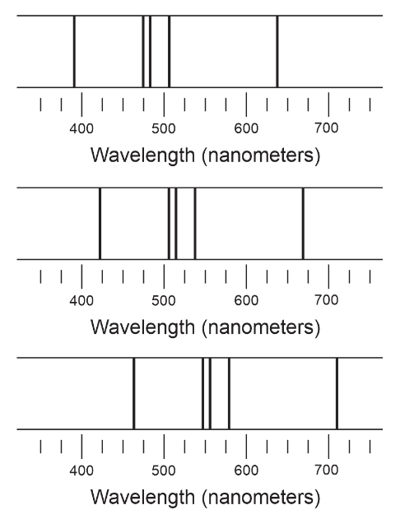
40. Explain how to correctly answer a question like this one…

The diagram on the right shows the spectral lines given off by one element. One set of lines was observed by heating up the element here on Earth. Another set of lines was observed coming from star that is moving toward us. The other set of spectral lines was observed coming from a star that is moving away from us.

Label each of the sets of spectral lines with one of these labels:
- “Observed on Earth”
- Moving toward Earth
- Moving away from Earth

41. How old is the Universe?

