ESS 100 Name: _________________________________
Meteorology Practice Quiz 1: Pressure and Wind

1. What causes wind?

2. Use arrow to draw the wind that will blow in the diagram below.
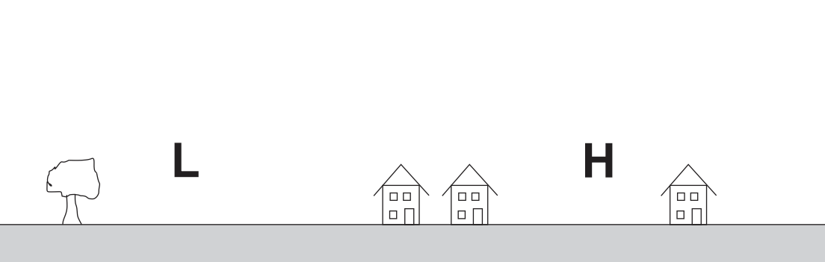

3. There is pressure in the air all around us. We call this atmospheric pressure. What causes that pressure?

4. Where is air pressure weaker – at high altitudes (mountain tops) or at low altitudes (valleys)?

\

5. Explain why air pressure is weaker in those locations.

6-8. What happens to eardrums when we descend to lower elevations? Add to the drawing on the right to show and explain happens to the eardrum when someone travels to a lower elevation.
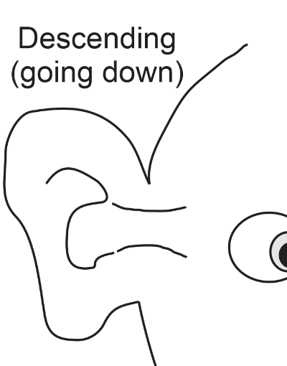
6. Show the shape of the eardrum itself.
7. Show why the shape of the eardrum is changing.
8. Use words to explain why going to a lower elevation has caused this change.

9. What is the average air pressure at sea level (approximately)?
a. 1,500psi b. 150psi c. 15psi d. 1.5psi

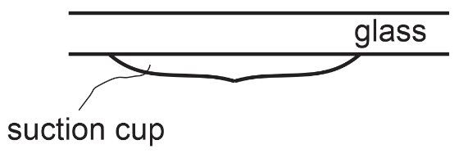
10. Add to the drawing on the right to show why a suction cup sticks to glass. Then use words to explain what your drawing means, and how it shows the reason for a suction cup sticking to glass.

11-14. In the diagram below…
11. Label the “heavy” and “light” air masses
12. Below the air masses, label the areas of high (H) and low (L) pressure.
13. Use arrows to draw the winds that will be produced by these pressure differences.
14. Fill in the rest of the currents in the diagram.

