ESS 100 (Stapleton) Name: __________________________
Notes: The Big Bang

1. When did the Big Bang occur? Briefly describe the Big Bang Theory.

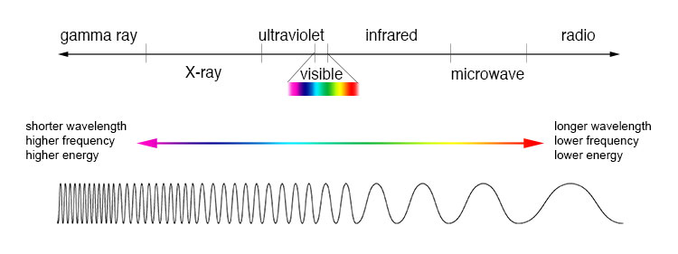
2. a. Draw a picture representing the waves of radiation that filled the early universe. Label the waves with their type of radiation.

b. Then draw another picture representing those same waves today. Label the waves with their type of radiation.

3. Explain how these waves provide evidence for the Big Bang Theory.

4. What does Hubble’s Law say?

5. Draw a picture illustrating and describing the Doppler Effect that we would observe if a star were
a. coming toward us b. going away from us

6. Describe what Edwin Hubble observed when he measured the wavelengths of distant galaxies, and explain how that provided evidence for the Big Bang theory.

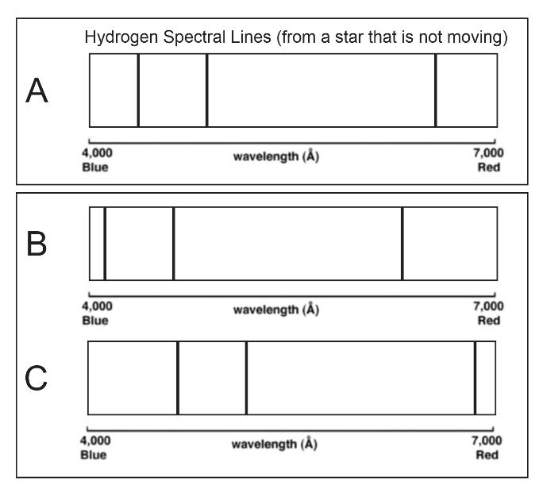
7. Scientists don’t really judge the color of a star to determine red shift. They use “spectral lines.” What are spectral lines?

Part A of diagram on the right shows the spectral lines given off by hydrogen in a star that is not moving.

8. Which letter shows hydrogen spectral lines that have been red-shifted? If this light is coming from a star, which way is the star moving?

9. Which letter shows hydrogen spectral lines that have been blue-shifted? If this light is coming from a star, which way is the star moving?

10. How do we know how long ago the Big Bang Occurred?

