ESS 100 Name: ___________________________
Rock Dating – Relative Dating

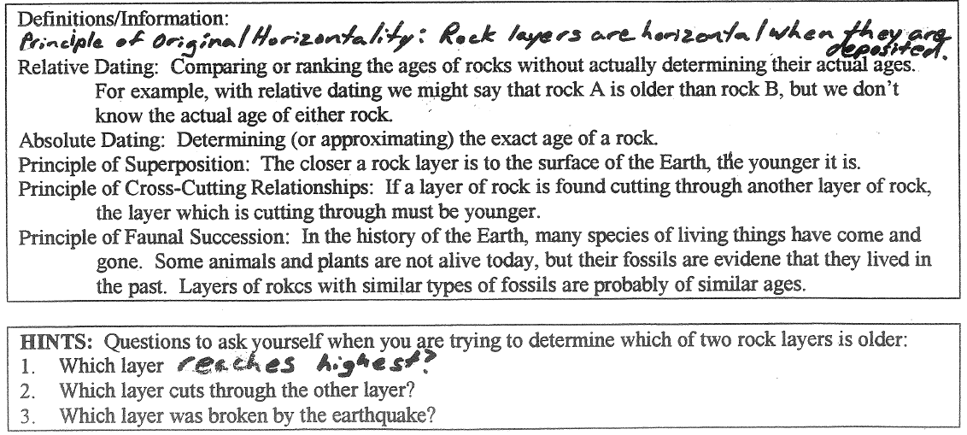

Practice #1. Rank the rocks in the diagram from oldest to youngest.
Oldest Youngest
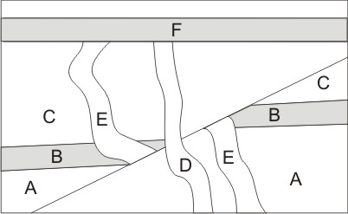

Practice #2. Rank the rocks in the diagram from oldest to youngest.

Oldest Newest

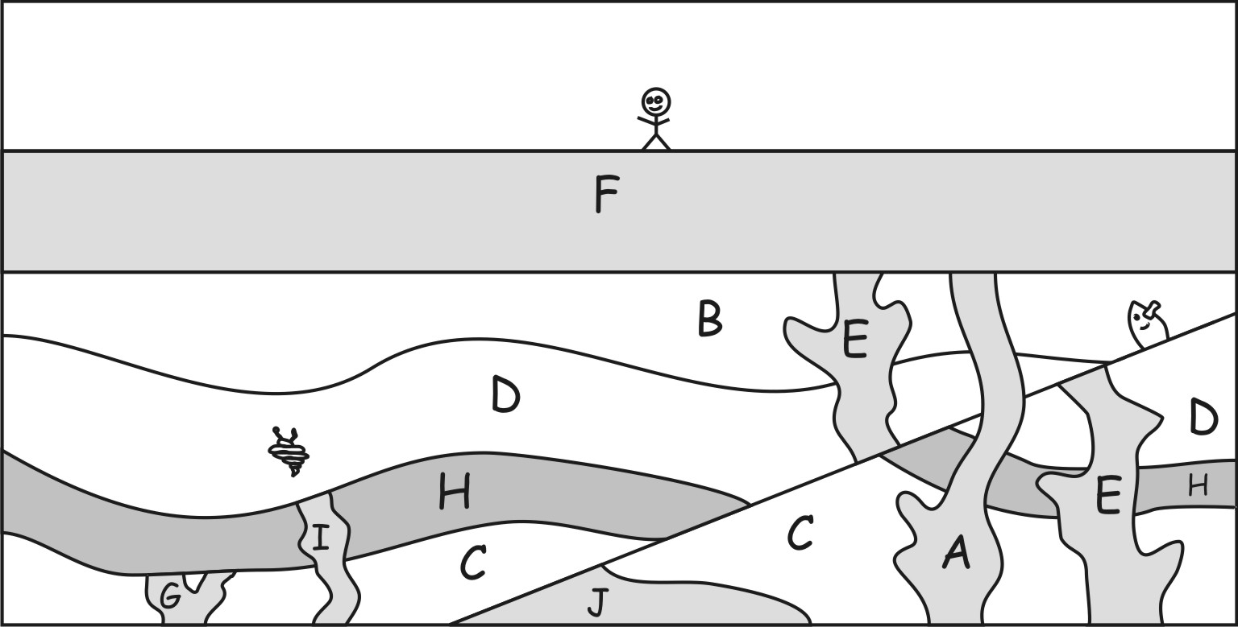

Oldest Newest

Practice #3. Rank the rocks in the diagram from oldest to youngest.
