ESS 100 (Stapleton) Name: ___________________________
Notes: Wind, Atmospheric Pressure, and Buoyancy

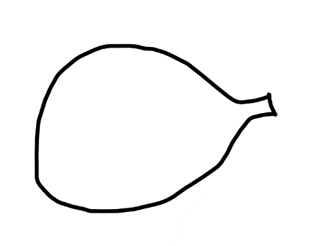
Part 1: Pressure Differences Create Winds

1. The picture on the right shows an inflated balloon. Label the air in and around the balloon to show where the air pressure is higher (H) and where it is lower (L).

2. Use an arrow to show how the air will move when the valve (hole) of the balloon is allowed to open.

3. Another name for moving air is ______________.

4. On the Earth, air moves because of differences in pressure. Does air move from low pressure to high pressure or from high pressure to low pressure?

5. Restate the information from above. Explain what causes wind, and explain what determines the direction of wind.

6. The diagram below shows areas of high pressure and low pressure. See if you can determine which person experiences a wind blowing from the left? Draw the winds that will be created by the pressure differences.

Part 2: Atmospheric Air Pressure (pressure in the air around us)

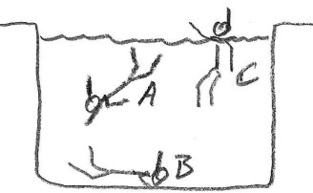
7. In the first picture on the right, which swimmer is experiencing the strongest water pressure?

8. What causes the water pressure you feel when you dive?

9. Does air have weight? Explain how you know.

10. Just to prove that air has weight, an empty balloon has a mass of _______ g. An inflated balloon has a mass of ________ g.

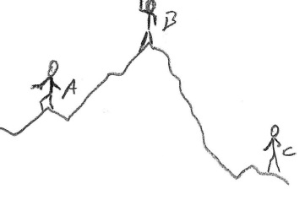
11. The picture on the right shows three mountain climbers. Who is experiencing the greatest air pressure?

12. Explain why that person feels more air pressure.

13. Show/explain why our ear drums hurt when we rapidly descend or rise to different elevations.
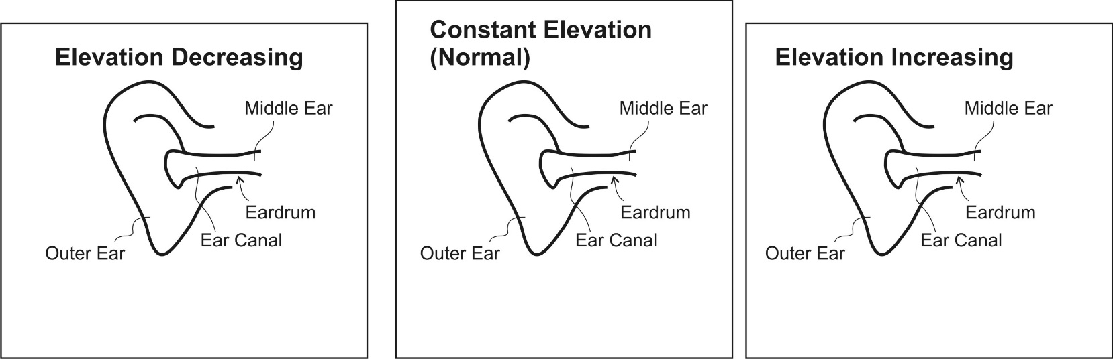

14. We are close to sea level. At sea level, the weight of the air above us creates an average air pressure of

_______ psi

15. “psi” stands for ____________________________________________________________________

16. Explain/show why a suction cup sticks to a glass surface and why a ball does not.

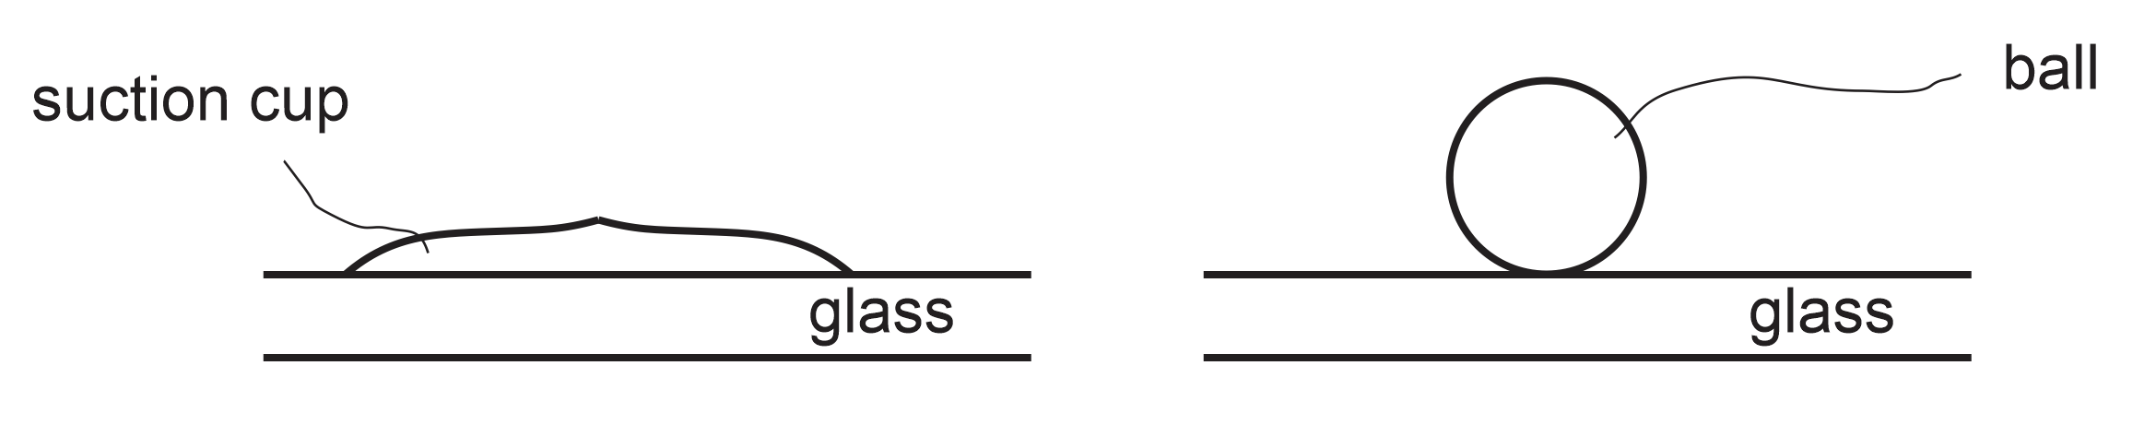

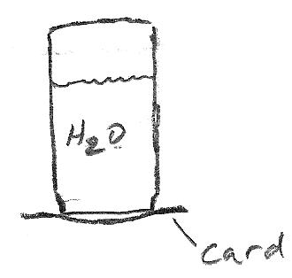
17. What happens if you fill a jar with water, cover it with a laminated card, and then turn the jar upside down? Explain why.

Part 3: Winds Caused by Temperature Differences

18. Quick review… what causes atmospheric air pressure (pressure in the air around us)?

19-22. After your experience with plate tectonics, you should be able to draw the air currents that will form in the diagram below. But now we will figure out convection currents and winds using different reasoning.

19. Label each air mass “heavy” or “light.”
20. Use the weight of the air to determine the amount of pressure beneath each air mass. Label each region below an air mass with either an H (high pressure) or an L (low pressure).
21. Use arrows to draw the winds that will be produced by these pressure differences.
22. Now use your knowledge of currents to fill in the rest of the currents in the diagram.

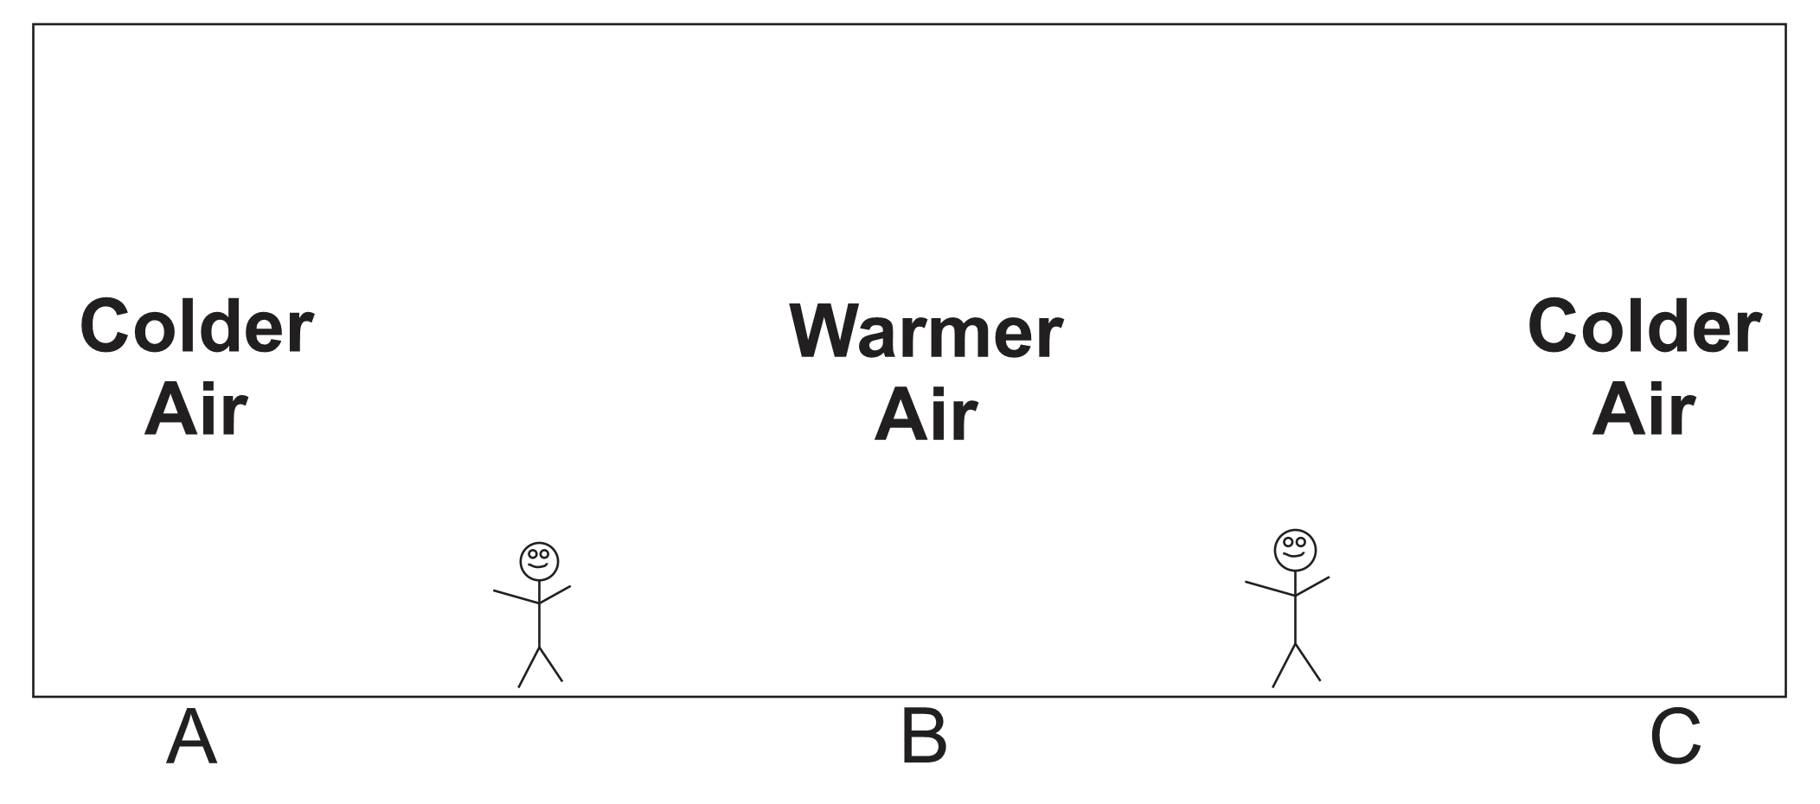

Part 4: Buoyancy Is Caused by Pressure Differences

23. A helium balloon floats upward. Show and explain how it “knows” which way to go.
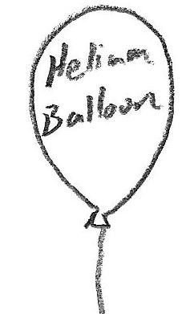

24. The upward force of pressure (that makes some things float) is called

__________________________.

25. Does everything around us experience buoyancy? _______

26. Why don’t most things float?

27. Explain why denser things sink and less dense things float.

ESS Practice Quiz Name: ________________

. What causes wind?
. What determines the direction of wind?
. How will the winds blow in the diagram below?

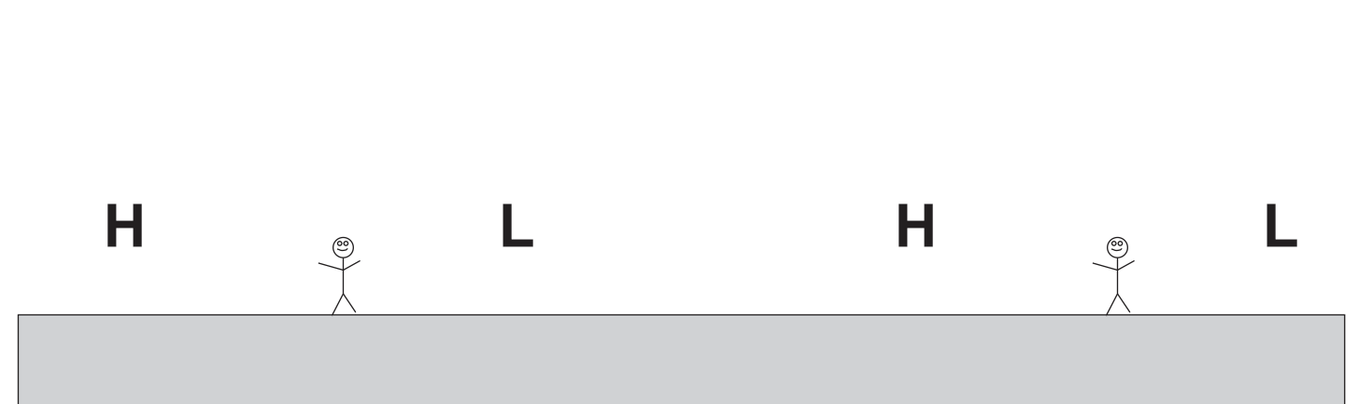

. What causes atmospheric pressure (the pressure in the air around us)?
. Where is air pressure stronger – at high altitudes or at low altitudes? Why?
. What happens to your eardrum when you travel rapidly upward? Why?
. What happens to your eardrum when you travel rapidly downward? Why?

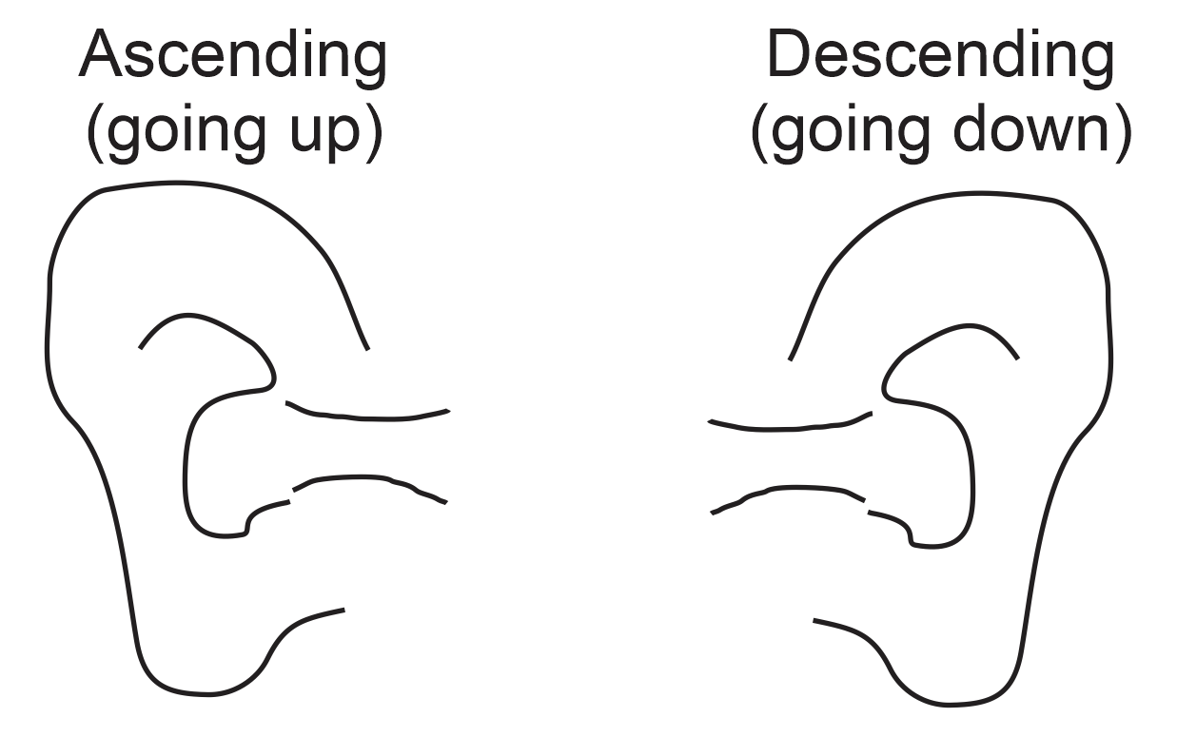

. What does “psi” stand for?
. What is the average air pressure at sea level (approximately)?
a. 1.5psi b. 10.5psi c. 15psi d. 150psi e. 1,500psi
. Explain why a suction cup sticks to glass, but other things don’t.
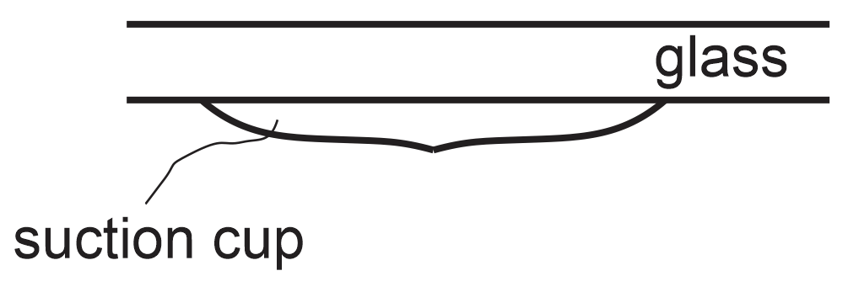
. In the diagram below…
a. Label the “heavy” and “light” air masses
b. Below the air masses, label the areas of high (H) and low (L) pressure.
c. Use arrows to draw the winds that will be produced by these pressure differences.
d. Fill in the rest of the currents in the diagram.

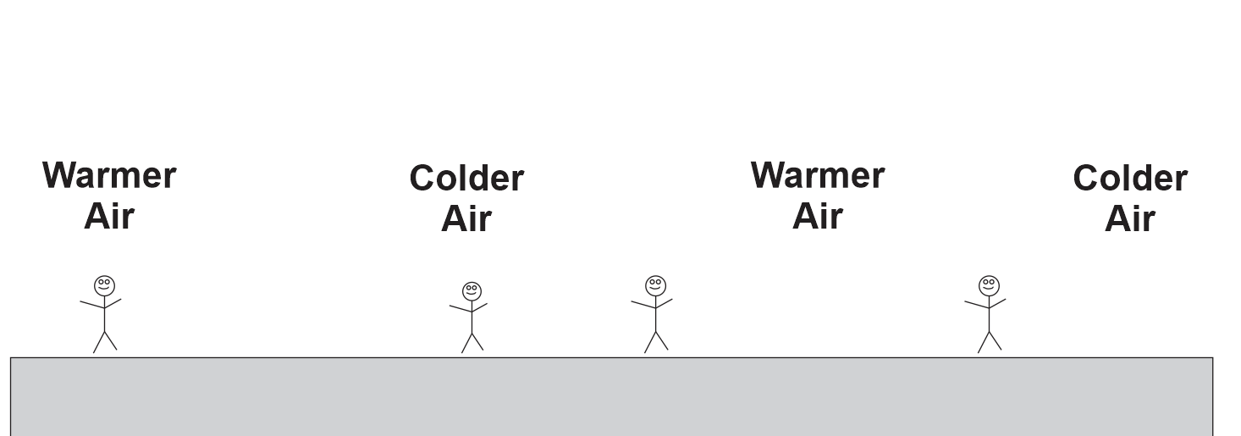

. On some parts of the Earth, winds near the ocean blow in one direction during the day and in the opposite direction during the night. Label the areas of high and low air pressure and draw the winds in the diagram below.

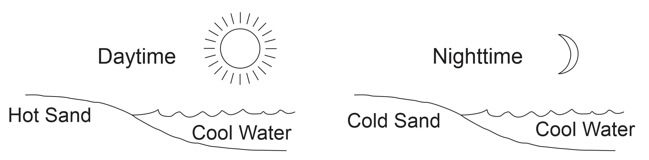

. Mountain peaks heat up and cool off much more quickly than valleys. In the mornings, mountain peaks heat up faster than valleys, and in the evenings, mountain peaks cool off faster than valleys. This results in winds. Draw those winds.

