ESS 100 (Stapleton) Name: ___________________________
Notes: Waves Part 1 -- Light, Color, and Star Temperature
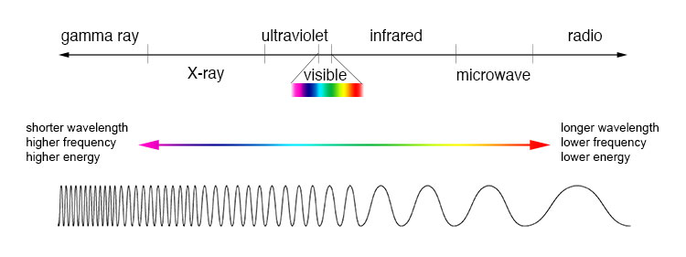
1. What is the general name that includes gamma rays, x-rays, ultraviolet, visible light, infrared, microwaves, and radio waves?

2. Stars give off many of the waves in the diagram. Which of those waves can our eyes see?

3. Draw a wave. Label a crest, a trough, and a wavelength.

4. a. List the colors of the visible spectrum from longest wavelength to shortest wavelength (hint: there’s a good mnemonic for this. And a catchy song!)
b. Draw waves representing those colors.
c. Label the colors that have the most and least energy [Hint: think of the waves as ropes that are being shaken.]

5. Rank these star colors from hottest to coolest (Hint: think about wavelengths). Orange, Red, Yellow, Blue, White

6. What do you see if you mix a paints of all different colors together? Why does this happen?

7. What do you see if you mix light of all different colors together? Why does this happen?

8. White isn’t exactly a color. What is it?

9. Black isn’t exactly a color. What is it?

10. The hottest stars are ____________ and the coolest stars are ____________. But medium temperature stars aren’t green. Why not?

11. a. Which stars are the hottest, larger stars or smaller stars?

b. Why?

c. What color are the largest stars? What color are the smallest stars?

