ESS 100 (Stapleton) Name: _________________________
Wave Behavior: Scattering, Reflection, Refraction

Scattering: Instead of traveling in a straight line, scattered waves get bounced in random directions.

1. Draw a picture of a ray of sunlight getting scattered.

2. A mnemonic for scattering… Imagine that you’re shooting bags of hay with the arrows shown here. Which arrow will penetrate best? Which will be most likely to bounce off?

3. Which of these colors is most likely to penetrate air, dust, and smoke, and which is most likely to get scattered? Why? Colors --- Red, Green, Blue

4. The Sun is white, but it looks yellow. The sky is blue. Use scattering to explain why.

5. In the diagram below, label the time of day where each of the people is standing. Then explain why the Sun looks redder at sunrise and sunset.
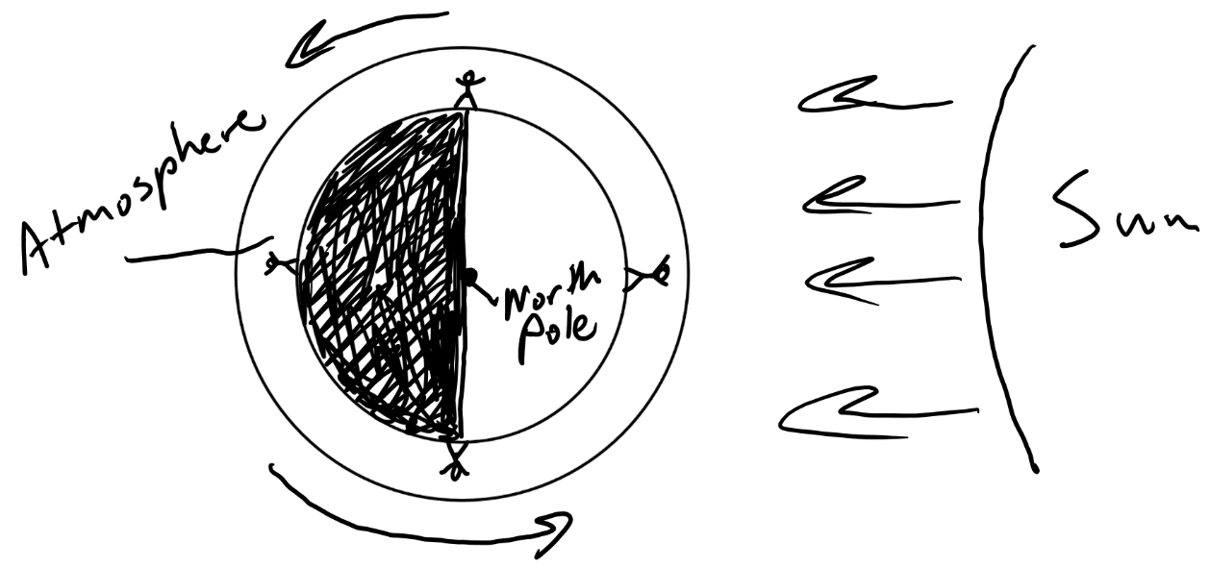
6. Explain why distant stars look redder than they really are.

7. Why does the Sun look Redder in a forest fire?

Refraction: Bending of waves. Waves refract when they enter a material where they travel slower or faster.

8. Draw a picture of white light refracting as it passes through a prism.
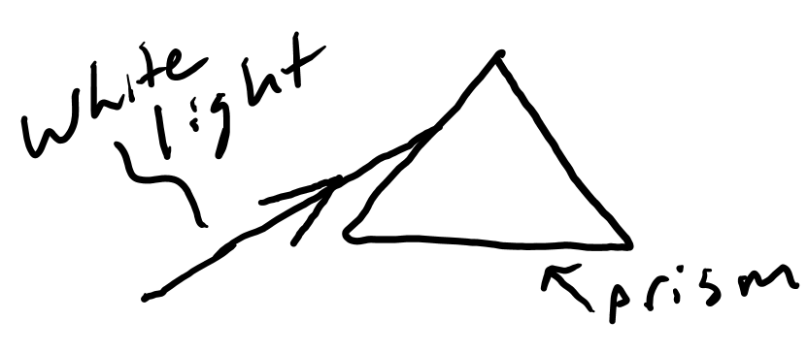

9. Draw a picture of light refracting as a child uses a lens to burn some paper.

Reflection: Bouncing off a surface. Waves reflect off of a surface at the same angle at which they hit the surface.

10. Show how light reflecting off of a flashlight mirror can be used to burn paper.

11. What do we call sound waves that reflect off of a surface and come back to us?

