ESS 100 (Stapleton) Name: ___________________________
Waves part 2: The Doppler Effect

In order to demonstrate and understand the Doppler Effect, we need talk about sound waves, which are a lot slower than light waves.

1. Draw a sound wave traveling through the air. Label a wavelength.

We can understand sound waves by thinking about making water waves by tapping the surface of a pool. Imagine how you would have to tap the water to make the sets of waves below.

2. Label the sets of waves to indicate how fast you would have to tap to create them.

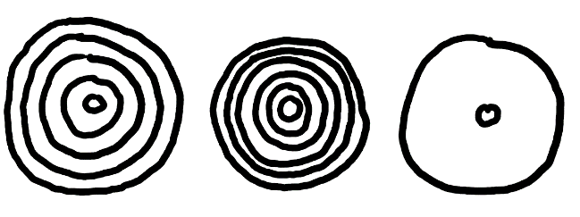
Frequency describes how often something happens. Wave frequency describes the number of waves produced each second. High frequency means waves are created quickly, one after another. Low frequency means waves are created more slowly.

3. Rank the waves on the right according to their frequency.

4. How are frequency and wavelength related to one another?

5. Pitch describes the highness or lowness of a sound. Find a zipper or some rough fabric. Zip the zipper or scrape the fabric to make a sound. You can also do this with a ruler. This sound is produced by individual clicks. Each zipper tooth or each fabric bump makes a sound wave.

a. How is zipping speed related to pitch?

c. What is the relationship between frequency and pitch?

6. Which person in this diagram is making a sound with a higher pitch?

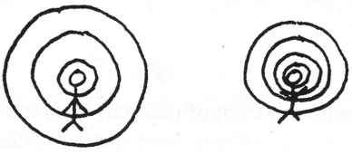

8. Draw sound waves coming from a noisy object that is moving to the right. Then draw two people, one in front of the object and one behind it. Describe the pitch that each person hears.

9. When a moving object is producing waves what happens to the waves in front of the object?

What happens to the waves behind the object?

The Doppler Effect: An apparent change in the wavelength and frequency of waves, caused by movement of an object and or an observer. This can happen with sound or light.

10. One of the waves on the right represents blue light, and the other represents red light. Label them appropriately.

11 The diagrams below show three white stars and light leaving those stars. For each star, show its direction of movement (if any). Then tell whether the observer would see a white star, a slightly bluer star, or a slightly redder star.

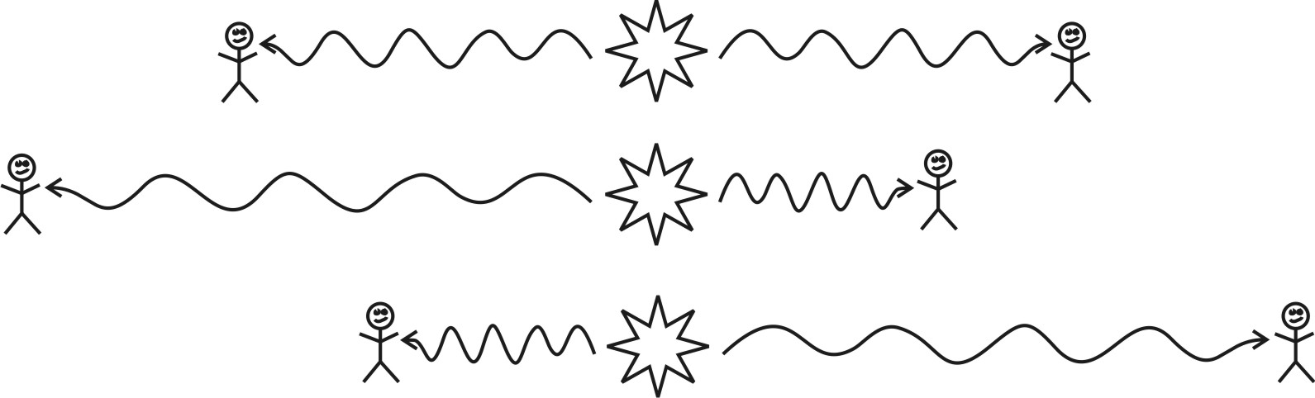

12. When we look at light from a start that is moving away from us, the light waves we see get________________ (stretched or compressed). We call this a ______________ (red-shift or blue-shift). When we look at light from a star that is moving toward us, the light waves we see get________________ (stretched or compressed). We call this a ______________ (red-shift or blue-shift).

