Plate Tectonics Quiz #4 Version 2 Name: ______________________________
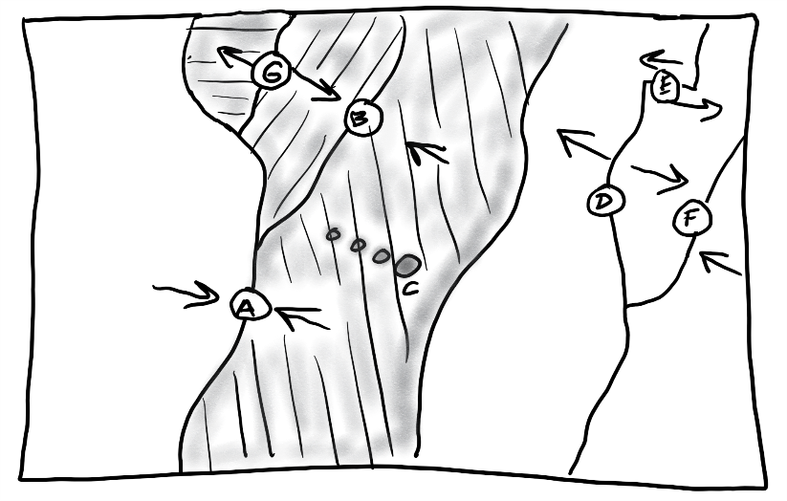
PLEASE DARKEN THE CORRECT ANSWER CHOICES.

For each lettered feature on the map on the right, darken all of the characteristics below that apply. [Suggestion: start with letter A. Darken that letter for all of the descriptions that apply to location A on the map. Continue the process one map feature at a time.]

1. A B C D E F G There is an ocean trench in this location
2. A B C D E F G Relatively violent eruptions of lava can occur here.
3. A B C D E F G Relatively gentle eruptions of lava can occur here.
4. A B C D E F G There are tall mountains , but they are not volcanoes.
5. A B C D E F G Situated over a relatively hot part of the mantle
6. A B C D E F G Situated over a relatively cool part of the mantle
7. A B D E F G New ocean crust is being created here.
8. A B C D E F G Deep earthquakes can occur here.
9. A B C D E F G There are shallow focus earthquakes.
10. A B C D E F G Rounded, shield volcanoes exist here.
11. A B C D E F G Steep, composite cone volcanoes can be found here.
12. A B C D E F G This is a subduction zone.

