ESS 100 Midterm Review (Stapleton) Name: ___________________________
Unit 1 Test: Physical Properties and Air Pressure

Part I: DARKEN each correct answer choice.

The objects below are mostly empty space. The circle is the edge of each object. The dots inside represent all of each object’s mass. The empty space inside the objects has no air or mass of any kind. All of the objects are in similar locations on the same planet.

1. Which object has the most mass? A B C D E F

2. Which object has the least mass? A B C D E F

3. Which object has the most volume? A B C D E F

4. Which object has the least volume? A B C D E F

5. Which object is most dense? A B C D E F

6. Which object is least dense? A B C D E F

7. Which object has the most weight? A B C D E F

8. Which object has the least weight? A B C D E F

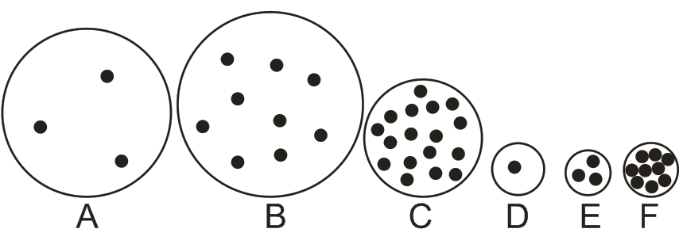

Part II: For the following questions, tell whether each property increases, decreases, or stays the same. Darken the correct symbol, either +,-, or =.

9-12. An object’s size doesn’t change, but more stuff is added to it.

9. mass + - = 10. volume + - =

11. density + - = 12. weight + - =

13-16. The particles inside an object become less crowded, but the amount of stuff in the object doesn’t change.

13. mass + - = 14. volume + - =

15. density + - = 16. weight + - =
Part III:
1. What is causing the air pressure that we are feeling right now?

2. One way to measure air pressure is in psi.

“PSI” stands for _________________ per _________________ ___________________.

3. On Earth, ordinary air pressure at sea level is approximately ________ psi.

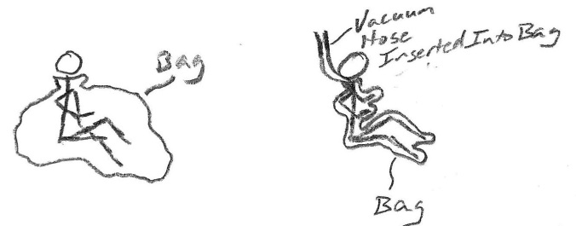
4. The pictures on the right show a student before and after being vacuum packed in a plastic bag. Use arrows to show why the student on the right is being squeezed by the bag, while the student on the left is not.

5. a. An airplane is flying from New Jersey to Vermont. As the plane approaches the Burlington airport, it begins to descend toward the ground [It flies lower.] As the plane gets lower, what happens to the air pressure that is felt by the people in the plane? Does it increase or decrease?

b. Explain why.

6. When you climb up a mountain, do your eardrums stretch inward or do they stretch outward?

7. Explain why your eardrums stretch in that direction.

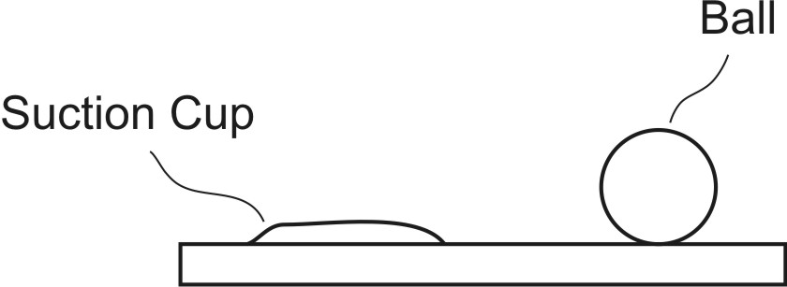

8. The diagram on the right shows a ball sitting on a table, and it also shows a suction cup that is stuck to the table. In the diagram on the right, draw arrows representing air pressure. Use those arrows to show why the suction cup sticks to the table and why the ball does not.

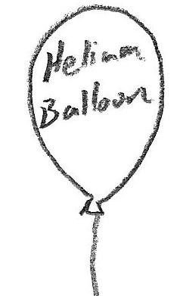
9. Use arrows to show why helium balloon rise. Your arrows should represent the air pressure pushing against the helium balloon in the picture. If you feel like your arrows don’t fully explain why the balloon rises, you can also use words to explain how pressure causes the balloon to rise.

Unit 2 Test: Temperature and Pressure
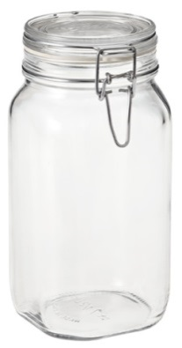
Suppose you have some air trapped in a sealed jar. Air cannot leave the jar, and air cannot enter the jar.

1. If you cool down the jar, what happens to the speed of the air molecules in the jar?
a. They slow down b. They speed up c. No change

2. If you heat up the jar, what happens to the speed of the air molecules in the jar?
a. They speed up b. They slow down c. No change

3. If you heat up the jar, what happens to the air pressure inside the jar?
a. Air pressure increases b. Air pressure decreases

4. What causes the air pressure to change when the jar cools down?
a. The air molecules’ weight changes
b. The air molecules push against the jar with more force.
c. The air molecules push against the jar with less force.
d. Suction pulls against the jar walls.

Suppose you blow up a balloon and tie it off. No air can leave the balloon, and no air can enter it. What will happen the balloon if you put the balloon in a refrigerator and cool it down? Assume that the balloon does not pop or leak.
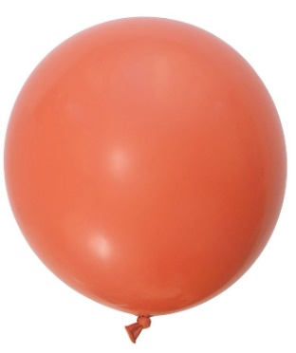
5. What will happen to the mass inside the balloon when it is in the oven?
a. It will increase b. It will decrease c. It will stay the same

6. What will happen to the overall volume of the balloon while it is in the oven?
a. It will increase b. It will decrease c. It will stay the same

7. What will happen to the overall density of the balloon?
a. It will increase b. It will decrease c. It will stay the same

8. What will happen to the overall pressure of the balloon?
a. It will increase b. It will decrease c. It will stay the same

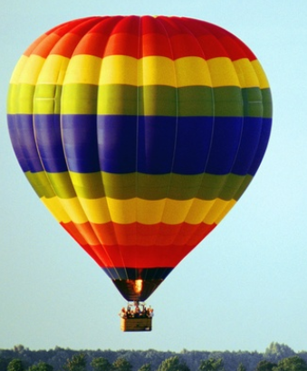
A hot air balloon flying over Essex has a big hole in its bottom (all hot air balloons have holes). A flame heats the balloon, and then the flame shuts off, leaving the balloon hotter than before. Assume that the hot air balloon cannot get bigger.

9. What happens to the overall volume of the balloon when it is heated?
a. It will increase b. It will decrease c. It stays about the same

10. What happens to the speed of the air molecules when the balloon heats up?
a. They speed up b. They slow down c. No change

11. What happens to the overall density of the balloon when it is heated?
a. It increases b. It decreases c. It stays about the same

12. What happens to the overall mass of the balloon when it is heated?
a. It increases b. It decreases c. It stays about the same

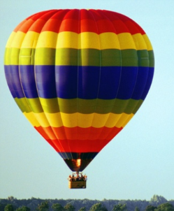
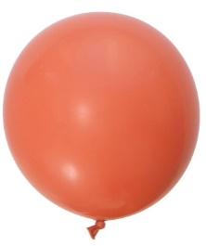
There are many differences between the inflated rubber balloon and a hot air balloon on the right. For example, one of the balloons has about the same air pressure inside and out, and the other balloon has air pressure inside that is very different than the air pressure outside.

13. Which balloon has approximately the same pressure inside and outside?

14. When that balloon heats up, why doesn’t the pressure inside the balloon get stronger and stronger?

15. Suppose you have a sealed container, and the air inside the container has lower pressure than the air outside of the container. If you open the container, what will happen?

a. Air will move into the container.
b. Air will move out of the container.
c. Air will not move.

ESS 100 Name: _____________________________________
Unit 3 Quiz 1 – Atmospheric Circulation

On the diagram below….

1. Use arrows to show the circulation of the Earth’s atmosphere. You only have to draw ¼ of the pattern, if you want.
2. Use Hs and Ls to label all of the areas of high and low pressure.
3. Use arrows to draw the prevailing winds.

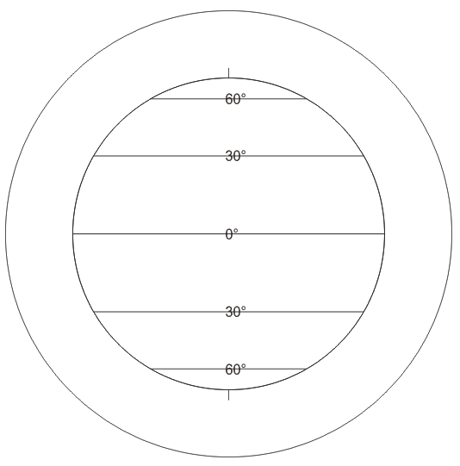

Unit 3 Quiz 2 – Climate Map Drawing
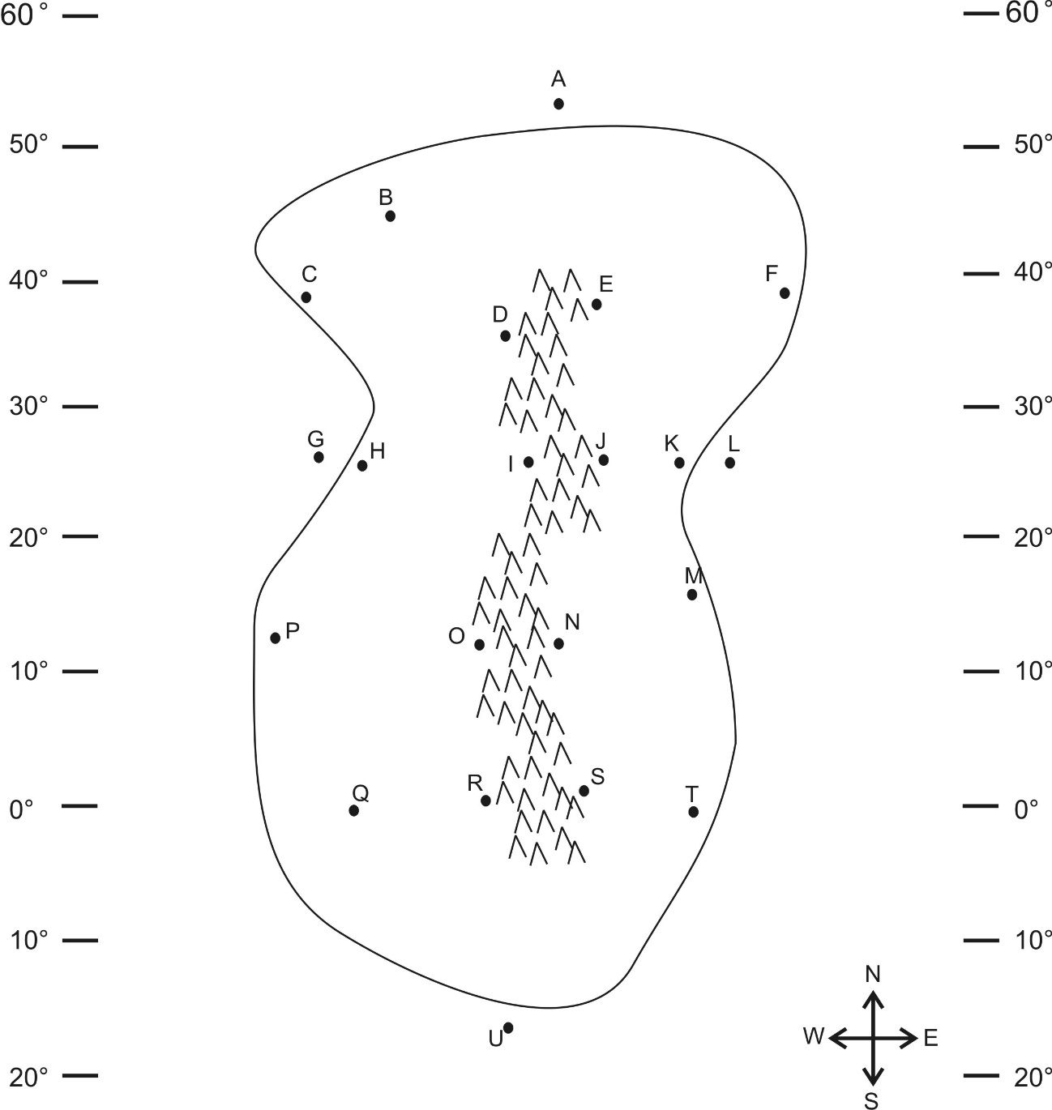
Part 1: Multiple Choice. Complete the map on the right. Then answer the questions below. Choose all of the answer choices that apply.

1. Which letter is in a high pressure belt?
A E J N S U
2. Which letter is in a low pressure belt?
A E J N S U
3. At which letter does the wind blow toward the southwest?
A E J N S U
4. At which letter is there a cold current?
G L
5. Which letter is in a major rainforest?
A B D I O R U
6. Which letter is in a major desert?
A B D I O R U
7. Which letter is in a coastal wet climate? Pick two.
C H P T
8. Which letter is in a wet climate caused by the rain shadow effect?
E J N S
9. Which letter is in a dry climate caused by the rain shadow effect?
E J N S
10. Which letter is in a humid climate?
C K H F B
11. At which letter does the ocean current flow toward the west?
A G L U

Semester 1, Big Questions:
- Why is air pressure different at different heights and in different parts of the world?
- Explain why hot air balloons rise when the pilots turn on the flame. Make sure that you explain what is happening to the balloon’s mass, volume, and density; and explain why.
- When you make a cloud in a bottle, how what do you do to make the cloud disappear? Why does this work?
- Explain, in detail, why clouds form in the real world.
- Describe the steps in the water cycle.
- What types of weather are associated with high pressure and low pressure? Why?
- What is the ultimate cause of the Earth’s prevailing winds?
- What causes ocean currents? Why are some hot and some cold?
- What causes the Earth’s major deserts and rainforests?

Answers to the Semester 1 Big Questions:

  - Air pressure is caused by the weight of the air above us.
  - If you go higher, there is less air above you, so there is less air pressure.
  - If you go to the North or South Pole, the air pressure is high because the air above you is cold, so it is dense and heavy.
  - If you go to the Equator, the air pressure is low because the air above you is warm, so it is light.

  - When a pilot turns on the hot air balloon flame, the air molecules inside the balloon begin to move faster.
  - When the air molecules move faster they push away from one another; the air expands.
  - The expanding hot air can’t fit in the balloon, so some of the expanding air leaves the balloon through the hole.
  - When air leaves, the balloon has less mass in the same amount of space, so that means it is less dense (less crowded).
  - When the balloon becomes less dense than the air around it, it rises.

  - The cloud disappears when you squeeze.
  - Squeezing heats up the air in the bottle
  - Heating causes the tiny cloud droplets to evaporate.

  - Clouds form when air rises.
  - As air rises, it encounters lower air pressure.
  - Lower air pressure allows the rising air to expand.
  - Expanding causes the rising air to cool.
  - Cooling causes water vapor in the rising air to condense into liquid.

  - Water evaporates from the ocean,
  - rises into the sky,
  - condenses to form clouds,
  - and then falls back to the ocean as precipitation…

  - High pressure causes clear weather because…
  - High pressure compresses the air.
  - Compression heats up the air and causes water to evaporate.
  - Low pressure causes cloudy weather because…
  - Low pressure allows air to expand.
  - Expanding air cools down, causing water to condense.

  - Winds are caused by movement of air at the poles and the equator.
  - Hot air rises at the equator, and cold air sinks at the poles.

  - Ocean currents are caused by winds.
  - Warm ocean currents come from the equator. Cold currents come from the poles.

  - The major deserts are caused by areas of high pressure and sinking air.
  - The major rainforests are caused by areas of low pressure and rising air.

