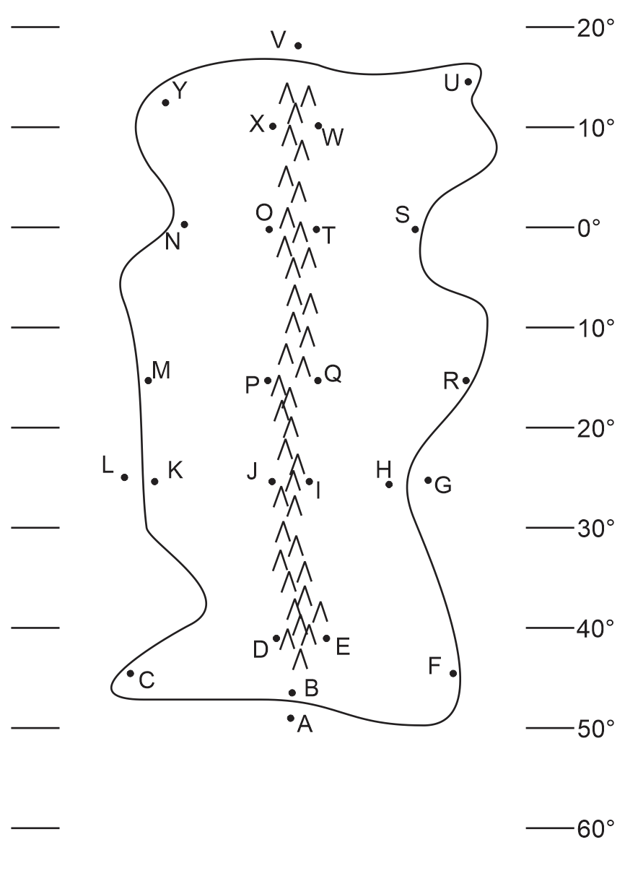
ESS 200 (Stapleton) Name: _______________________________
Climate Mapping Practice Test #4

Part 1: Multiple Choice. Complete the map on the right. Then answer the questions below. Choose all of the answer choices that apply.

1. Which letter is in a high pressure belt?
W T Q I E A
2. Which letter is in a low pressure belt?
W T Q I E A
3. At which letter does the wind blow toward the southwest ?
W T Q I E A
4. At which letter is there a cold current?
G L
5. At which letter is there a warm current?
V A
6. At which letter does the ocean current flow most directly toward the South Pole?
V L G A
7. At which letter does the ocean current flow toward the east?
V L G A
8. Which letter is in a major rainforest?
W T Q I E A
9. Which letter is in a major desert?
W T Q I E A
10. Which letter is in a coastal wet climate?
H F B C K M N
11. Which letter is in a wet climate caused by the rain shadow effect?
O P J D
12. Which letter is in a dry climate caused by the rain shadow effect?
O P J D
13. Which letter is in an area that can only be classified as a humid climate?
K J H R M C F B

