ESS 200 (Stapleton) Name: _______________________________
Climate Mapping Practice Test #2
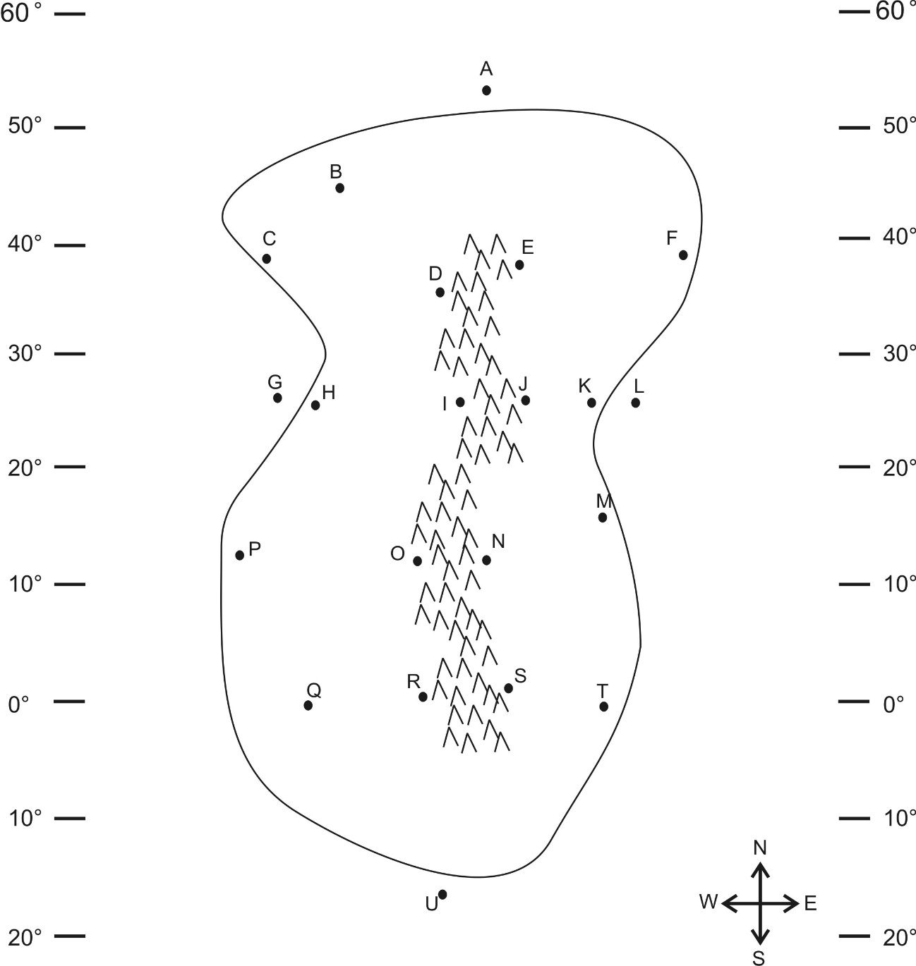
Part 1: Multiple Choice. Complete the map on the right. Then answer the questions below. Choose all of the answer choices that apply.

1. Which letter is in a high pressure belt?
A B D I O R U
2. Which letter is in a low pressure belt?
A B D I O R U
3. At which letter does the wind blow toward the northwest?
A B D I O R U
4. At which two letters is there a cold current? Pick two.
A P E H V
5. Which letter(s) is(are) in a major rainforest?
A B D I O R U
6. Which letter(s) is(are) in a major desert?
A B D I O R U
7. Which two letter(s) is(are) in a coastal wet climate? Pick two.
C H P T M K F
8. Which letter is in a wet climate caused by the rain shadow effect?
D I O R
9. Which letter is in a dry climate caused by the rain shadow effect?
D I O R
10. Which letter is in an area that can only be classified as a humid climate?
Q T M K F B C H P
11. At which letter does the ocean current flow most directly toward the North Pole?
A G L U
12. At which letter does the ocean current flow toward the east?
A G L U

