ESS 200 (Stapleton) Name: _______________________________
Climate Mapping Test #1
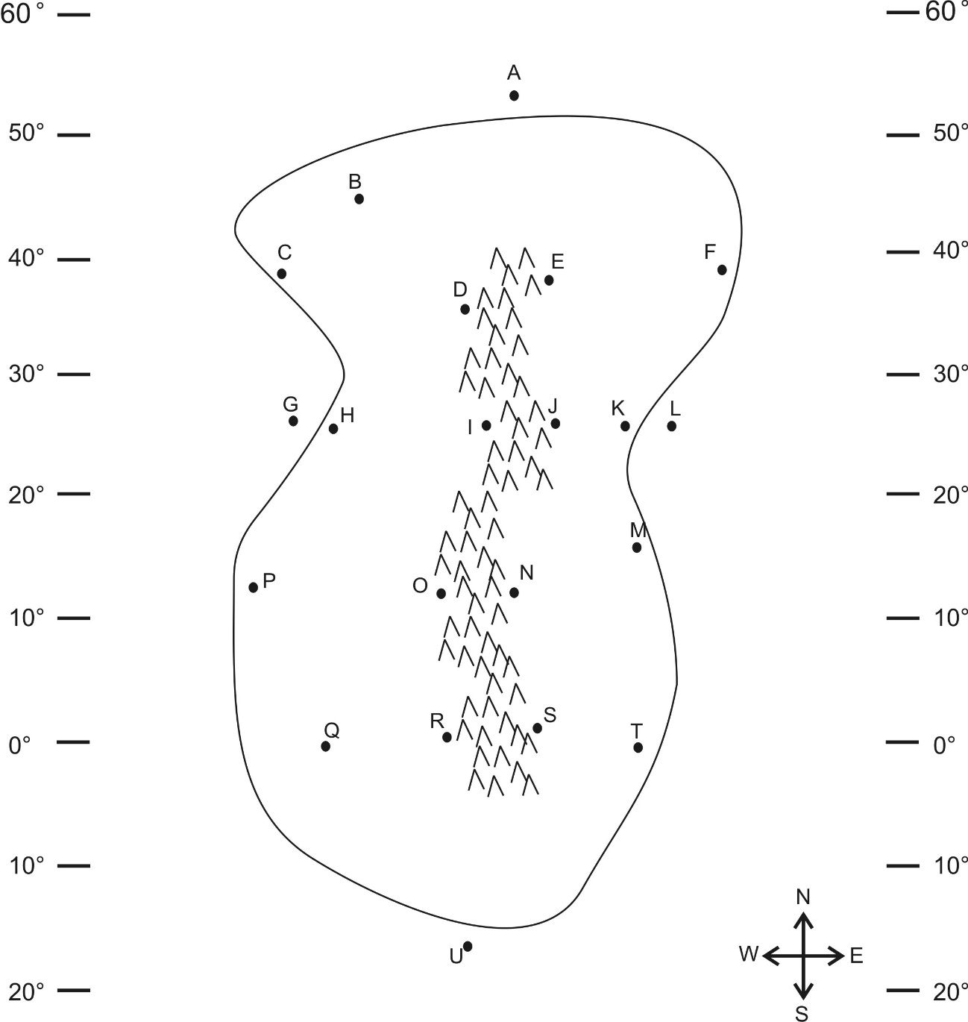
Part 1: Multiple Choice. Complete the map on the right. Then answer the questions below. Choose all of the answer choices that apply.

1. Which letter is in a high pressure belt?
A E J N S U
2. Which letter is in a low pressure belt?
A E J N S U
3. At which letter does the wind blow toward the southwest?
A E J N S U
4. At which letter is there a cold current?
G L
5. Which letter is in a major rainforest?
A B D I O R
6. Which letter is in a major desert?
A B D I O R
7. Which letter is in a coastal wet climate?
C H P T
8. Which letter is in a wet climate caused by the rain shadow effect?
E J N S
9. Which letter is in a dry climate caused by the rain shadow effect?
E J N S
10. Which letter is in a humid climate?
C K H F B
11. At which letter does the ocean current flow toward the west?
A G L U

