ESS 100 Name: ___________________________
Practice Quiz Version 3
Hot Air Balloon Density and Temperature Calculations
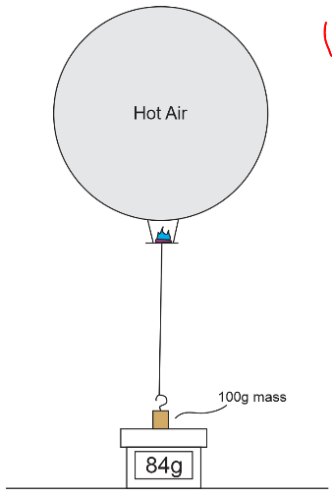
Data:
- Flight conditions:
  - Classroom temperature = 65°F
  - Air pressure =30.1 inHg
  - Dewpoint = 20°F
  - Air Density = ____________kg/m³
- Balloon Data
  - Shop vac fill rate = 0.0025m³/second
  - Fill time = 78 seconds
  - Envelope and platform mass = 20g
  - Fuel mass = 3g
  - Mass of weight on the scale during flight = 100g
  - Lowest scale reading during flight = 84g
  - Mass “lifted” by balloon = ____________g

1. Use the data above and the calculator at https://www.omnicalculator.com/physics/air-density to find the air density in kg/m³. Round it to the hundredths place and write it in the space above.

2. Calculate the mass that the balloon was able to lift, in grams, and write it in the space above.

3. Calculate the volume of the balloon in cubic meters and round it to the hundredths place.

Volume = ___________m³

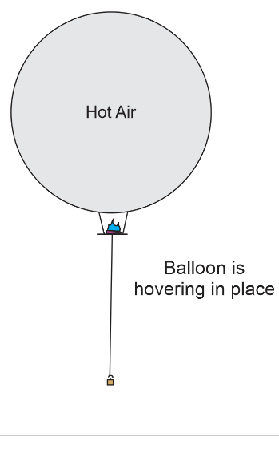
For the rest of the questions, imagine that you attach that exact lifted mass to your balloon. When you do this, the balloon does not rise, and it does not sink. It will hover in the same place (see diagram below). [More added mass would make it fall, and less added mass would cause it to rise.]

4. a. What is the overall density of the hovering balloon and everything that is attached to it?

Overall density of everything hovering on the right = __________ kg/m³.

b. How do you know?

5. Calculate the total mass of the hovering balloon and everything that is attached to it (including the attached weight and the hot air), in kilograms.

Total Mass = _________ kg

6. a. Add up all of the mass in the hovering hot air balloon that was not hot air. Units should be in grams.

Non-Air Mass = _________ g

b. Convert that total non-air mass to kilograms.

Non-Air Mass = _________ kg

7. a. Calculate the mass of the hot air in the balloon, in kilograms.

Hot Air Mass = _________ kg

b. Explain how you found the mass of the balloon’s hot air.

8. Calculate the density of the hot air in your balloon.

Hot Air Density = _________ kg/m³

9. Find the temperature of the air in your balloon, in degrees Fahrenheit. Use the calculator at https://www.omnicalculator.com/physics/air-density to find this answer.

Hot Air Temperature = ________°F

