ESS 100 Name: _____________________________________

Plate Tectonics Test Review



**Part 1:**

1. Match each Earth layer, below, to its letter in the diagram

______ Inner Core ______ Lower Mantle

______ Upper Mantle ______ Outer Core

______ Lithosphere (Including Crust)

2. Match each layer listed below to the type of material that is in that layer

Choices: A. Solid Rock B. Hot, flowing rock C. Solid Iron/Nickel D. Liquid Iron/Nickel

_____ Outer Core _____ Inner Core _____ Lithosphere (Including Crust)

_____ Upper Mantle _____ Lower Mantle

3. Describe two sources of the heat inside the Earth.

The diagram below shows several plates that are floating on the Earth’s surface. The gap between each plate represents a plate boundary. Material flowing below the Earth’s surface cannot pass beneath the bottom line. Sketch the plate and mantle movements and then answer the questions.

7. In which direction is the plate moving at position 7? ↑ ↓ ← →

8. What type of plate boundary exists at position 8? a. convergent b. divergent c. transform

9. In which direction is the plate moving at position 9? ↑ ↓ ← →

10. What type of plate boundary exists at position 10? a. convergent b. divergent c. transform

11. In which direction is the earth material flowing at position 11? ↑ ↓ ← →

12. In which direction is the earth material flowing at position 12? ↑ ↓ ← →



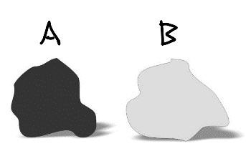

**Part 2:**

1. Which type of rock is most often found in continental crust? A B  
2.  Which type of rock is most similar to the material in the Earth's mantle? A B  
3.  Which rock is more viscous (gooier) when it is melted into magma or lava?  A B  
4.  When these rocks are melted into lava, which one forms less steep volcanoes? A B 5.  Which type of rock is most often found in ocean crust? A B  
6.  Which rock erodes, washes into the ocean, and settles as seafloor sediment? A B   
7.  Which of the rocks on the right looks more like basalt? A B   
8.  When these rocks are melted into lava, which one causes the most gentle eruptions? A B

9. Which of the rocks on the right looks more like granite? A B

10. Which rock is less dense? A B

**Part 3:**

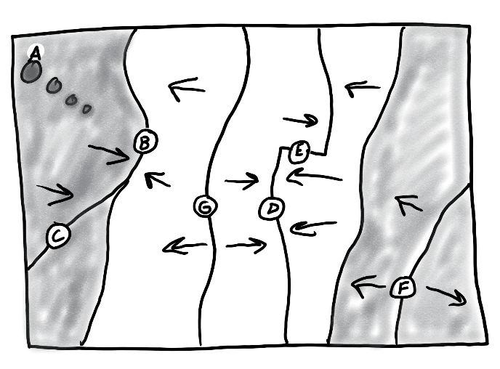

Match each feature name to the corresponding feature on the plate map on the right.

1. A B C D E F G Ocean/Continent Convergent

2. A B C D E F G Transform Boundary

3. A B C D E F G Continent/Continent Convergent

4. A B C D E F G Hotspot

5. A B C D E F G Ocean/Ocean Divergent

6. A B C D E F G Ocean/Ocean Convergent

7. A B C D E F G Continent/Continent Divergent

Each of the real-world locations below forms in an area that is similar to one of the lettered locations on the map. Match each real-world location to its corresponding map location.

8. A B C D E F G Mid-Atlantic Ridge

9. A B C D E F G San Andreas Fault, California

10. A B C D E F G East Africa

11. A B C D E F G Andes Mountains (South America)

12. A B C D E F G Himalayas (Mt. Everest)

13. A B C D E F G Japan

14. A B C D E F G Hawaii

**Part 4:**

For each lettered feature on the map above, darken all of the characteristics below that apply. [Suggestion: start with letter A. Darken that letter for all of the descriptions that apply to location A on the map. Continue the process one map feature at a time.]

1. A B C D E F G There is an ocean trench in this location

2. A B C D E F G *Relatively* violent eruptions of lava *can* occur here.

3. A B C D E F G *Relatively* gentle eruptions of lava *can* occur here.

4. A B C D E F G There are tall mountains , but they are not volcanoes.

5. A B C D E F G Situated over a relatively hot part of the mantle

6. A B C D E F G Situated over a relatively cool part of the mantle

7. B C D E F G New ocean crust is being created here.

8. A B C D E F G Deep earthquakes can occur here.

9. A B C D E F G There are shallow focus earthquakes.

10. A B C D E F G Rounded, *shield* volcanoes exist here.

11. A B C D E F G Steep, *composite cone* volcanoes can be found here.

12. A B C D E F G This is a *subduction zone*.