Physics 200 Name: _________________________________
Laser Cutting From a Rhino File

- Sometimes things go wrong for inexplicable reasons. Often this is because so many people share this equipment and monkey with the settings. If something doesn’t work right, please be patient. You can ask Mr. Stapleton for help.
- Find your Rhino file (it should have a .3dm suffix).
- Open the file on the computer that is plugged in to the laser cutter.
- In Rhino, click into top view.
  - Make sure that only the items you want to cut are showing. Make sure that they are arranged in top view in your preferred orientations. You do not have to cut a 2-D drawing, but it’s best if you do.
  - Strength or flexibility? If you are cutting long pieces that need to be rigid, they should run parallel to the grain of the wood or parallel cardboard corrugations. If you want flexibility along the length of pieces, arrange them perpendicular to the grain.
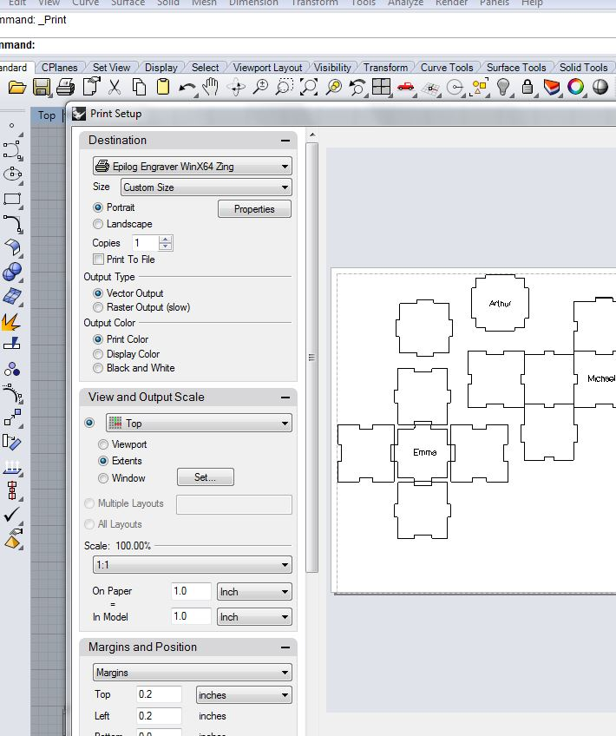
- Open the print dialog using the File Menu or Ctrl+P.
- Choose the destination (epilog engraver) as shown in the screen shot.
- Select the view and output scale as shown.
- Set the scale as shown (1:1).

- In the destination settings, click the printer properties button. This will open the blue window shown in the second screen shot. In this window…
  - Enter the piece size. For the cardboard we will be using, the piece size is close to 2’x1’, but to make sure that everything fits on your material, enter 23.5” for the horizontal dimension and 11.5” for the vertical dimension.
  - Enter the vector settings for speed, power, and frequency. These will vary depending upon the material that you are using. You can keep frequency at 500 for everything we will cut, but speed and power will need to be adjusted
    - Basic settings for cardboard: Speed = 100, Power = 65%, Frequency = 500.
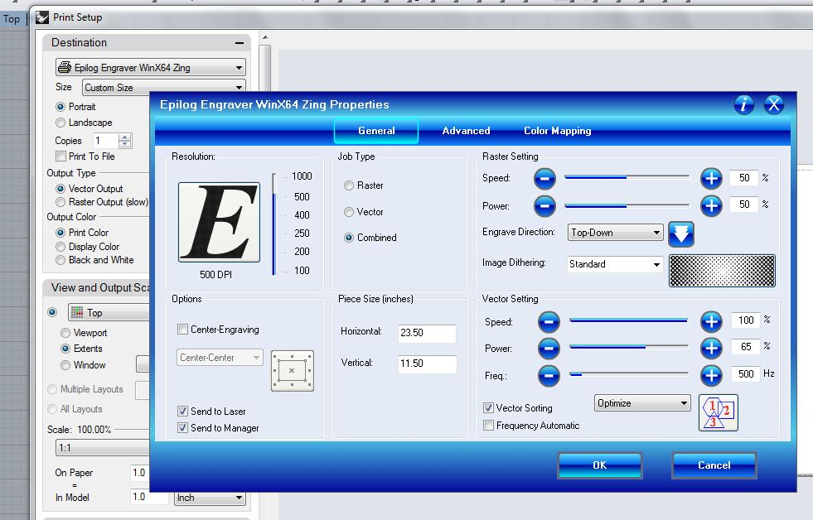
    - Basic settings for cutting wood: Speed = 50, Power = 100, Frequency = 500. You may be able to cut faster, but if you go too fast, you will have to trim your parts, and that is a hassle.

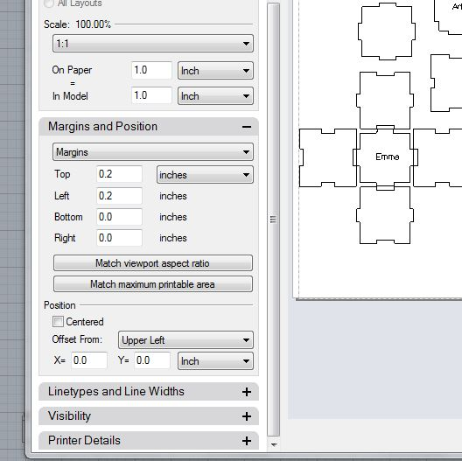
- Click okay in the properties window to return to the main print dialog.
- Adjust the Margins and Position settings.
  - In the 3rd screen shot, I have selected the upper left as my reference point. I have entered my top and left margins as 0.2” each. Sometimes the print grid shifts a little. If you print with 0” margins, you run the risk of going off of your print material. You can see the dotted line representing the left margin in the preview of the print.
  - Instead of positioning your print in the upper left of the work piece, you can position it relative to the center or one of the other corners of the laser cutter bed. I would only recommend using the center if I were certain that I did not want to save some of my plywood or cardboard. If you print something small in the top left, then you might be able to use the bottom right section again.
- When everything looks good, click print.
- Go to the laser cutter and see if your file name has appeared in the window with a new job number. Every time you send something new to the laser cutter, it will give it a new number (e.g. Job3: blah blah). When you turn off the laser cutter, the numbers reset.
- Adjusting the material on Laser Cutter Itself:
  - Open the lid.
  - Place your material to be cut on the laser cutter, shifting it to the top left corner of the grid.
  - Press the focus button. Move release the dangling height measurer, and then use the up and down arrows until the dangling thing is almost or just barely touching the material surface.
  - Press reset.
  - Close the lid
- TURN ON THE EXHAUST FAN!
- Recommended: Temporarily delete your file to be cut and draw a small circle in rhino. Press print and then click GO on the laser cutter. Confirm that the cut is making it all of the way through your material and that the cut is actually in the correct top left corner position.
- Make sure that the job that is ready to go is actually your real job. Then Press GO on the laser cutter.
- Wait for the beep to remove your parts.
- Clean up your mess.
- Turn off the laser cutter and the fan.
- At this point, you may want to cut some more files for other people. They can email you files to cut, and you can import them into your Rhino file using the import command. If you download a file from your email, it will be in your downloads folder. This may save time, because it cuts out the process of logging off, loggin on, reopening Rhino, etc. If you do this, perform a save as to change your file name so that you are not altering your original file with other people’s stuff.

